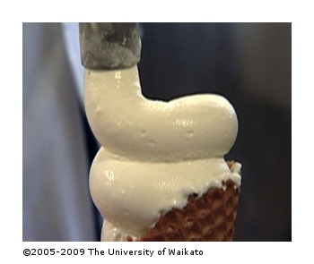
Activity: Testing fish oil in ice cream
This activity will allow students to appreciate that adding fish oil to foods affects their taste and shelf life. This provides a lead in to help them understand factors that may have influenced the development of microencapsulation technology. The activity also introduces the principles of sensory testing.

Health and safety:
It is important to identify students who have a fish or dairy allergy before embarking on this activity and manage the process so that these students do not taste the samples.
What you need:
- 2 litres ice cream
- Fish oil or fish oil capsules
- Measuring spoons
- Spoons for mixing
- Small disposable containers and spoons for tasting
- Access to a freezer
See unit plan: Promoting omega-3 enriched food
What to do:
- Divide the class into 4 groups and give each group 200g of ice cream.
- Get each group to add a different amount of fish oil. Add ⅛, ¼, ½ or ¾ the recommended daily dose and mix through the ice cream. Record on the container the amount of fish oil added.
- Label each group’s ice cream and the control (with no fish oil) A–E and record on a separate document the amount of fish oil in each. Students should not know which samples are which.
- Read the article: Consumer testing of functional foods
  - Identify and list all the requirements of the sensory testing process.
  - Have each group plan how they could set up a suitable environment and manage the sensory testing process in the classroom.
  - Discuss each group’s idea and decide how it will be done.
  - Assign group tasks to set up the tasting booths, prepare tasting portions of the ice cream (making sure each sample is carefully labelled A–E) and prepare a questionnaire to record testing results.
  - Keep some of each ice cream to test at a later date.
- Select 1–2 people from each group to make up the tasting panel.
- Carry out the tasting, collate and discuss the results.
  - Did all tasters identify the samples with and without fish oil?
  - Was it easier to identify in some samples than others?
  - Did the results vary between different tasters? Why is this?
  - Would people buy foods with fish oil added in this way? Why/why not?
- Repeat the tasting again after 1–2 weeks, using the same students as tasters. Collate these results and compare with the initial tasting results. Discuss any differences and the possible reasons for these.

