ACTIVITY: Making a food web

Activity idea

In this activity, students construct a food web using string to show connections between species.

By the end of this activity, students should be able to:
- describe relationships between particular organisms within the Antarctic ecosystem
- build their own food web to show the interdependence of organisms in an ecosystem.

Introduction/background notes
What you need
What to do

Introduction/background

This activity is a practical way for students to understand the complexity of food webs.

What you need

- Access to the image The food web in the Ross Sea
- String
- Scissors
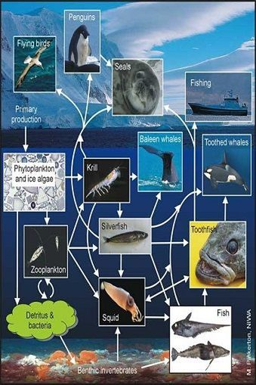
What to do

- Introduce the activity by showing students the image The food web in the Ross Sea. Explain that a food chain is used to describe the way energy moves from a producer – a plant – through to a predator. It is a simple linear view of who is eating what. But how many animals eat only one type of food? The picture of the Antarctic system shows that most animals are eating – and being eaten by – more than one animal. This forms a food web – a more complicated but accurate view that helps us to understand how the different living things in an ecosystem depend upon each other. The arrows go from prey species (these get eaten) to predators (the hunters).

- Have all the students stand in a circle. The first student holds on to a ball of string and names a plant.

- Another student names an animal (don’t forget about insects!) that eats that plant. They then take the ball of string while the first person holds onto the string end.

- Next, someone must come up with something that might eat that animal. This continues until a top level predator is reached.

- Cut the string. You will now have one piece ranging from a plant through a number of animals.

- Name another plant and repeat the procedure. If the same animal is named, the original person must hold the string, causing it to cross over.

- How complicated does the web become when the same plant or animal is eaten by many animals?

- What would happen if you removed any given species or added in something that is not normally part of the natural ecosystem?

