ACTIVITY: Hiding in plain sight

Activity idea

In this activity, students explore some of the adaptations fish use for camouflage.

By the end of this activity, students should be able to:
- describe why fish use camouflage
- explain some fish camouflage adaptations.

Introduction/background notes
What you need
What to do
Student handout: Hiding in the water
Fish template

Introduction/background

Introduce the idea of fish camouflage by creating simple fish shapes and hiding them on newspaper.

Students then read about different adaptations fish have for camouflage and discuss these before hiding their own fish.

What you need

- Newspaper with lots of text
- Different coloured paper
- Copies of the student handout: Hiding in the water
- Fish template (optional)
- Clear plastic sheets for making transparent fish (optional)
- Simple map of the classroom

What to do

  - Before the lesson, cut out 12 fish – 3 fish from each coloured paper and 3 fish from one sheet of newspaper – and glue them to a second piece of newspaper, hiding the newsprint fish as well as possible. Tape the newspaper to the wall where it will be easily viewed by all students and cover the newspaper before the students enter the room.

  - Tell the students that their job is to count as many fish as they can in 20 seconds.
Uncover the paper and start timing. After 20 seconds, cover the paper again.
  - Ask the students how many fish they found and what they looked like – did any of them find the newspaper fish?

  - Move the newspaper to a window and hold it up to the light. Begin a discussion on which fish will be the last ones eaten and why.

  - Distribute copies of the student handout Hiding in the water and read it together.

  - Talk about fish camouflage, and discuss how some of the fish that students are familiar with show some of these listed adaptations.

  - Ask students to work in groups and create a fish that will be placed in plain view in the classroom but designed to be camouflaged. They need to decide on a good location for their fish, and it should be a minimum size of 150 mm x 50 mm. (Students could use the Fish template for this.)

  - Tell each group when they can hide your fish without other students seeing. Remind them it must be in plain sight and cannot be hidden.

  - When all fish are hidden, allow 2–3 minutes for the fish hunt. Have students mark on a map of the classroom where each fish is placed. The team who have the best-hidden fish (fewest times seen) wins a prize.

  - Discuss the fish adaptations for hiding in the classroom with the class.

Student handout: Hiding in the water

Unlike living in the jungle where trees can provide shelter, animals in the water need to be able to hide from predators – or their prey – without the aid of objects.

Having a body form that blends in with its surroundings is definitely beneficial if you want to avoid being eaten.

Some of the approaches for hiding in the water are described below:

Small size

Many Antarctic fish are very small and may hide in amongst rocks and sponges on the seafloor to avoid predation.

The plunderfish (Artedidraco scottsbergi) grows to a maximum length of about 100 mm and lives on the seabed in shallow waters in the Ross Sea. This one was caught in about 300 metres.

The dragonfish (Gerlachea australis) grows to a maximum length of about 250 mm and lives at depths of 200–700 metres on the seabed in the Ross Sea

Disruptive coloration

Many Antarctic fish show banding along the side of the body, which is a form of disruptive camouflage. Some of these fish live in shallow waters where sunlight may produce dappled lighting. The shading will allow them to merge into the background as can be seen in the two photographs below.

The fish in top photo is a cod icefish (Trematomus) whilst the fish in the lower photo is a crocodile icefish (Chionodraco hamatus).

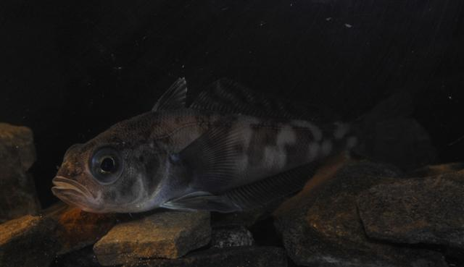

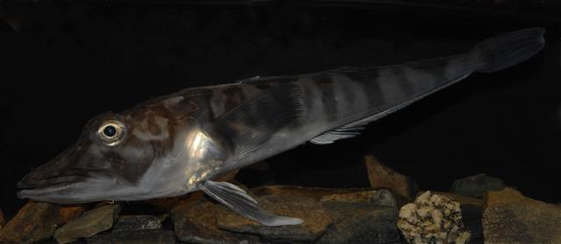

Mimicry of surroundings

Some fish are coloured and shaped to appear as though they are a part of their surroundings. Good examples of this are flat fish (such as flounder) and fish that are members of the ray family (such as stingrays and skates). Antarctic skates are coloured and shaped to merge into the seabed. Some are uniform grey whilst others are mottled. This photograph shows a Maccain’s skate, which is occasionally caught in the Ross Sea. It grows to a maximum length of 1.2 m.

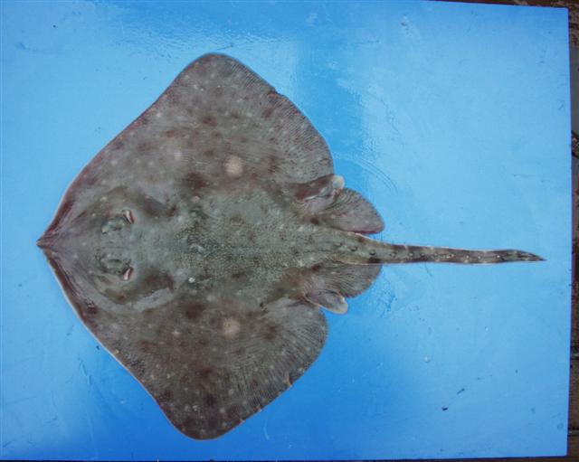

Schooling behaviour

The most common fish of the Ross Sea is the Antarctic silverfish (Pleuragramma antarcticum). This lives in large schools in the water column and, as you can see in the photo, has silvery scales that reflect light. When a predator attacks a school of these fish, the reflections from the silver sides dazzle the predator and allow many fish to escape. These fish grow to a maximum length of 250 mm and are the most important food for penguins, fish and whales living in the Ross Sea.

Counter shading

Many Antarctic fish may move up off the seabed into the water column to feed on krill and other mid-water prey. Some of these fish are darker on the dorsal (top) surface of their body and are lighter on the underside of their body. This is called counter shading, and the fish use it for camouflage. From above, the fish looks dark like the seabed, whilst from below, the fish matches light coming down from above. The fish in the photo is an Antarctic toothfish (Dissostichus mawsoni), which can weigh up to 100 kilograms and grow up to 2 metres long.

Bioluminescence

Some mid-water fish have specialised cells called photophores that can emit light – bioluminescence. The fish in the photo below are two species of Antarctic lanternfish (Gymnoscopelus braueri and Electrona antarctica) and are probably the most common lanternfish occurring in Antarctica. In a live state, they are covered in silvery scales, but these were lost when they were captured in the trawl net. The small silver circles on the ventral (lower) part of the body are the photophores. It is thought that, in dimly lit waters, the light from these photophores mimics the faint light reaching mid-water from above.

Transparent fish

The transparent fish in the photo below are 60–70 mm long juvenile icefish. They live in the upper layers of the water column in the Ross Sea where they feed on small zooplankton such as krill. Being transparent, they are very difficult for predators to see. As they get older, they develop more colouration and become more benthic.

The Science Learning Hub acknowledges the assistance of NIWA and the IPY Voyage scientists who supplied images for this resource. All rights remain with the originators.
Fish template

