ACTIVITY: Sources and effects of air pollution

Activity idea
In this activity, students use images and information to investigate sources and effects of air pollution.

By the end of this activity, students should be able to:
- recognise sources of air pollution
- know about some solutions to air pollution
- understand how air pollution affects them personally
- discuss this scientific and social issue with others.

Introduction/background
What you need
What to do
Discussion questions
Student handout: Investigating air pollution

Introduction/background

Unless you live in an area obviously affected by air pollution, you may not be aware that it is a problem in New Zealand. It is the big cities such as Los Angeles in America and Beijing in China that get in the news because of air pollution.

Read the resources Air quality and Air pollution in Christchurch before doing this activity.

What you need

- Copies of the student handout Investigating air pollution

What to do

- Divide the class into small groups and give each group a copy of the student handout Investigating air pollution to work through. An alternative would be to give each group a different single photo and share answers as a class.

Discussion questions

- What are some links between the photos?
- Which other places in New Zealand, apart from Christchurch, suffer from air pollution?
- What are some sources of air pollution that you cannot see?
- China (www.scmp.com/topics/beijing-air-pollution) and America (www.latimes.com/science/la-me-0430-air-pollution-20140430-story.html) have some well known and serious examples of air pollution. Do you think we need to worry about situations like these ever happening in New Zealand?

Student handout: Investigating air pollution

Answer the questions for the photos on the following pages.

Use this table of information about major sources of air pollution and their effects to help you.

Pollutant | Source | What effect does it have?
Carbon monoxide  – a colourless, odourless, tasteless gas that converts to carbon dioxide over a period of about a month | - Vehicles burning petrol.  - Domestic fires. | - Interferes with the ability of the blood to absorb and circulate oxygen.  - Can affect people with heart conditions.  - Causes headaches and vomiting.  - Large amounts are lethal.
Nitrogen dioxide  – a reddish brown, pungent, acidic gas | - Vehicles burning diesel or petrol.  - Domestic fires.  - Power stations burning fossil fuels.  - Major industry. | - Can lead to throat and lung infections.  - Low-level exposure can affect growth and cause damage to some plants.  - Can significantly affect visibility as it contributes to hazes and smog.
Ozone  – a colourless gas with a distinctive odour | - Vehicle exhaust fumes.  - Other pollutants in the presence of sunlight. | - Can seriously damage plants and animals.  - Causes runny eyes, nose and throat irritation and breathing difficulties, especially in asthmatics.  - Affects the functioning of the heart.

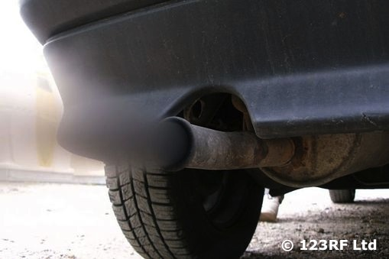

Write a title for this photo.

Write a brief description of what you can see.

If you were there, what do you think you could smell?

What would you be feeling if you were in the photo?

What problem does this photo show?

What could you do about this problem?

Who could help you achieve this?

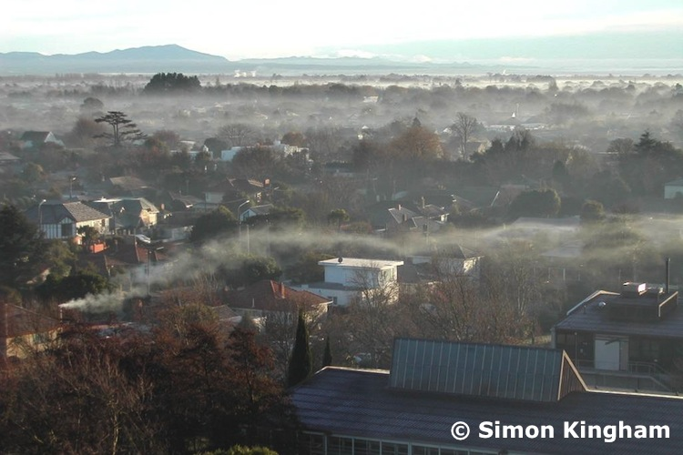

Write a title for this photo of Christchurch.

Write a brief description of what you can see.

If you were there, what do you think you could smell?

What would you be feeling if you were in the photo?

What problem does this photo show?

What could you do about this problem?

Who could help you achieve this?

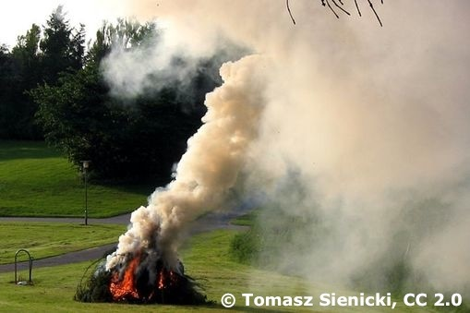

Write a title for this photo.

Write a brief description of what you can see.

If you were there, what do you think you could smell?

What would you be feeling if you were in the photo?

What problem does this photo show?

What could you do about this problem?

Who could help you achieve this?

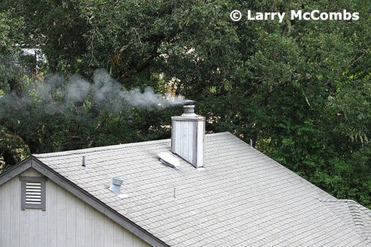

Write a title for this photo.

Write a brief description of what you can see.

If you were there, what do you think you could smell?

What would you be feeling if you were in the photo?

What problem does this photo show?

What could you do about this problem?

Who could help you achieve this?

