ACTIVITY: Challenging switches

Activity idea

In this activity, students construct a variety of circuits that all contain a switch. The activity builds on their understanding of how electrical circuits work and the role of switches within a circuit.

By the end of this activity, students should be able to:
- understand the role of switches in circuits
- design/construct a variety of circuits incorporating a switch for particular purposes.

Introduction/background notes
What you need
What to do
Extension ideas
Making circuits
Activity answers

Introduction/background

The flow of electric charges through a circuit can be controlled by switches.

Switches often work by causing a break in the circuit that stops the flow of electric charges. They can then be turned on to complete the circuit again and enable current in the circuit. Components such as bulbs, motors and buzzers can be turned on and off by switches.

Switches can be operated by being pushed, pulled, turned or flicked but they all work in the same way, by simply interrupting or breaking the electrical circuit. Most switches can only be on or off, but the variety of switches and the way they are used allow all sorts of circuits to be designed.

When building these circuits, students need time to be able to construct a working model. For instance, with a door switch, they need to fold cardboard into a box, create the moving door and then design their switches.

What you need

- Copies of student instructions Making circuits
- Copy of Activity answers
- Batteries (AA, 1.5V)
- Battery holders (AA)
- Copper wires (1.5mm are best)
- Bulbs (1.5V)
- Bulb holders
- Any other components, e.g. buzzer, LED, cardboard boxes

What to do

- Discuss the concept of switches and how they control the flow of electrical charges in circuits.

- Give each student a copy of the student instructions Making circuits and have them complete step 1.

- Compare and discuss the circuits. Are there other arrangements you can use to make each circuit?

- Have students complete step 2 and compare and discuss the circuit diagrams.

Extension ideas

Challenge students to draw circuit diagrams of their constructed circuits.

Encourage students to build their own switches. Students should realise that creating a short circuit to turn a bulb off or silence a buzzer is not an acceptable solution – it will quickly ruin the battery and, in real life situations, it is dangerous.
Making circuits

- Make at least 3 of the 6 circuits described below. To be successful, the switch must operate reliably at least 5 times in a row:
  - A switch that will turn a light off when a door opens.
  - A switch that will turn a light on when a door opens.
  - A switch that is operated by a magnet.
  - A switch that sits outside a pencil case and will turn on an alarm if the pencil case is stolen.
  - A switch that sits inside a pencil case and will turn on an alarm in the pencil case if it is stolen.
  - A switch that will allow a light to be turned on/off over a flight of stairs. (2 switches are required – one at the top and one at the bottom.)

- The interior light of a car comes on regardless of which door opens. Make a model of this circuit using a light bulb, battery, wires and four switches.

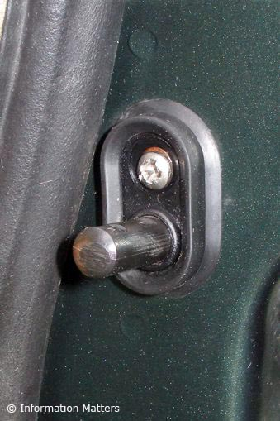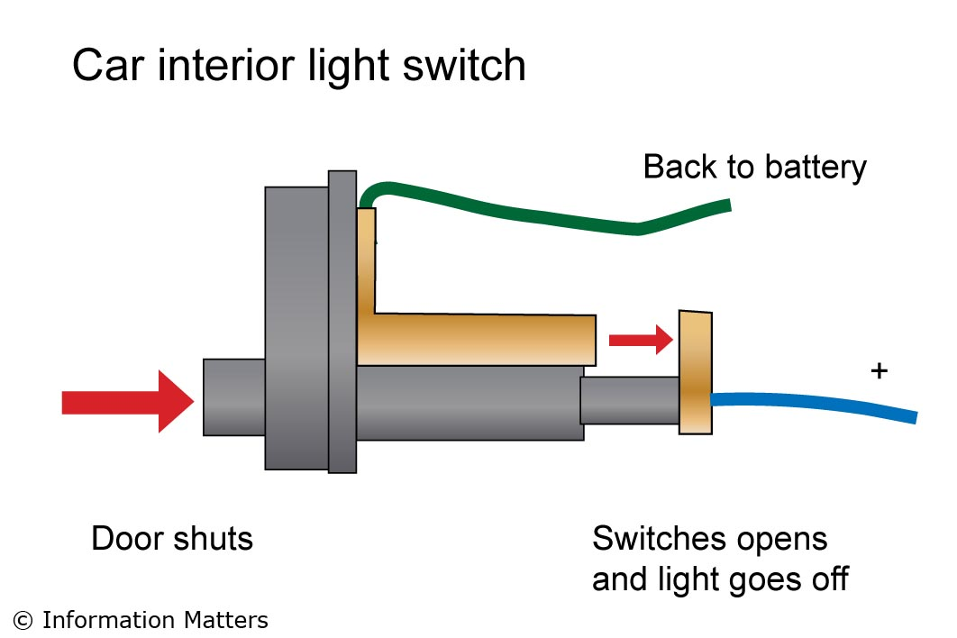

Draw a circuit diagram to show how you completed this challenge.

Activity answers

- Make at least 3 of the 6 circuits described below.
  - A switch that will turn a light off when a door opens. Use a push-to-make switch, so that, when the door is shut, the circuit is complete. Put the switch between the door and the door frame.
  - A switch that will turn a light on when a door opens. Use a push-to-make switch, so that when the door opens, the circuit is complete. Put the switch on the wall behind the door. Alternatively, place a push-to-break switch between the door and its frame
  - A switch that is operated by a magnet. Magnets attract iron, hence paperclips and staples can be moved by the magnetic force. The paperclip might touch aluminium (tin foil) or copper wire, both of which conduct electricity, but are not attracted by the magnet. Students could also include a spring device, so when the magnet is removed, the switch reverts back.
  - A switch that sits outside a pencil case and will turn on an alarm if the pencil case is stolen. Battery, buzzer and switch. The removal of the pencil case turns the switch on, similar to the opening door in circuit b.
  - A switch that sits inside a pencil case and will turn on an alarm in the pencil case if it is stolen. The battery, buzzer, switch inside the pencil case must be insulated from the contents. A motion switch is needed, such as a metal ball that rolls and completes a circuit or a weight that moves and closes a switch.
  - A switch that will allow a light to be turned on/off over a flight of stairs. (2 switches are required – one at the top and one at the bottom.) Two double pole switches are needed.

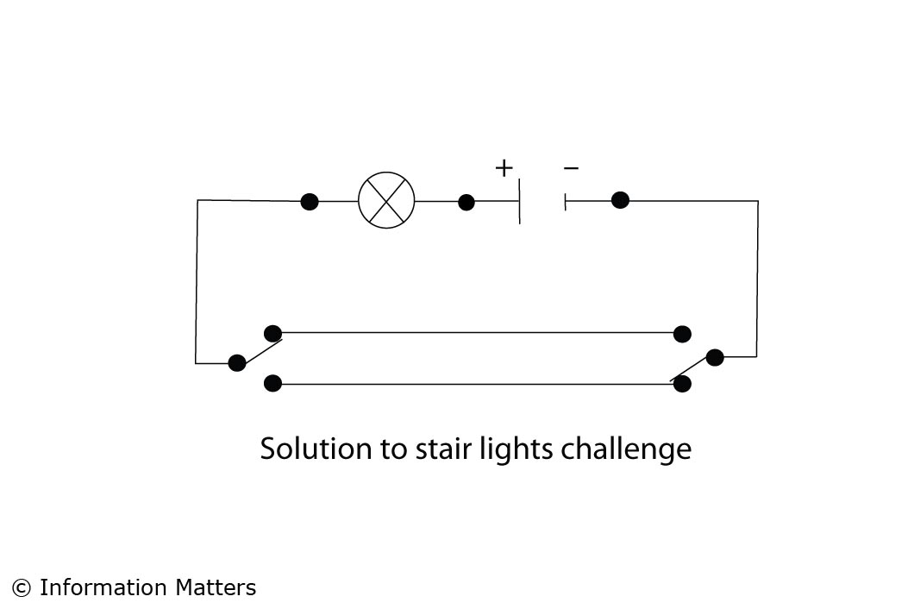

- Circuit can be drawn in many ways but any one switch must turn the light on. The switches on car doors are push-to-break and can be seen easily with the door open. Pushing them will turn the interiors light off.

