ACTIVITY: Is anything out there?

Activity idea

In this activity, students consider evidence for life on other planets outside our Solar System. They examine data to decide on the likelihood of life on certain extrasolar planets.

By the end of this activity, students should be able to:
- discuss what ‘life’ is
- use data to draw conclusions
- understand how hard it is to know if there is life on other planets
- communicate ideas to others
- know some information about planets in our Solar System.

Introduction/background notes
What you need
What to do
Student handout: Which planets could support life? (4 pages)
Planet info cards
Extrasolar planet cards

Introduction/background

Our Sun is not the only star in the galaxy that has planets in orbit around it. Astronomers have found evidence of many stars that have planets orbiting around them in our galaxy, and they constantly discover more. These are called extrasolar planets or exoplanets.

Could any have life on them? The answer depends on many things, but it starts with another question: what is life? Could life on another planet be different and why would that be? At the moment, we don’t have the technology to give us the information we need to answer this, but we can work out which planets could have life. They might be worth a closer look.

Using their knowledge of life on Earth and the characteristics of the other planets in our Solar System, astrobiologists rule out life as we know it on most new planets. One of the key requirements is liquid water. They look for planets that fall inside a habitable zone around a star – a planet must be not too close, not too distant; not too hot, not too cold; not too big, not too small and so on. This is called the ‘Goldilocks principle’, after the character in the story ‘Goldilocks and the Three Bears’ who always chose things that were ‘just right’. Even if the conditions are ‘just right’ for water and life on another planet, that doesn’t mean there is life, but it’s worth investigating further as technology improves.

What you need

- Access to the introductory video Life on other planets
- Copies of the student handout Which planets could support life?
- Planet info cards
- Extrasolar planet cards

What to do

- As a class, watch the introductory video Life on other planets.

- Divide the class into a maximum of 8 small groups. Give each group a copy of the student handout Which planets could support life? and a set of Planet info cards.

- When they have completed the task about planets in our own Solar System, give each group one extrasolar planet card for the next task.

Student handout: Which planets could support life?

First, let’s look at planets in our own Solar System to answer the question “Why is Earth the only planet that can support life?”

- Collect information about planets in our solar system and fill out the table on the next page. You could use the planet info cards or research on the web or in the library.

What makes a planet just right for life?
- Planets that are rocky could have the nutrients needed for life.
- Planets that are all gas would not be suitable for life.
- The temperature of a planet needs to be just right, as life needs liquid water. If a planet is too hot, water evaporates. If a planet is too cold, water freezes.
- Planets need to have an atmosphere, with gases to support life and to protect the planet from harmful radiation.

- Cross out the names of planets that don’t have what’s just right for life. Which planet(s) are you left with that could support life?

- Use the information on the planet cards to plot planet distance from the Sun against temperature on the graph ‘Planet temperatures and distances from the sun’. To help you, the temperature range of Mercury has already been plotted.

Could there be life?

Planets in our solar system are close enough to get lots of information from them, but at the moment, it is not possible to find out the same details about planets around other stars. For example, it is not possible to tell if a planet around another star is rocky or gassy.

There are some clues that tell us if a planet could have life, and they would certainly be worth a closer look when we get better technology:
- Star type: The colour of a star tells us the temperature – only stars that are yellowish-white, yellow or orange will be ‘just right’ for life. These stars will be most like our Sun.
- Habitable zone: If a planet is too close to its star, it will be too hot for there to be water. If it is too far away, it will be too cold for there to be liquid water. If a planet is just the right distance away, it could have liquid water, so scientists say that it is in the ‘habitable zone’. A guide is that a planet needs to be between 126 million and 255 million kilometres away from its star (though that does depend on the temperature of the star).
- Planet size: If a planet is too small, it will not have enough gravity to keep an atmosphere from escaping into space. If a planet is too big, the atmosphere would be too thick.

Your teacher will give your group a card that describes an extrasolar planet orbiting a star in another part of the galaxy. (It’s not real, but this is the type of data astrobiologists work with.)

- Give your star and planet a name. (In reality, most stars are only designated numbers, not names. A planet has the same designation as the star, plus a letter ‘b’ for the nearest planet, ‘c’ for the next and so on, so a planet found around the star HD10814 is called HD10814b.

- Use the ‘Could there be life?’ flowchart to decide if your planet could possibly support life.

- Present your findings to the class, explaining why you think your planet is worth investigating more or why it is not.

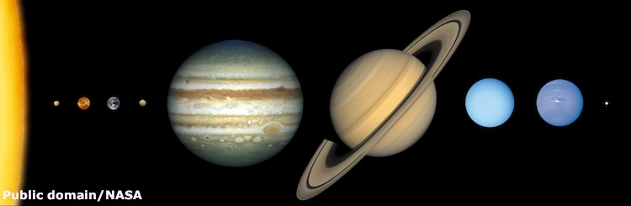

Size of planets in the Solar System to scale (distances not to scale)

 | Mercury | Venus | Earth | Mars | Jupiter | Saturn | Uranus | Neptune
Size
Small
Medium
Large
Temperature
Cold
Medium
Hot
Atmosphere
None
Thin
Thick
Planet nearly all gas
Distance from Sun (million km)
Diameter/size (km)
Gravity (g)

Planet temperatures and distances from the Sun

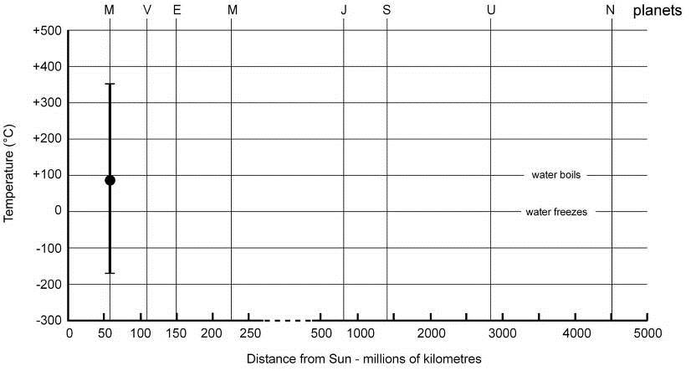

Could there be life?

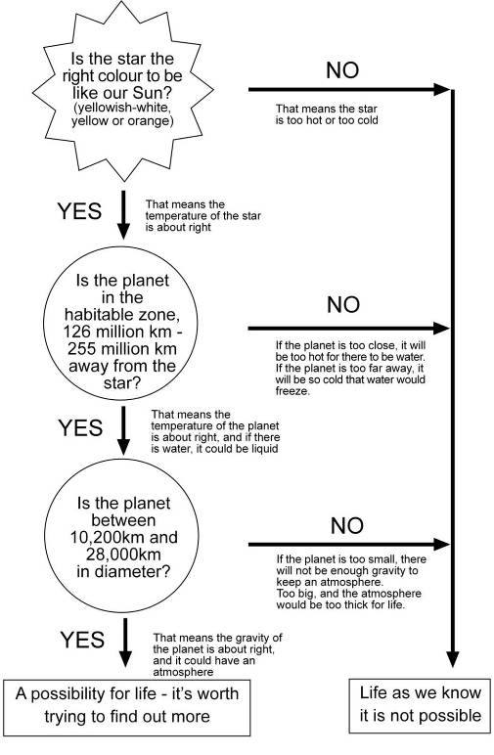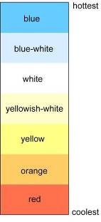
Planet info cards
All planet images released into the public domain/courtesy of NASA.

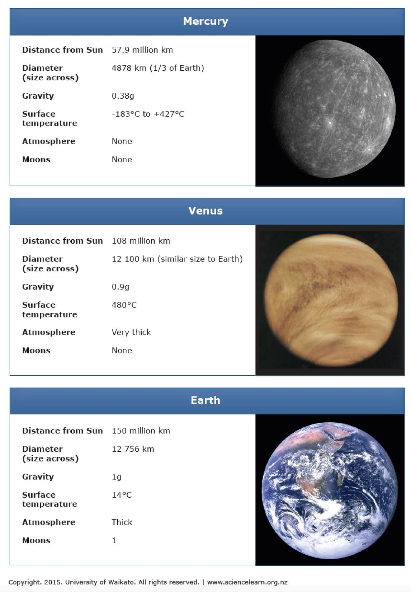
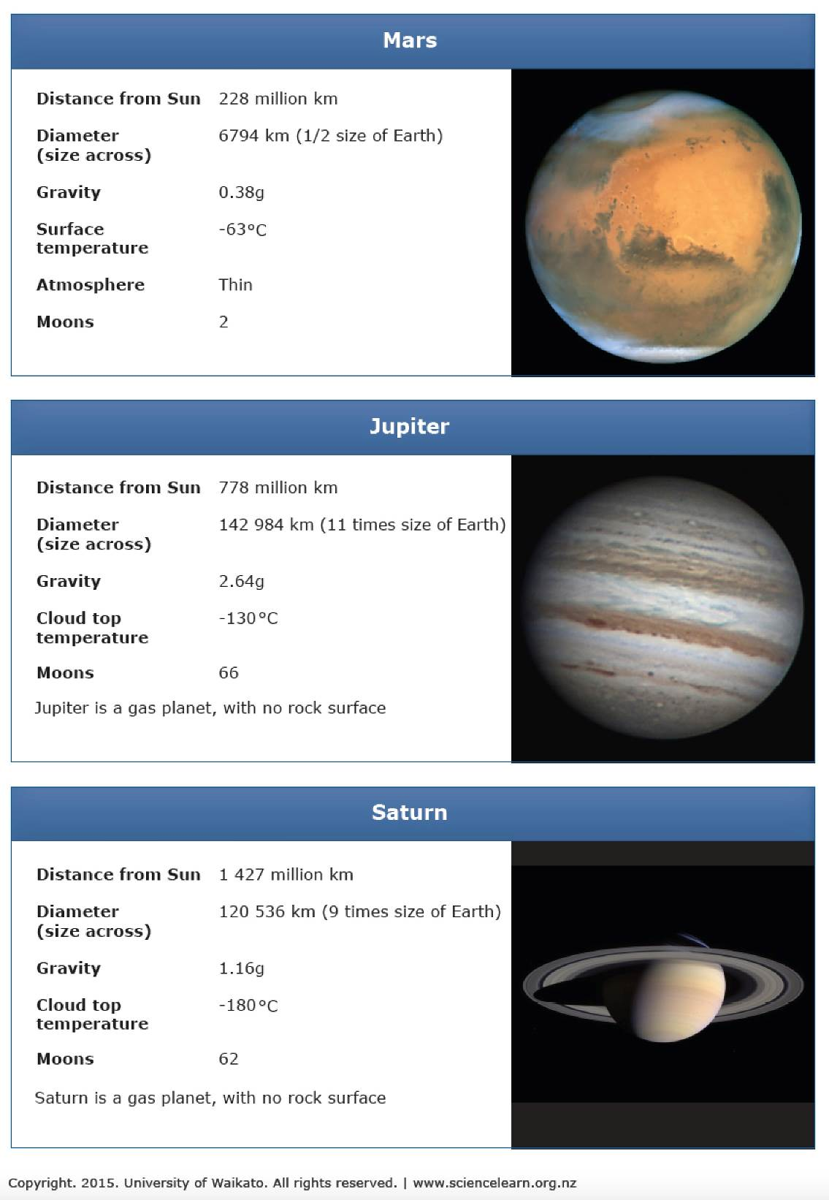
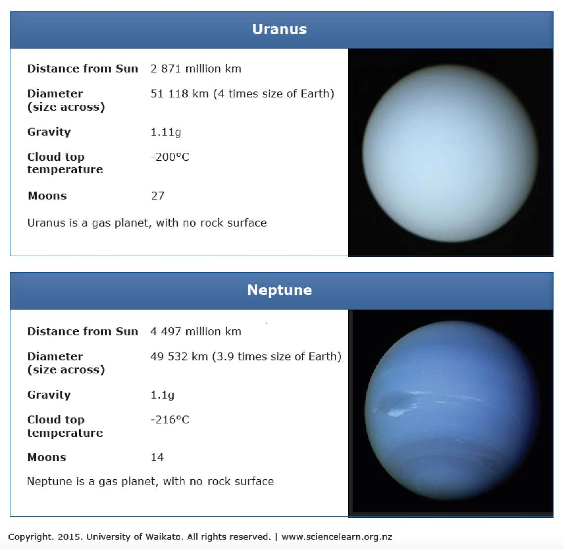

Extrasolar planet cards

