ACTIVITY: The marshmallow challenge

Activity idea

This is a simple experiential activity where teams of students are given a challenge to build the tallest freestanding structure that will support the weight of one marshmallow.

Teams have 18 minutes to complete the challenge and are given a set number of building materials. By participating in this challenge, students are put into a situation where they are able to experience key aspects of innovation – idea generation, collaboration, creativity and teamwork.

By the end of this activity, students should be able to:
- discuss their experience of working in a team for this challenge
- identify some of the key challenges and benefits of working in a team
- identify some of the key steps required to successfully complete this activity
- identify some of the key behaviours required to successfully complete this activity
- discuss what they might do differently next time
- relate their experience to key information in the About innovation video clip.

Introduction/background notes
What you need
What to do
Extension idea
Student handout: Marshmallow challenge rules

Introduction/background

This is a fun activity that encourages teams to experience simple but profound lessons in key aspects of innovation – ideas generation, collaboration, creativity and teamwork. Teams are given a challenge to build the tallest freestanding structure that will support the weight of one marshmallow. They have 18 minutes to complete the challenge and are given a set amount of building materials. Allow 45–60 minutes to run this activity.

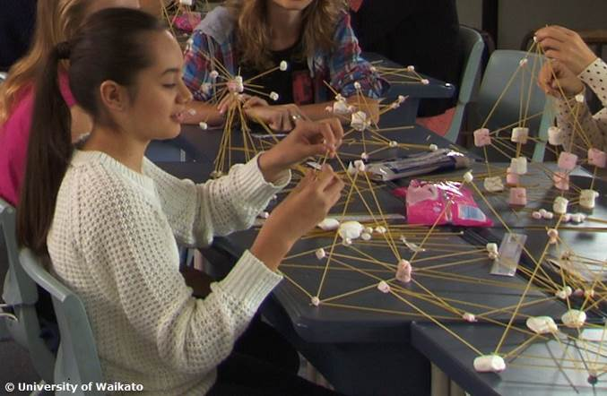During a marshmallow challenge, teams work hard, racing against the clock to turn flimsy ingredients into stable towers. They’ll display a variety of working styles and team dynamics to bring together a whole range of different structures – some successfully, others not. However, it’s what happens after the challenge where really important learning can occur.

There needs to be time for individual teams to discuss what they learnt about collaboration, ideas generation, creativity and teamwork and then time for whole class discussions. Reflection time is essential to get the most out of this activity. Watch for interesting conversations and ‘aha’ moments as you guide students through these discussions.

The marshmallow challenge is an ideal introduction to several key aspects of innovation – idea generation, collaboration, creativity and teamwork. The activity is cheap to set up and easy to run. It’s entertaining and engaging for students.

To give students a framework for their discussions, the About innovation video clip is watched and discussed before beginning the marshmallow challenge.

Background
This challenge originates from the world of design and has been used to foster creative problem-solving among CEOs, business students and others whose work depends on being able to come up with ideas. Tom Wujec, thought leader and award-winning innovator, has spread the word of the benefits of the marshmallow challenge through his 2010 TED talk Build a tower, build a team and his Marshmallow Challenge website. (You may want to download a copy of the slideshow that accompanies Tom Wujec’s TED talk.)

The marshmallow challenge has been run with many different groups around the world. Through the many marshmallow challenges Tom has facilitated, he has made observations, collated information and drawn conclusions. He promotes this challenge as a method for improving a team’s ability to generate ideas, to collaborate and to see the value of prototyping – all essential for thinking innovatively.

Tom Wujec talks about the following lessons:
- Kids are more successful at building towers than business students.
- Prototyping matters – teams that practise ‘learning as you go’ or ‘building by trial and error’ are more successful than those that spend a lot of time planning before building and have little time left to fix up the design at the end.
- Team diversity/make-up is important – teams with an administrator/facilitator do better than those without.
- Background knowledge can be important, as architects and engineers (who know how to build structures) are one group that consistently do well in this challenge.
- Rewards for high performance can sometimes have the opposite effect.

You may be able to draw out other lessons!

What you need

- Access to the About innovation video clip
- Access to the Marshmallow Challenge website
- Copies of the student handout: Marshmallow challenge rules
- Tape measure or ruler
- Camera

For each team:
- 20 sticks of dry spaghetti
- 1 marshmallow
- 1 m masking tape
- 1 m string
- 1 pair of scissors

What to do

- Begin by watching the About innovation video clip.

- Talk about innovation in broad terms – the process, the people, the terms used. You might like to jot some key words on the board for when it comes to the reflection time.

- Introduce the challenge – the teams have 18 minutes to use a set amount of building materials to build the tallest freestanding structure that will support the weight of one marshmallow.

- Organise the students into team of 4–6 and hand out copies of the student handout Marshmallow challenge rules and discuss.

- Give out the kits of building materials and ensure everyone is clear about the task and the parameters.

- Start the stopwatch – teams have 18 minutes to complete the task.

- Walk around the classroom and observe the different structures and how the teams are working together. Encourage everyone to have a look around. Remind teams of how much time they have left at 12 minutes, 9 minutes (halfway point), 7 minutes, 3 minutes, 1 minute. Remind teams of the rules if necessary.

- At the end of 18 minutes, ask all teams to step away from their desks. Take a look around. Record how many structures are standing and holding a marshmallow up. Measure these and record the heights on the board. Take photos to show all the different structures.

- Identify the winning team.

- Reflect on the activity. Start by asking teams to reflect on their experience using the discussion starters on the student handout, then broaden the discussion to include the entire class.

- Rewatch the About innovation video clip. Discuss with your students what they relate to now.

Extension idea

In this extension activity, after students have done the marshmallow challenge, they watch Tom Wujec’s entertaining Build a tower, build a team TED talk. Students then discuss the learning outcomes he observed and relate it to their own marshmallow challenge experiences.
Student handout: Marshmallow challenge rules

Materials

- 20 sticks of dry spaghetti
- 1 marshmallow
- 1 m masking tape
- 1 m string

What to do

- Build the tallest freestanding structure: the winning team is the one that has the tallest structure measured from the tabletop/surface to the top of the marshmallow. That means the structure cannot be suspended from a higher structure, like a chair, ceiling or chandelier.

- The entire marshmallow must be on top: the entire marshmallow needs to be on the top of the structure. Cutting or eating part of the marshmallow disqualifies the team.

- Use as much or as little of the materials: you can use as many or as few of the 20 spaghetti sticks as much or as little of the string or tape. You cannot use any other materials.

- You can break up the spaghetti, string or tape: you are free to break the spaghetti and cut up the tape and string to create new structures.

- The challenge lasts 18 minutes: you cannot hold onto the structure when the time runs out. Any team touching or supporting the structure at the end of the exercise will be disqualified.

Discussion starters

- Teamwork: How helpful was everyone on your team? Did anyone appear to be an expert? Were all members of the team able to contribute their ideas? Were all members fully engaged? Did you learn from others? Did you have a variety of skills in your team? Did any one person dominate? Did your team try and fail at different approaches before agreeing on a final structure?
- Collaboration: How was collaboration demonstrated in your team? Were all teams collaborative? Is there a difference between teamwork and collaboration?
- Leadership: Did your team have a leader? Who was it and who decided this? How did a leader help in the challenge? If you had no leader, how did you go? Would you have benefited from having a leader?
- Creativity: How did your team create its design? Did you learn from others in your team or from other teams? Take a look around at the structures built by other teams. Are any significantly different to the others? Why might this be?
- Ideas generation: Where did the ideas come from for building your structure? Did everyone contribute? Were ideas received in a systematic way? Did you use a method of trial and error? Rapid prototyping? Rebuilding? Redesigning? Plan and execute? Did you fail? Did you learn from your failures?
- Energy: Did you feel the time pressure? Did you think that this was a possible task or not? Was there a good vibe in your team?
- Learning from experience: In retrospect, what could you have done better? What might you have changed?
- Innovation: How many standing structures are there in your classroom? Are the structures similar in design or different? What roles did team members play – leader, follower, doer, thinker, risk-taker, planner, others? Can you identify some of the key steps in the process of innovation? How did the winning team succeed? What do you think the key to their success was?

