ACTIVITY: Using heat energy

Activity idea

In this activity, students explore the transformation of the Sun’s energy into heat energy through several experiments.

By the end of this activity, students should be able to:
- explain that different objects absorb different amounts of light energy and that this gives them their various colours
- explain that dark coloured objects absorb more light energy, which transforms into radiated heat energy (infrared rays), and black coloured objects are the best for absorbing light energy and radiating heat energy
- show that materials that appear light in colour or have a shiny and smooth surface reflect solar energy best
- show there are ways of trapping the Sun’s heat energy (for example, using dark coloured objects, insulation, creating a greenhouse effect, facing objects to the Sun for maximum exposure, reflecting more light onto a given area).

Introduction/background notes
What you need
What to do
Extension ideas

Introduction/background

In this activity, students explore the concept of solar energy absorption and reflection by participating in some experiments that show them how heat energy can be measured (to compare absorption and reflection of different objects) and how it can be used in everyday life, for example, for heating water.

Dark coloured objects absorb more light energy than light coloured objects. This means that, as dark objects absorb more of the light, the particles in the object will vibrate more. Because there is more light energy being changed into heat energy for dark objects, the object will heat up more.

Lighter coloured objects reflect more light energy away than they absorb and therefore do not heat up as quickly.

Note that students often confuse temperature with heat. Temperature is a way of measuring the amount of heat energy at the point where a thermometer is in contact with the object.

Students may also be interested in how thermometers work. The more heat energy there is, the more the liquid particles in the thermometer vibrate. As they vibrate, the particles are pushed further apart so that the liquid expands – moving up the thermometer.

What you need

- Squares of paper for wrapping chocolate biscuits (red, white, black)
- Squares of aluminium foil for wrapping chocolate biscuits
- Chocolate biscuits
- A4 sized boards painted different colours (red, black, white, dark green, blue and orange)
- Black alkathene pipe (about 20 metres) or a garden hose and a sheet of black polyethylene
- Water heater made with a length of black piping that can be shut off at the ends so that the hose can be left full of water
- A set of thermometers

What to do

Melting biscuits

- Divide the class into groups of four. Give each group four chocolate biscuits and one of each of the squares of paper – red, black and white – and of aluminium. Each student wraps a chocolate biscuit in one of the squares of paper or aluminium.

- Leave wrapped biscuits in the Sun for about half an hour depending on the strength of the Sun. (The trick is to not leave the biscuits in the Sun too long because you don’t want all the biscuits melted – you only want to see which biscuits melt first. The length of time depends on the time of year and the strength of the Sun. You might have to do some initial trials before the students do it.)

- Compare and discuss in small groups which biscuit has the most melted chocolate. Why has the chocolate melted more in some than others?

- As a class, tabulate the results of all groups showing which biscuits in which coloured wrapping melted the most. Discuss why you think that happened. Don’t feed too much knowledge in until students have done the experiments and have been able to test their own predictions.

(The biscuits wrapped in black should melt first. This is because more light energy – infrared and visible light – is absorbed by the black paper than by the coloured papers. The light energy is transformed into heat energy – particle vibration. The heat energy is conducted to the biscuit, which becomes warm, and the chocolate melts. This will also happen with the biscuit in the red coloured paper, but to a lesser extent because not all the light energy is absorbed. The white paper and the aluminium reflect most of the light energy, so these biscuits should take much longer to melt.

Note that scientists say it makes no difference which side of the aluminium foil is on the outside. Both the shiny and dull side reflect light to a similar extent. The dull side scatters it more than the shiny side, which has a smoother surface and acts more like a mirror. Note on conduction: It is the transfer of heat energy through one substance to another when they are in direct contact. The moving particles of a warm material can increase the movement of particles in a cooler material, so the coloured paper transfers heat energy to the chocolate biscuit.)

Colours, heat energy and thermometers

- Discuss with the class that thermometers are a way of measuring heat energy – ‘thermo’ meaning warm and ‘meter’ meaning to measure. Discuss the measurement scale:
- What scale do we use? (Degrees Celsius °C)
- Where does it start?
- What can it go to?
- What is the highest (average) temperature our air gets to during the day?
- Has the doctor taken your temperature? What was it? What is the normal temperature of people? (37°C)

- Divide up the coloured boards and thermometers among groups of students.

- Have students shake the thermometers (carefully) to get the liquid down near 0°C. Record the starting temperature.

- Have students carefully tape the thermometers to the coloured boards and put the boards in a sunny spot. Check the temperatures after a half hour or so and record. Students may wish to take another temperature recording after a set period of time.

- As a class, record the final temperatures from all the coloured boards. Discuss the differences in temperature:
- Which colours have the highest temperatures? (The boards with the darker colours should have the higher temperature – black should have the highest.)
- Which colours have the lowest temperatures? (The lighter coloured boards should be cooler and have lower temperature readings.)
- Why are some higher than others?

- Demonstrate heating water using solar energy:
- Run an outside tap for about 30 seconds and then collect some water into a container.
- Take the temperature of the water and record it and the time it was taken. When taking the temperature, hold the thermometer at the top (to avoid hands warming the thermometer) and suspend the thermometer in the water (so that you measure just the water and not the bottom of the container).
- Attach the black alkathene pipe (or garden hose) to a tap and loosely unravel it across the ground. (If using a garden hose, put a sheet of black polyethylene under it.)
- Put a hose attachment onto the nozzle end of the pipe/hose so that the water can be turned off at that end.
- Turn on the tap and fill the pipe/hose with water. Seal off using the hose attachment.
- After 5 minutes, collect some water from the nozzle end of the hose.
- Take the temperature of the water and record it and the time it was taken.
- Continue to take some water every 5 minutes and record the temperature for about half an hour or so. The results could be graphed.

- Discuss why the water became warmer after it had gone through the piping.

Making a water heater (solar collector)

- This solar collector is designed to absorb as much solar energy as possible that can be transformed and retained as heat energy to heat water. (Alternatively the heater can be made before the lesson and students can use it to pass water through and then discuss the science involved that causes the water to heat.)
- Paint the inside of an open wooden box black.
- Attach some piping (black coloured plastic or copper piping) to the base of the box. There should be a hole in the upper and lower sides of the box for the piping.
- Cover the open side of the box with a see-through material (glass, plastic, cling film).
- Set the box to face the Sun.
- Put a funnel in the top of the piping and pour water through. If the Sun is hot enough, the water will be warm when it exits the box. Students may need to pour the water through the piping several times to notice the increased temperature, which (should feel warmer to the hand).
- Alternatively, the ends of the piping could be clamped to seal the water in the piping. The solar collector could then be left in the Sun for a period of time before checking the temperature of the water.
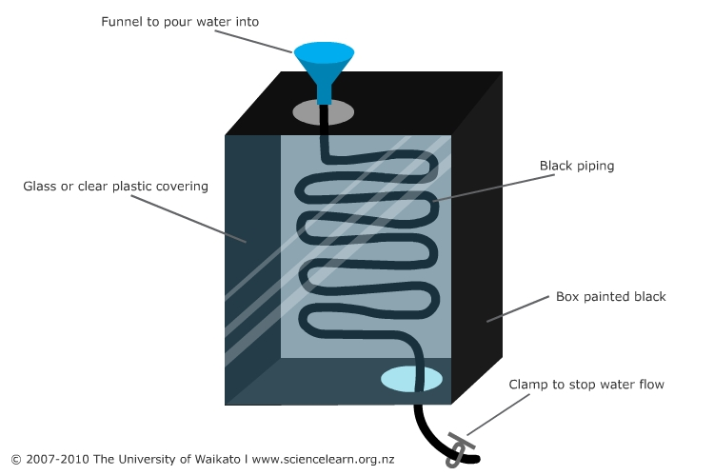
- Discuss why the water was warmer after it had gone through the piping. (The black object absorbs light energy. The energy is transformed into heat energy, which is conducted to the piping and to the water. The greenhouse effect of the see-through layer allows the light in but slows the heat energy from radiating out from the box – retaining the heat and keeping the water warmer longer.) Are there any examples of similar systems of water heaters that you are aware of? (School swimming pool? Home water heaters?)

Extension ideas

More capable students could design and build their own water heaters after learning how heat is generated from the Sun and what makes a good solar collector.

