ACTIVITY: Minerals present in granite

Activity idea

In this activity, students identify the main minerals present in granite and investigate some of their properties.

By the end of this activity, students should be able to:
- identify the rock known as granite
- recognise and identify the main minerals present in granite
- state some of the physical properties of each of the component minerals
- effectively use optical aids such as hand lenses and simple binocular microscopes.

Introduction/background notes
What you need
What to do
Discussion questions
Extension ideas
Student worksheet

Introduction/background

Traditional ceramics are clay-based. The minerals present in some clays have their origin in a type of igneous rock known as granite. It is the weathering of the feldspar minerals in granite that produces the main clay minerals such as smectite and kaolinite.

This activity involves identifying the main minerals such as quartz, micas and feldspars present in granite:
- Quartz is a very common mineral making up about 12% of the Earth’s crust. It is one of the main minerals in the igneous rock known as granite.
- Mica is one of the minerals found in the igneous type of rock known as granite.
- Plagioclase feldspars form part of the structure of the igneous rock known as granite. They are generally white in colour.
- Orthoclase is a potassium feldspar mineral. The presence of the element potassium gives colour to the mineral.

Some of the properties of these minerals such as colour, hardness and cleavage are investigated

What you need

- Small samples of granite (easily hand-held)
- Small samples of the minerals quartz, mica, plagioclase feldspar and potassium feldspar
- Hand lenses
- Simple binocular microscope
- Small pocket knife or scalpel
- Small hammer
- Sketch pad and pencil
- Copies of the student worksheet
- Access to information on the chemical composition of the minerals studied (the internet or a mineralogy handbook)

What to do

- Make sure each student has samples of granite and observation equipment and a copy of the student worksheet.

- After step 3 of the student worksheet, discuss the students’ findings. (The main minerals present are quartz, feldspars – pink is plagioclase, off-white is potassium – and micas – biotite is dark and shiny.)

- Hand out samples of the other minerals. After step 4 of the student worksheet, discuss the students’ findings.

Discussion questions

- All minerals have their own characteristic physical and chemical properties. Minerals can be readily identified by consideration of certain key physical properties such as colour, hardness and cleavage. What other physical properties can be used to identify minerals?
- Compare the physical properties of the feldspar minerals that you have been investigating. Are there any significant differences?
- Discuss the observations for cleavage. Minerals with no cleavage planes fracture on impact. The broken surface may be uneven/rough or a smooth curved surface (known as conchoidal). Do any of the minerals you have been working with fit into this classification?
- Compare the chemical composition of the feldspar minerals. Is there a significant difference? If so, which elements are responsible for this difference? Can a slight change in the elemental composition of a given mineral alter its physical properties?

Extension ideas

- Mineral hardness can be assessed using Moh’s scale. This is a relative scale based on the fact that any mineral can be scratched by harder minerals. How does Moh’s scale work? Can you assign a Moh’s scale hardness value to the minerals you have tested?
- When feldspar minerals in granite are weathered over a long time, they undergo a change to form clay minerals. How does this change come about? What chemical composition do these clay minerals have? Describe the structural features of these clay minerals.
- Minerals have a crystalline structure. Describe the crystal structure of quartz – one of the main minerals present in granite.
Student worksheet – Minerals present in granite

- Look carefully at the sample of granite that you have been provided with. It is a type of igneous rock made up of distinctive minerals. Sketch what you see.

- Use a hand lens to view the main minerals present in more detail. Sketch what you see.

- View a small piece of granite using a simple binocular microscope. Sketch what you see. Label the minerals present.

- Look at the samples of the minerals quartz, mica and the feldspars and note your findings in the table below:
- What is the colour of each sample?
- What is the lustre? (‘Lustre’ is the way a mineral surface looks when light is reflected off it, for example, metallic, glassy, pearly, silky, greasy or earthy.)
- Look at the hardness of each sample. Can you scratch the sample with a pocketknife blade? Can you scratch a sample with one of the other minerals?
- Note the cleavage planes of the mica by using a pocket knife to break apart the planes. (‘Cleavage’ is the ability to break easily along certain directions.) Try to do the same with the quartz and the feldspar minerals. If your results are inconclusive, use a small hammer to hit sharply a sample of the mineral. Note how it fractures on impact.
- What is the chemical composition of each of the minerals? (Use the internet or a mineralogy handbook to help.)

Mineral name | Colour | Lustre | Hardness | Cleavage | Elements present
Quartz
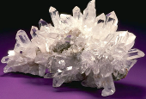
Mica
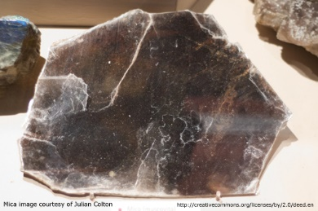
Plagioclase feldspar
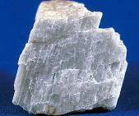
Orthoclase feldspar
