ACTIVITY: Crystal systems

Activity idea
In this activity, students investigate crystal shapes and crystal systems. Traditional ceramics are clay-based – clays have a mineral composition and minerals have a crystalline structure.

By the end of this activity, students should be able to:
- describe the main points of difference between a crystalline solid and an amorphous solid
- recognise and identify at least 3 of the 7 crystal systems
- use models to point out the angular and side length differences that characterise the cubic, triclinic and rhombohedral crystal systems
- effectively use optical aids such as hand lenses and simple microscopes to view crystalline solids.

Introduction/background notes
What you need
What to do
Student worksheet
Crystal systems
Cubic crystal template
Triclinic crystal template
Rhombohedral crystal template

Introduction/background

Traditional ceramics are clay-based. Clays have a mineral composition and minerals have a crystalline structure. A mineral is defined as a naturally occurring inorganic substance with a certain chemical composition and set of physical properties. Many minerals occur in characteristic crystal shapes.

A crystalline solid is made up of an orderly repeating pattern of constituent atoms, molecules or ions extending in all 3 spatial dimensions.

A limited number of crystal shapes have been found in nature. There are only 7 groups, or crystal systems, into which all naturally occurring crystals can be placed. Careful observation of crystal shapes is one of the best ways to classify and distinguish between different minerals. This activity focuses on three of these crystal systems – cubic, triclinic and rhombohedral.

What you need

- Crystal systems diagram
- Copies of the student worksheet
- Small dropper bottles of 1 molL⁻¹ solutions of sodium chloride (NaCl) and copper sulfate (CuSO₄)
- Clean ‘golden’ beach sand
- Simple light microscope plus microscope slides
- Electric hot plate
- Templates to construct models of cubic, triclinic and rhombohedral crystal systems
- Paper glue

What to do

- Hand out copies of the crystal systems diagram and discuss with the class. Explain that they will be investigating 3 of these crystal systems – cubic, triclinic and rhombohedral.

- Make sure each student has the necessary materials and equipment and a copy of the student worksheet and templates.
Student worksheet – Studying crystal systems

- Cubic crystals:
- Place a drop of the sodium chloride solution supplied in the centre of a microscope slide.
- Gently heat the slide by placing it on a hot plate (low setting).
- When all the water has evaporated, view the sodium chloride crystals that remain under the low power of a microscope.
- Note the shape of the crystals and sketch what you see.

- Triclinic crystals:
- Place a drop of the copper sulfate solution supplied in the centre of a microscope slide.
- Gently heat the slide by placing it on a hot plate (low setting).
- When all the water has evaporated, view the copper sulfate crystals that remain under the low power of a microscope.
- Note the shape of the crystals and sketch what you see.

- Rhombohedral crystals:
- Place a small sample of beach sand in the centre of a microscope slide and spread out the grains.
- View under the low power of a microscope.
- Note the shape of the grains with a clear or whitish appearance – these are grains of the mineral quartz. Sketch what you see.

- Compare the sketches you have drawn to the crystal systems diagram.

- The mineral halite, a naturally occurring form of sodium chloride, has a cubic crystal structure. Use the cubic crystal template to construct a model of a halite crystal. Fold all edges. Glue the tabs and stick together.

- The feldspar minerals plagioclase and orthoclase have a triclinic crystal structure. Copper sulfate crystallises out of solution as triclinic crystals just like the feldspars. Use the triclinic crystal template to construct a model of a feldspar mineral crystal. Fold all edges. Glue the tabs and stick together.

- Quartz minerals are commonly found in beach sand. These tiny grains have a rhombohedral shape (cubic system stretched along a body diagonal). Use the rhombohedral crystal template to construct a model of a quartz crystal.
Crystal systems

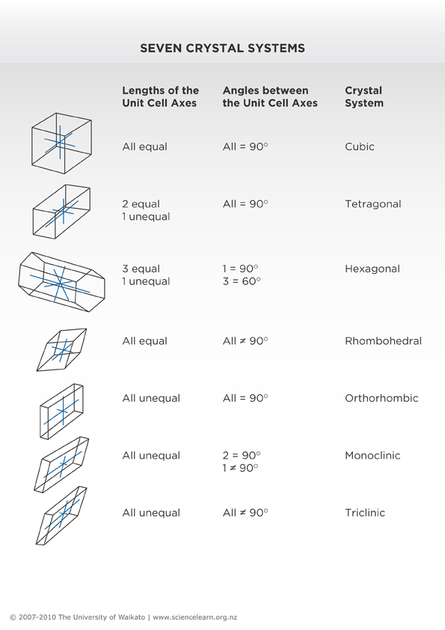

Cubic crystal template

All axes are of equal length. All axes are at 90° to one another.
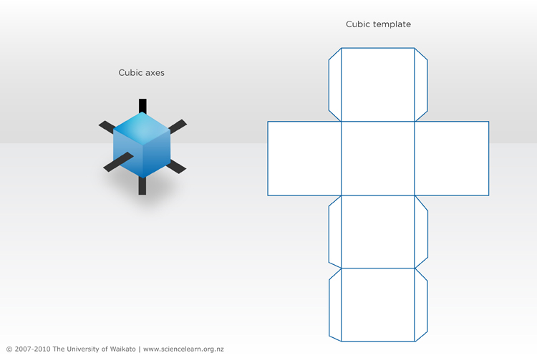

Triclinic crystal template

All axes are of variable lengths. All axes are at variable angles.
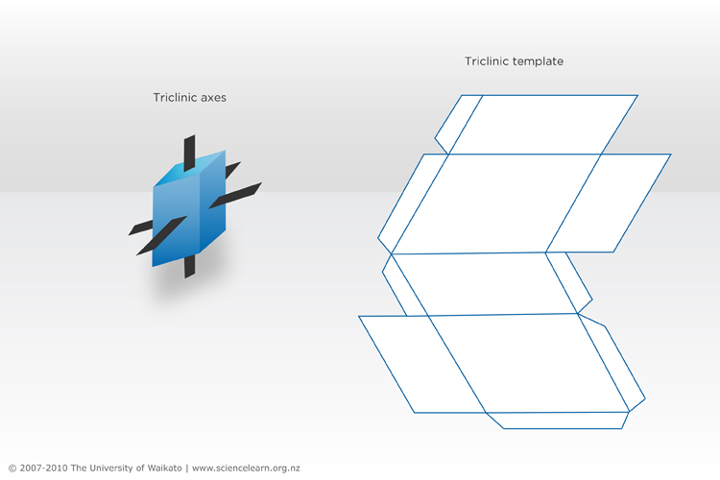

Rhombohedral crystal template

All the axes are equal. All axes are at angles other than 90°.

