ACTIVITY: Elements reacting with oxygen

Activity idea

In this activity, students investigate the reaction between copper and oxygen and watch a demonstration of the rapid reaction between hydrogen and oxygen.

By the end of this activity, students should be able to:
- describe the chemical reaction between copper and oxygen
- explain how reaction conditions can affect the rate of a chemical reaction
- write balanced chemical equations for the copper-oxygen and hydrogen-oxygen reactions
- explain how copper sheeting used in building construction weathers.

Introduction/background notes
What you need
What to do

Introduction/background

Copper-oxygen reaction

Students or the teacher could conduct this experiment.

Copper oxide is black in colour. Pure copper metal has a salmon pink colour.

Copper reacts slowly with the oxygen in the air. When heated in air, this reaction speeds up.

copper + oxygen → copper oxide
2Cu(s) + O2(g) → 2CuO(s)

The limited oxygen supply on the inside of the envelope results in little copper oxide formation.

At the end of the experiment, if the copper foil squares are placed in a moist, carbon dioxide-enriched atmosphere in a sealed container, over a period of time, the copper becomes coated with a green coating or patina. This coating is a form of copper carbonate. Copper roofs, bronze statues and brass fittings when they weather take on this surface coating.

Hydrogen-oxygen reaction

In this teacher demonstration, mixtures of hydrogen and oxygen gases are ignited. By varying the proportions of the two gases the loudness of the bang can be altered.

This is a noisy demonstration and should be carried out in a spacious room so that the audience can be seated well away from the site of the explosions.

Wear eye protection and ear protectors and ask the audience to cover their ears.

Hydrogen-air mixtures explode on ignition if they contain between 4–75% hydrogen.

2H2(g) + O2(g) → 2H2O(g)

The reaction is exothermic, with 484kJ of energy being released. This heat energy causes rapid expansion of the gaseous product that we experience as an explosion. An explosion is an extremely rapid chemical reaction.

The explosions increase in loudness as the percentage of oxygen in the mixture increases. The ideal hydrogen-air volume ratio is 2:5. The ideal hydrogen-oxygen volume ratio is 2:1.

What you need

- Copper sheet (22 gauge)
- Bunsen burner
- Tongs
- Tripod and gauze mat
- Protective eyewear and ear protectors
- Hydrogen
- Party balloons
- Cotton thread
- Clamp stands
- Candle
- Metre rule

What to do

Copper-oxygen reaction

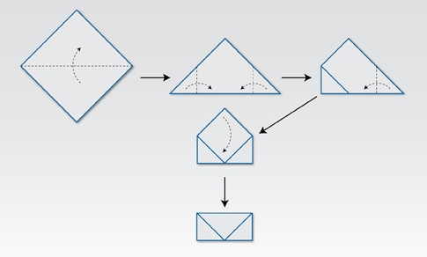
- Cut a 4 cm by 4 cm square of copper foil and fold the foil into the shape of an envelope as indicated.

- Wearing eye protection, light the Bunsen burner.

- Hold the envelope with a pair of tongs and heat strongly in a hot Bunsen flame for 5 minutes.

- Place the envelope on a heat-resistant gauze mat resting on the tripod and leave to cool for 5 minutes.

- Open the envelope and compare the inside to the outside surface. Discuss the difference.

Hydrogen-oxygen reaction

- Prior to the demonstration, inflate five small party balloons to the same degree with the following mixtures:
- Normal ‘lung’ air
- Pure hydrogen
- One-third hydrogen, two-thirds ‘lung air’
- Two-thirds hydrogen and one-third oxygen
- Pure oxygen

- Attach the balloons with cotton thread and tether each to a clamp stand. Make sure there are at least 1 metre separations between the clamp stands.

- Using a small candle attached to a metre rule, ignite the first balloon at arm’s length. Note the result.

- Ignite the other balloons in sequence, carefully noting the result each time.

