ACTIVITY: Biceps curl

Activity idea

In this activity, students model a biceps curl using a lever system. The model measures the force in the biceps muscle when the forearm is carrying a mass held horizontally.

By the end of this activity, students should be able to:
- describe how the arm is an example of a lever (in which the elbow is a hinge)
- use a model of this hinged lever to measure the forces acting
- describe the size and direction of the forces acting on this hinged lever
- explain that the force produced by the biceps muscles pulling on the bone of the forearm is much greater than the load of the weight force at the hand.

Introduction/background notes
What you need
What to do

Introduction/background

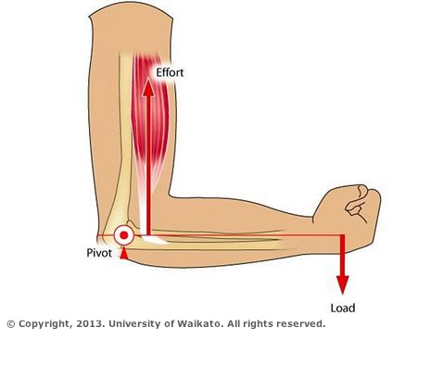
The purpose of this activity is to model a biceps curl using a lever system. Using this model, students will measure the force in the biceps muscle when the forearm carrying a mass is held horizontally.

Students test that the force produced by the biceps is much greater than the load weight at the hand.

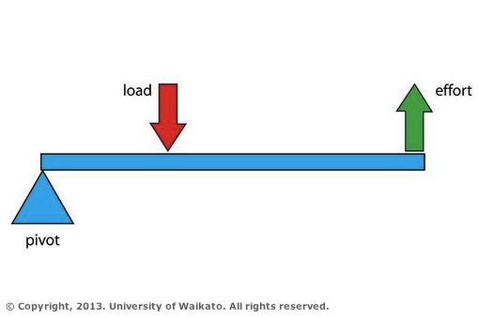
The way in which the biceps muscle acts on the forearm to move it is the same as a class 3 lever. The pivot is at the elbow and the forearm acts as the lever arm. The biceps muscle provides the effort (force) and bends the forearm against the weight of the forearm and the weight of any mass that the hand might be holding. A small contraction of the biceps produces a large movement of the forearm (small force, big distance).

Refer to the article What levers does your body use? for more information about the types of levers in the human body.

What you need

- Access to the article What levers does your body use?
- Retort stand
- Clamp
- 20 newton force measurer
- 3 x 50 g masses (or similar)
- 1 x 50 g mass hanger
- String
- 2 lengths of thin wood (25 cm and 35 cm) joined by a hinge to form an L shape

What to do

- Read through and discuss the article What levers does your body use? Explain that this activity focuses on the arm and elbow as a class 3 lever.

- Assemble the lever system as shown in the photo. Clamp vertically the length of wood that models the upper arm. If time permits, discuss the use of models in science.

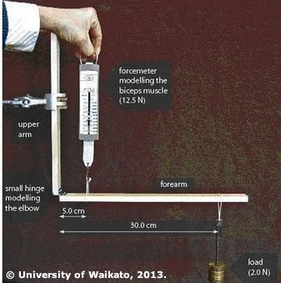
- Hang a 50 g mass 30 cm from the hinge. This mass models a load held in the hand.

- Pull vertically up on the force meter, which is attached 5 cm from the hinge (elbow). The force meter models the biceps muscle.

- Record the reading on the force meter when it lifts the forearm length of wood to a horizontal position off the bench. The 50 g mass produces a load of 0.5 newtons.
weight (N) = mass (kg) x 10
= 0.050 kg x 10
= 0.5 N

- Repeat step 4 for 100 g, 150 g and 200 g masses. These produce load forces of 1.0 N, 1.5 N and 2.0 N.

