STUDENT ACTIVITY: Lateral arm raise

Activity idea

In this activity, students perform a lateral arm raise and use the information to calculate their one repetition maximum (1RM). The accompanying calculator uses seven different prediction equations.

By the end of this activity, students should be able to:
- collect and use data with a 1RM predictor calculator
- discuss why it is safer to estimate 1RM than to measure the value directly
- discuss the benefits of calculating their 1RM for various strength movements.

Introduction/background notes
What you need
What to do
Extension idea

Introduction/background

The aim of this activity is to find the maximum mass (measured in kilograms) students can lift only once while raising their arms laterally as in this picture. This movement is also called a ‘single arm shoulder abduction’. The maximum mass they can lift is called their one repetition maximum (1RM) for this movement. 1RM is used frequently in strength measurement, for example, by weightlifters. Lifting heavy masses near their 1RM limit can be dangerous and cause muscle strain or worse – this method uses lighter weights to estimate the maximum mass they are able to lift.

Knowing the 1RM for various strength movements means that a person knows the limit below which they can safely train. 1RM can also be used as an indication of strength development. People undergoing strength training can repeat this measurement at regular intervals to find out if they are gaining strength.

The 1RM predictor calculator provides results for seven different equations. Each equation is based on the research of different scientists, and the results can vary widely when high numbers of repetitions are entered. This reflects the tentative nature of scientific knowledge. (Another example of differing or conflicting results is found in the article Whole body vibration training.)

What you need

- Access to the article Measuring muscle strength
- Access to the video How 1RM is predicted
- A load that is moderately heavy to lift, such as two 2-litre plastic milk containers full of water (mass = 2 or 4 kg), a dumbbell (from the physical education department) or a strong bag filled with weights from the science department
- Scales
- Paper and pen for recording data
- Computer to run Excel spreadsheet 1RM predictor calculator

What to do

- Review the article Measuring muscle strength with the class and discuss why and how 1RM is measured.

- Watch the video clip How 1RM is predicted to learn more about the process.

- Discuss the terms ‘mass’ and ‘weight’.
- Mass is the amount of matter an object has, measured in kilograms.
- Weight is the force due to gravity acting on an object, measured in newtons.
- A 1 kg mass has a weight force of 10 newtons.

- Choose a load that is moderately heavy to lift. For safety, the student needs to be able to hold the load firmly so that it does not slip from their grasp. Do not choose a load that is too light – it should be heavy enough so that they will only be able to lift it at most 12 times before getting too tired.

- Measure the mass of the load in kg.
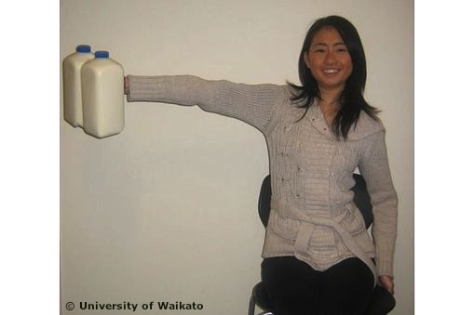
- Have a student sit upright in a chair as shown in the picture. This isolates the rest of the body from the arm movement and stops them from swinging their hips to help them start the arm raise each time. (People tend to do this when their arm muscles get tired.)

- Have another student stand near to watch the student lift the load and to take it from them when they stop.

- The student repeatedly raises the load from their side to a horizontal position and down again. They do this at a steady rate (1 to 2 seconds per lift), keeping their arm locked straight.

- Have the other student count the number of times they lift the load and get the other student to tell them to stop when either their arm starts to bend or they take too long to lift the load (say 4 seconds). The number of lifts counted is called the repetitions to fatigue (RTF).

- Enter the load (mass) in kg and the RTF count into the 1RM predictor calculator. The spreadsheet uses seven different equations to make seven predictions of the greatest load students can lift only once. Students can then take an average of the predictions.

- After giving their muscles a few minutes to rest, ask students try to lift the mass given by the 1RM calculator. Which prediction equation was most accurate?

Extension idea

- Use the above method to estimate 1RM for other body movements, for example, a seated calf raise – sitting on a chair, support a heavy mass on the knees (another person?), flex both calf muscles and pivot the feet to lift the heels off the ground.

