ACTIVITY: Measuring the power output of elite athletes

Activity idea

In this activity, students analyse data from an experiment that measures force and velocity for various load conditions in a bench press situation.

By the end of this activity, students should be able to:
- use given force and velocity values to calculate power produced for different bench press loads
- interpret and graph data and make predictions
- discuss some of the methodology researchers used while setting up this experiment.

Introduction/background notes
What you need
What to do
Student handout: Measuring power output
Measuring power output – answers

Introduction/background

Power is a measure of work done per second. This activity analyses the power output of athletes for different loads.

In this activity, students use data from an experiment carried out by sports science researchers at AUT in 2006. The student handout describes some aspects of the experiment including who participated, experimental procedures, equipment and results.

This activity gives students a chance to work with actual scientific data and is an ideal way to initiate discussions about the nature of science strand communicating in science – scientific knowledge is communicated through text and associated symbols, diagrams, graphs and equations.

What you need

- Access to the article Measuring muscle strength
- Copies of the student handout Measuring power output

What to do

- Read through and discuss the article Measuring muscle strength so that students are familiar with the concept of 1RM.

- Hand out copies of the student handout Measuring power output and read through the first part to discuss experimental design.

- Ask students to complete the rest of the handout individually or in pairs. When complete, display graphs from the Measuring power output – answers and compare them with student graphs. Discuss any discrepancies.

- Discuss whether students find it easier to gain a better understanding of the results from the table or from the graphs. If students were writing up a report on the experiment, which method would they choose to present the data – graphs, the table or both? Ask students to justify their reasoning.
Student handout: Measuring power output

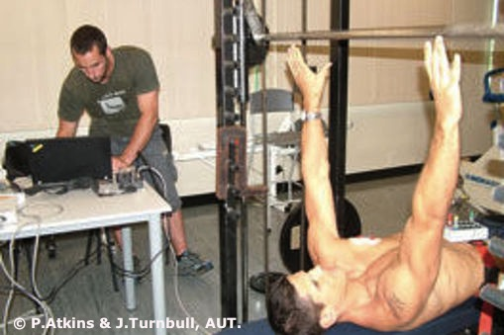This activity uses data from a larger experiment conducted by sports science researchers at AUT in 2006 to compare elite athletes’ power outputs in bench press and bench pull exercises.

We will look at the data taken in the bench press exercise and analyse it to find the power load spectrum averaged over all the athletes who took part in the experiment. A power load spectrum is a graph that shows how much power a person can produce for a specific movement (bench press in this case) at different amounts of load (mass lifted in kg). In a bench press movement/exercise, a person lies on their back on a bench and pushes a weighted bar upwards from a position held just above their chest.

Participants
Twelve elite-level yachtsmen from the Emirates Team New Zealand America’s Cup syndicate participated in this study. The yachtsmen’s mean age, body mass and height were 33.9 years, 97.8 kg and 186.0 cm. All participants had an extensive strength-training background (minimum 3 years), and bench press exercises were commonly used as part of their training.

Procedures
Each participant completed a 60-minute testing session, half of which involved the bench press exercise. Participants used a 10-minute exercise-specific warm-up to become familiar with the experiment set-up. Following the warm-up, the individuals’ 1RM was determined. Load for the power profile was then determined from 10–100% of 1RM at 10% intervals.

After the warm-up, single repetitions of each load were performed in ascending order, with the instruction that each lift should be performed as explosively as possible. All lifts were separated by a rest period of 1–2 minutes.

BENCH PRESS:  Warm-up & 1RM determination (10 min) |  | BENCH PRESS:  10–100% 1RM load spectrum testing (20 min)

Equipment
Testing was performed on a modified Smith machine (see the picture above). A computer data logger was used to measure and record the height of the weighted bar during the progress of the bench press. A computer program analysed the data from the data logger and calculated average values of velocity and force for each bench press movement. These values were averaged for the 10 participants.

Results
The average bench press 1RM for the 12 yachtsmen was calculated as 119.7 kg. This table shows the force and velocity values for the bench press across the range of relative loads.

Load (%1RM) | Velocity (m/s) | Force (N)
10% | 0.95 | 122
20% | 0.85 | 234
30% | 0.72 | 354
40% | 0.61 | 473
50% | 0.52 | 592
60% | 0.44 | 708
70% | 0.34 | 829
80% | 0.24 | 942
90% | 0.15 | 1049
100% | 0.09 | 1176

What to do

- Use the formula power = force x velocity to calculate the power that these yachtsmen have produced at each load and enter this in the table. Note that power is measured in watts (W).

Load (%1RM) | Velocity (m/s) | Force (N) | Power (W)
10% | 0.95 | 122
20% | 0.85 | 234
30% | 0.72 | 354
40% | 0.61 | 473
50% | 0.52 | 592
60% | 0.44 | 708
70% | 0.34 | 829
80% | 0.24 | 942
90% | 0.15 | 1049
100% | 0.09 | 1176

- Construct three graphs:
  - Velocity against load
  - Force against load
  - Power against load

- What happens to the velocity as the load increases?

- What happens to the force as the load increases?

- Describe the shape of the power graph.

- At which load is the greatest power produced?

- Think about the strength action of grinding on a large racing yacht – two people turn handles to operate a winch that pulls ropes attached to sails. The action of grinding uses many of the same muscles involved in a bench press exercise. Grinding starts off with a light load and progressively gets harder. Look at the power against load graph you have drawn and predict where, in the grinding activity, the yachtsmen would be producing the greatest power.

Measuring power output – answers

- Use the formula power = force x velocity to calculate the power that these yachtsmen have produced at each load and enter this in the table. Note that power is measured in watts (W).

Load (%1RM) | Velocity (m/s) | Force (N) | Power (W)
10% | 0.95 | 122 | 115.9
20% | 0.85 | 234 | 198.9
30% | 0.72 | 354 | 254.9
40% | 0.61 | 473 | 288.5
50% | 0.52 | 592 | 307.8
60% | 0.44 | 708 | 311.5
70% | 0.34 | 829 | 281.9
80% | 0.24 | 942 | 226.1
90% | 0.15 | 1049 | 157.4
100% | 0.09 | 1176 | 105.8

- Construct three graphs:

  - Velocity against load

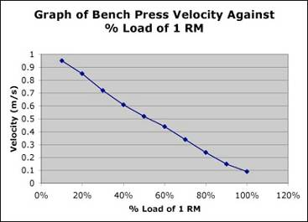

  - Force against load

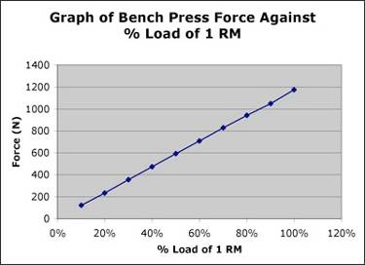

  - Power against load

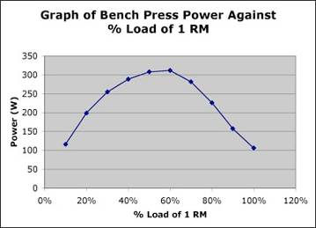

- What happens to the velocity as the load increases?
As the load increases, the force increases.

- What happens to the force as the load increases?
As the load increases, the velocity decreases.

- Describe the shape of the power graph.
As the load increases, the power curve increases to a maximum and then decreases as the load is increased further towards the maximum load.

- At which load is the greatest power produced?
Reading from the power against load graph, the greatest power is produced at about 60% of 1RM.

- Think about the strength action of grinding on a large racing yacht – two people turn handles to operate a winch that pulls ropes attached to sails. The action of grinding uses many of the same muscles involved in a bench press exercise. Grinding starts off with a light load and progressively gets harder. Look at the power against load graph you have drawn and predict where, in the grinding activity, the yachtsmen would be producing the greatest power.
The yachtsmen would be producing the greatest power at around about the middle loading of their grinding activity. (This would be very approximate since it would depend upon a number of factors, such as both yachtsmen having the same 1RM strength and that the maximum grinding load is near to their 1RM load strength.)

