Class case study: Making fermented drinks
A Year 8 class embarked on a biotechnology project in which they explored how they could alter the recipes for traditional fermented drinks by taking into account consumer surveys and optimum growing conditions of yeast.
Get unit plan: Making a fermented drink

Class and teacher background

There were 32 Year 8 students in the class, and this was their first biotechnology unit. The teacher, whom we will call Jennifer, had 13 years of teaching experience and had taught technology units on candles, kites, and bikes. Although she had no biotechnology teaching experience, she had taught the science of fermentation.
Developing a scenario

When planning her year’s programme, Jennifer thought that a unit on yeast-based fizzy drinks might be of interest to her class, especially as they had already carried out some work in science on how yeast grow.

During a conversation with one of her students, she found that a relative of the student, Aunty Gail, was quite an expert in making this type of drink and had done so for the family for some years. This provided a good platform from which to launch the unit. Jennifer gave her class the following scenario to work from:

“You have found some recipes in your grandmother’s cupboard for traditional fermented soft drinks that you have never heard of! You decide to try out one of the recipes that you think you might like. You wonder if any of these drinks could be produced and sold at school, even though fizzy drinks are not allowed. You also wonder if there might be a market for these drinks in your community. You decide that you will do some market research to see if there is some way you can modify your recipe so that your principal might allow these drinks at school or so that people in your community would buy these drinks.”

The focus of the learning was on adapting a traditional recipe by considering both consumer feedback and how changes impact on the activity of the yeast.
Key messages:

- Choose a task that will engage the students for the duration of the unit.
- Identify the key biotechnology learning outcomes.
- Tasks should not be so open that any solution is possible or acceptable, or so limited that only a few solutions are possible and students become disinterested.
- Detailed planning helps the teacher to identify the key biotechnological ideas and issues that will be emphasised in the unit.

Biotechnology as a technological endeavour

When planning this unit, Jennifer was aware of need for authentic biotechnological activities, i.e., what does it mean to be ‘doing’ biotechnology?

For example, the unit first focused on the production and examination of traditional fizzy drinks. This allowed students to build on their understandings of the key features of fermentation as the key biotechnological process.

From this beginning point, the students were required to think about possible pathways they might pursue and the solutions they could create. Thus, they did not begin their biotechnological process from scratch – a key feature related to technological problem solving.

Making use of expert knowledge is another important feature of students’ work in technology education, and the interaction between the students and someone who has experience in making fermented drinks can be used to enhance student engagement and deepen learning. The resulting discussion can also be used to demonstrate that biotechnology – where living organisms are manipulated – is something that has been done for centuries.

Another feature of technological practice is to consider the needs of the consumer, and the students had to design and carry out a survey to identify consumer views on purchasing drinks such as ginger beer, and the sorts of flavours they might enjoy in a modified traditional drink.

At the same time, students needed to consider the implications any changes to the traditional recipe might have on the growth of the yeast and consequent fizziness of the drink. It is this emphasis on the growth and activity of the yeast that makes the programme of work a biotechnology unit, rather than food technology.

Key messages:

- Plan opportunities to discuss the nature of biotechnology and how the specific biotechnology in the unit relates to the nature of biotechnology.
- Maintain a biotechnology connection between achievement objectives, specific learning outcomes, classroom activities, and assessment tasks.

Making connections

This unit was based on a complex, long-term project that required students to carry out a range of activities, including:

- following a traditional recipe to make a fermented drink
- identifying the key components of fermented drinks and understanding what fermentation is
- carrying out taste tests of the traditional drinks
- designing and carrying out science experiments to identify factors that affect yeast growth
- designing and carrying out a consumer survey to identify consumer preferences
- adapting the traditional recipe to take into account taste tests, science experiments, and survey results.

It was important that the recipe adaptations were based on the findings from the other activities, and Jennifer was always aware of the need to help the students see the relationship between the different components. She regularly asked the students, “So, what does this mean? How can you use these results for making your modified drink?”

She began each session with a class discussion about how the task of the day would help the children make their modified drink. She also kept records of all class discussions and put student results up on the wall and regularly referred to these.

Group portfolios and annotated flow charts were used to help students see the links between the components.

Key messages:

- Tasks that include multiple variables can foster creative and critical thinking.
- Focusing on individual components without trying to bring them together makes it difficult for students to apply what is gained from each component to the overall task.
- Visual aids (class brainstorm sheets, whiteboard notes, results from activities like the science experiments and taste testing) that are kept easily visible and regularly referred to can help the students to keep focused on the whole task.
- Students need opportunities to reflect, predict, plan ahead, test, and make modifications.
- The teacher acts as critical supporter, working alongside student groups to guide them through the process and using questions to help them explore and articulate their thinking.
- Feedback needs to be immediate, ongoing, and appropriate.
- A combination of ‘front-end loaded’ and ‘need to know’ approaches is likely to work well.

Provide appropriate scaffolding

Jennifer deliberately designed the unit around the hands-on creation of a fermented drink. However, she was aware that these activities should not be allowed to overshadow conceptual development; she did not expect the children to develop their understandings just by undertaking the activities. Rather, she targeted and highlighted the conceptual aspects inherent in each activity using classroom discussions and student worksheets.

Practical aspects – carrying out a fair test, designing a survey – were planned for and taught. Jennifer also often demonstrated how to undertake the practical tasks (measuring accurately, setting up an experimental control) in order to make the inherent tacit knowledge explicit.

Key messages:

- Practical activity and conceptual development need to go hand in hand; don’t leave conceptual development to chance.
- Make the goals of the unit clear to the students.
- Give students opportunities to reflect on these goals and how well they have been achieved.
- Use real examples (for example, real surveys and actual products) that the students can refer to as a guide.

Student learning

Throughout this unit, students were encouraged to think about how they would apply the ideas they were gaining to make their modified drink. Direct intervention by the teacher encouraged students to do this.

The following examples of work by two different groups demonstrate that these students made an effort to justify the changes they made to their recipes, and that they understood the process they had undertaken, the need to optimise the conditions for growing yeast, and the need to include the results of their surveys and taste tests.
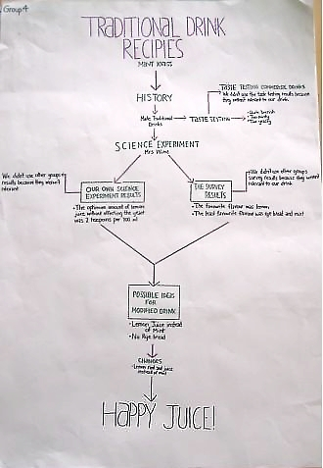
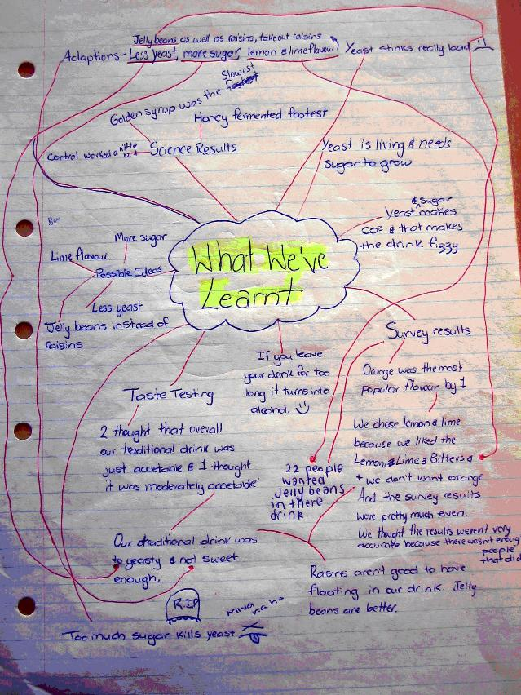

The students also realised that they sometimes had to compromise one aspect in order to accommodate another. Strategic decision-making was called for.

For example, one group wanted to make their drink sour because of their taste test results but knew it would affect the fermentation process:

“We wanted to add tartaric acid because people wanted a more sour drink, but we knew it would kill the yeast, so we added it after the drink had fermented.”

Another group wanted to make their drink less yeasty and more lemony because of their taste testing results. However, they knew they had to get the proportion of lemon to water correct or they would kill the yeast:

“Lemon is a good flavour to dominate the yeast flavour. Adding lemon is good for the growth of yeast, but of course too much is not good, and does not speed up the fermentation. Knowing how much lemon was okay for the yeast meant that we could put lemon in our drink without killing the yeast.”

Key messages:

- Students can use the results they have generated from different tasks when developing a biotechnological product/solution if supported by a knowledgeable teacher.
- Students are able to operationalise multiple concepts and procedures and work within constraints if they use a number of tactics, such as referring to instructions, talking with each other, observing and imitating, experimenting, seeking information from a variety of sources, and asking questions.

Conclusion

In order to produce their modified fizzy drink, students needed to consider the ways in which their changes would affect the fermentation of the yeast. To achieve this, Jennifer and her students engaged in an iterative process in which proposals and solutions were generated and then tested against the key biotechnological concepts.

Both Jennifer and her students needed to understand:

- the task – responding to it by making proposals
- the biotechnology ideas and processes (yeast produce carbon dioxide during the process of fermentation)
- the materials, tools, and processes (to both make the drink and carry out fair testing)
- that the final product needed to be critically evaluated against both the biotechnological constraints and the preferences of the consumer.

Although it is unlikely that the students would have gone on to full production and sale of their drinks, the positive feedback from their presentation audience was ample reward and motivation to duplicate the drinks at home.

Acknowledgements

This unit was observed and reported on by Dr Judy Moreland from the Centre for Science and Technology Education Research, University of Waikato. Dr Bev France from Auckland University’s Faculty of Education provided professional support to Jennifer (not her real name). The study was commissioned by the Ministry of Research, Science and Technology as part of a study into biotechnology practice in schools.

