Numbers and patterns:
How do they help ?
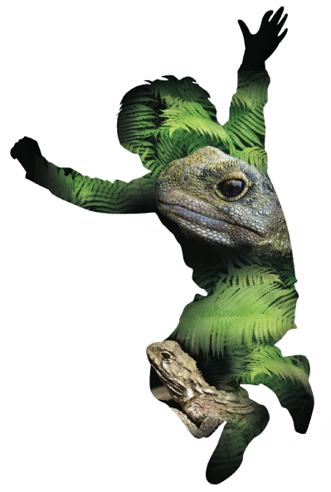
Overview:

Lesson Number: | Can be done throughout the inquiry as a standalone lesson, two separate sessions or within lesson three and lesson five.
Key Competencies: | Thinking; Using language, symbols, and texts; Managing self; Relating to others; Participating and contributing.
Unit/Topic: | Primary focus: Mathematics  Secondary focus: Science
Te Reo/Tikanga Māori: | Names of animals in Māori. Pre- European Māori world view.
Values: | Excellence; Innovation, inquiry, curiosity; Diversity; Equity; Community and participation; Ecological sustainability; Integrity; Respect.
Mathematics Strand | Statistics
Level: | 3
Achievement Objectives:  Statistics: | Students will:  Statistical investigation  - Conduct investigations using the statistical enquiry cycle:  - gathering, sorting, and displaying multivariate category and whole-number data and simple time-series data to answer questions.  - identifying patterns and trends in context, within and between data sets.  - Communicating findings, using data displays.  Statistical literacy  Evaluate the effectiveness of different displays in representing the findings of a statistical investigation or probability activity undertaken by others.
Lesson Objective: | Students will be able to collect real life data and display and communicate it in a way that aids a real world outcome.

Resources in folder:

- Report from trapping programme at Victoria University (Word and PDF).
- Vocabulary list in English and Māori (see Te Tikanga lesson).

Resources online:

Essential resources:
- https://prezi.com/uvm7nitfxcof/numbers-and-patterns-how-do-they-help/ how to access data from NatureWatchNZ or iNaturalist and get students to analyse this online.
- https://prezi.com/nt88y5rxtnze/how-to-make-your-school-a-nw-place/ how to make your school a ‘place’ on NatureWatchNZ or iNaturalist.

Additional resources:
- http://www.wildaboutnz.co.nz/2010/12/ship-rats/
- http://www.pestdetective.org.nz/culprits/ship-rat/
- http://www.pestdetective.org.nz/clues/other-clues/distribution
- http://www.gw.govt.nz/assets/Our-Environment/Biosecurity/Pest-animals/Rodents.pdf
- http://www.gw.govt.nz/assets/Our-Environment/Biosecurity/Pest-animals/WGNDOCS-882937-v1-MustelidbrochureupdateJan2011.PDF

Resources to set up:

- Print off one Victoria University trapping report per student.
  - Blank report to populate with school results (This can include all species not just pest species).
- Access to the iNaturalist website on a desktop (www.iNaturalist.org).

Lesson Structure:

Note: This lesson can be used at all stages of the tracking and trapping programme.
Below are suggested points at which to incorporate these sessions.
There are two main elements of this lesson:
- Analysing examples and gathering other sources of data.
- Collecting and displaying data to analyse to effect real world outcomes.

First session (best done in first half of unit):
Analysing examples and gathering other sources of data
Intent
The intent of this session is to introduce students to looking at real data and coming up with patterns. These patterns and trends will inform them of how to take real world actions.
Introduction and overview 10min
For students to be able to participate fully in these two standalone sessions they must be confident using the web browser to access the ZEALANDIA WWF Outreach projects on iNaturalist.
A great place to start is to briefly talk over the attached report. The goal is to make sure that students understand what the graphs and numbers represent. Their end goal will be to produce a report very similar to the one shown but using their own results from their school’s trapping. The way in which they display this data is up to them.
Theme and content 40min
Data analysis
Ask the students to analyse the data from Victoria University, which they are looking at in the hard copy of the report.

In groups, get them to think about alternative ways of displaying this data and ask them to present their findings from the report. Ask them what further information/data would help them in the current report? Please refer to teacher’s guide.

Groups will look at the overall distribution of pests caught in the area. They will then refine that to a specific species, choosing from ship rats, Norway rats and mice.
Analysing biodiversity
https://prezi.com/uvm7nitfxcof/numbers-and-patterns-how-do-they-help/
Use the above Prezi to help students to use the iNaturalist ‘place’ feature. This allows them to investigate biodiversity within an area. The Prezi explains how students can use this iNaturalist feature to analyse and present data.
Note: Due to time constraints you may wish to only do one of the above activities.
Wrap 10min
In their groups, students can suggest changes or improvements for the Victoria University trapping group, based on their analysis. Present this to the class. Also include suggestions on how to improve the data displayed in the report and maps.

Second session (best done in evaluation phase of unit):
Collecting, analysing and displaying data to effect real world outcomes.
Intent
For this session they will gather data from their school and display it in a clear and user friendly manner. Building on the first session, they will go from analysing others’ data to producing and analysing their own. This will lead them to make appropriate suggestions and comments to the school regarding future improvements which could be made in the biodiversity of their area. This second session is very similar to the first but all the data will come from their school trapping programme and the biodiversity they have mapped and observed in their place.
Introduction and overview 10min
This session is focused on the students analysing their own data and producing a report.
By using the following link, as a teacher you can set up your own ‘place’ on iNaturalist.
https://prezi.com/nt88y5rxtnze/how-to-make-your-school-a-nw-place/
By doing this, your students will be able to analyse their school data for their own ‘place’.
In regards to analysing a place you may use the same structure as found in session one.
Theme and content 40min
Students will use raw data from iNaturalist to show trends and patterns, and make suggestions.
Groups of students may choose to present these in different ways. Conclusions drawn from their data will allow them to suggest actions and possible outcomes for real world problems.
Ask them how does their report compare with the report seen in the first session? Are the same trends present? Can they use information they have researched to suggest reasons for data present?
Wrap 10min
How will they utilise this data? How can they share this information with other schools? What action will they take?

Points for Next Session:

Evaluation:

Points to Improve:

© 1986 Panda Symbol WWF – World Wide Fund For Nature (Formerly World Wildlife Fund)
® “WWF” is a WWF Registered Trademark

