ACTIVITY: Making a simple microscope

Activity idea

In this activity, students make a simple microscope with everyday materials.

By the end of this activity, students should be able to:
- make and use a simple microscope
- explain how tools can be used to observe the world.

Introduction/background notes
What you need
What to do
Discussion questions
Extension ideas

Introduction/background

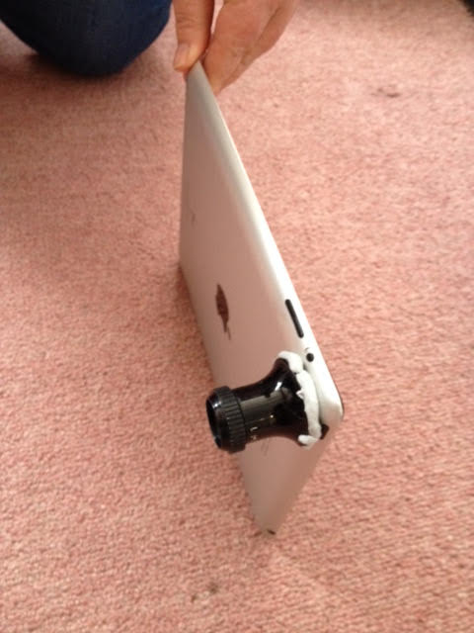
Observation is fundamental to the nature of science. In particular, it underpins the ‘Understanding science’, ‘Investigating in science’ and ‘Communicating in science’ strands of Science in the New Zealand Curriculum. The role of observation in science can be seen in the various articles on the Hub.

The New Zealand Council for Educational Research (NZCER) has identified five science capabilities that are essential to help students build those understandings and to becoming scientifically literate. Observation is crucial to the Gather and interpret data capability: “Learners make careful observations and differentiate between observation and inference. Science knowledge is based on data derived from direct, or indirect, observations of the natural physical world and often includes measuring something.”

Simple observation uses the senses. Many scientists also use tools to help them observe. Many of these tools are expensive. This activity shows how to make a simple microscope using accessible technology to increase students’ ability to observe closely.

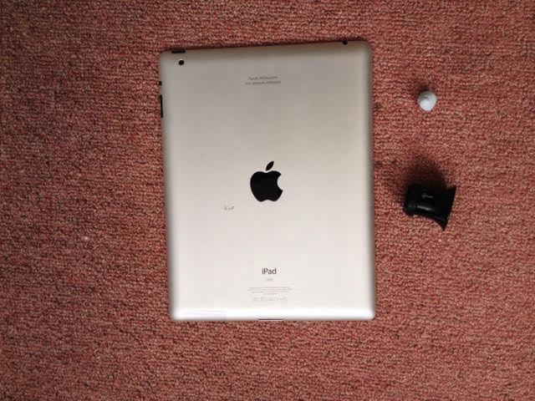
What you need

- A smartphone, iPad, tablet or similar device with camera and screen
- Blu-Tack
- Jeweller’s eyepiece
- Something to observe

What to do

- Take the Blu-Tack and attach the eyepiece over the camera on the device.  - The best results are achieved when the Blu-Tack makes a complete seal.  - Make sure the eyepiece is attached the right way around. It will pay to check this before instructing your students. | 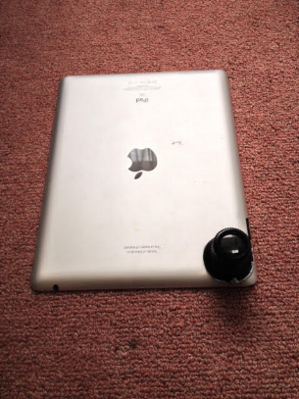
- Turn the camera on. | 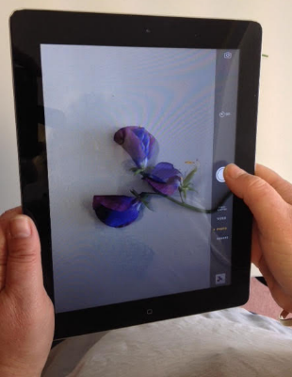
- View the object through the lens and take any photos you wish. | 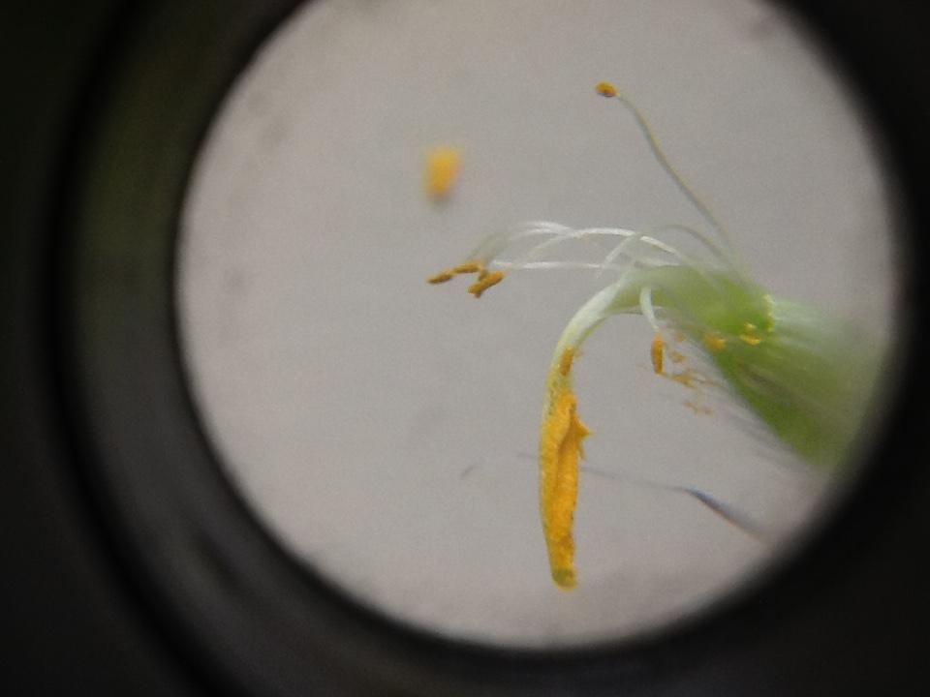
- Use the photos for whatever purposes fit your learning plan – to record observations, stimulate inquiry questions, illustrate writing or project work and so on.

Discussion questions

- How useful was your microscope?
- What did you see that you couldn’t see before?
- What do jewellers use the eyepieces for?
- How else could you use your microscope?
- What other tools do scientists use to help them find out about the world, and how do they help?

Extension ideas

- Ask the students to record and compare what they can see with and without the microscope.
- Explore how lenses and other magnifying tools work such as electron microscopes and telescopes.

