ACTIVITY: Do you see what I see?

Activity idea

In this activity, students are asked to view some optical illusions and critique what they see.

By the end of this activity, students should be able to:
- discuss the reliability of observational data
- discuss various interpretations of the same information
- discuss the importance of critiquing evidence and the need for replication and corroboration of data.

Introduction/background notes
What you need
What to do
Optical illusion cards
Student handouts
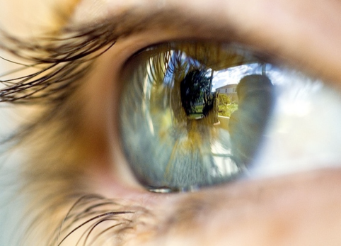
Introduction/background

We use our senses to provide our brain with information about the world around us.

The information provided by the eye is received as patterns of light on our retinal cells and sent to the brain by way of the optic nerve. Find out more in the articles Light and sight –
introduction and Sight.

The brain processes this raw data and interprets it in order to make meaning from what we see. It is the brain that ultimately provides us with a picture of the outside world.

The brain cannot possibly process all the information it receives. Over time, it learns to make sense of the information by making assumptions and picking the most likely scenarios that make sense of the information. These are the pictures we ‘see’, and most of the time, these pictures are fairly accurate.

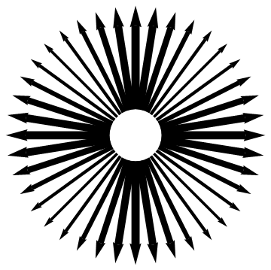
However, the interpretations may not actually represent the true image the eye sees. Optical illusions deliberately trick the brain into making incorrect assumptions, so we ‘see’ something that isn’t actually a true representation of what we are looking at.

By finding out what others know or think we can build a better understanding of the whole situation. We can discuss what the truth or best theory might be.

Using optical illusions with students is an engaging way to help them explore the nature of science concepts around validity and reliability of data and the need for repetition, replication and corroboration.

The science capability ‘Using evidence’ explains that: “Science is a way of explaining the world. Science is empirical and measurable. This means that in science, explanations need to be supported by evidence that is based on, or derived from, observations of the natural world.”

Hence we need to make sure the evidence is reliable, which is a concept that students often struggle with.

What you need

- Three optical illusions – the images of these can be displayed online or copied and distributed as A4 or A5 cards
- Copies of the student handout.

What to do

- This is a simple adaptation of the Think – Pair - Share strategy:
- Show Illusion A. Display as one image for the whole class to see, or allow the students to view the illusion on cards.
- Give time (1 minute) for the students to think individually about what they see.
- Students then turn to their neighbour and, in pairs, share and discuss what they see (1–2 minutes).
- Each pair can turn to another pair and again share and discuss what they see (2–3 minutes).
- Ask for feedback from the class.
- Distribute copies of the student handout and ask students to respond to the processing questions or continue with a class discussion using the questions on the handout as prompts.
- Repeat the above steps for the Illusion B and Illusion C, one at a time.

- In science, data, observations and other information can be collected again (i.e. experiments or observations can be repeated), other pieces of evidence can be used for corroboration (this may involve research, discussion, measurement or further investigation) and data can be critiqued and discussed in terms of its validity. You could foster discussion about how data may be interpreted and, if there are different interpretations, what that might mean.

Optical illusion cards

Illusion A

Illusion B

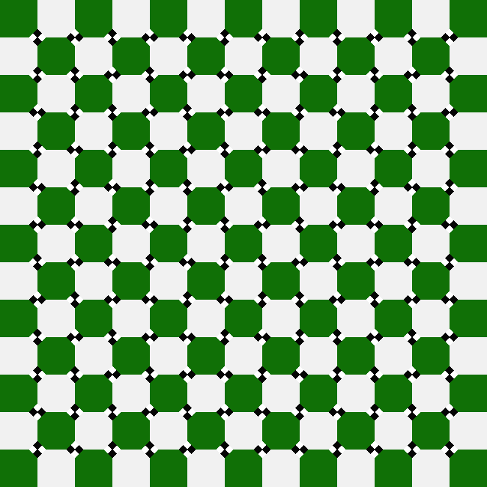
Illusion C

Student handouts

Illusion A
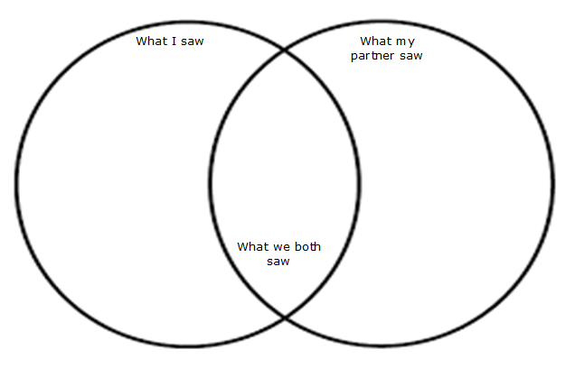
Did we see the same things as each other and as the rest of the class? Why do you think that might be?

Why do you think it is important for scientists to discuss their findings?

In science, it is important to be sure of our evidence. What could we do to make sure we agree about any information or evidence we find?

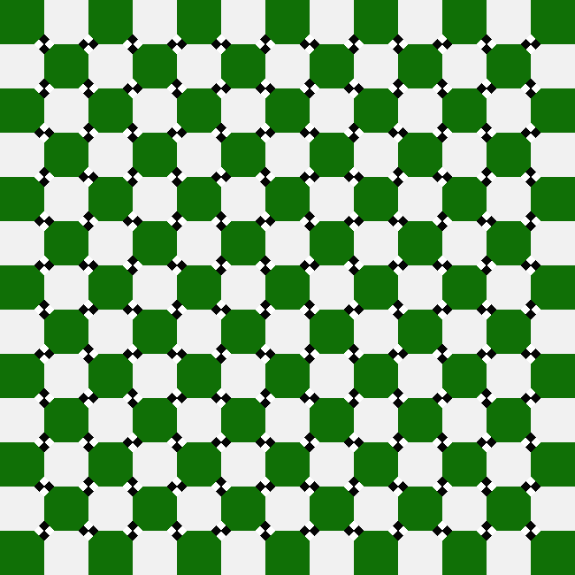
Illusion B

Describe what you saw in this picture.

Did you see what everyone else saw? Explain why you think this is.

When you first saw this diagram, do you think you saw what was actually there? Why/why not?

How could we prove what the picture actually shows?

What might scientists do when they don’t agree or aren’t sure whether their observations are correct?

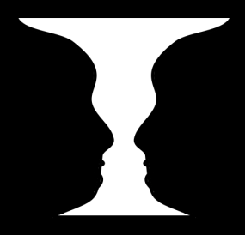
Illusion C

Describe what you saw in this picture.

Did you see what everyone else saw?

Do you think either of you was right or wrong? Explain your answer.

Do you think scientists ever have different views about things they are studying?

What might they do when they don’t agree or aren’t sure whether their observations are correct?

