Marine theme: Food webs

Food webs illustrate the networks of feeding relationships between organisms that live in a particular area. All food webs are made up of producers, consumers and decomposers. However, the number and type of species that make up web vary greatly between different areas and different ecosystems.

This topic planner offers a suggested pathway through Science Learning Hub education resources and connects to relevant programmes offered by the NZ Marine Studies Centre. Click on the links below to create your own personalised teaching unit. Feel free to use this material in any combination or order.

Images from www.sciencelearn.org.nz

Exploring the theme

Focus question: What can you find in your kitchen that links to life in the sea?

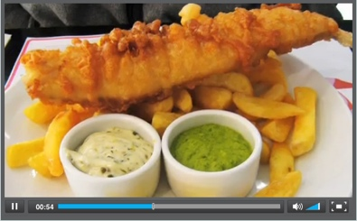 | 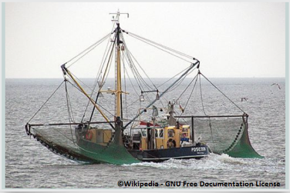

- Video > Understanding Food Webs

- Image > Commercial fishing boat

Activities – use these activities to expand on the focus question:

- Build a marine food web

- Making a food web (Antarctic ecosystem)

Understanding the theme

Focus question: What do you think would happen if one species was removed from the food web?

- Key terms > See food web, keystone species and ecosystem

- Article > Marine food webs

- Article > Plankton

- Video > Role of starfish in the ecosystem

Activities – use these activities to expand on the focus question:

- Interactive > Marine ecosystem

- Food chain card game > Gulp and swallow

Applying the theme

Focus question: How does human activity affect the marine food web?

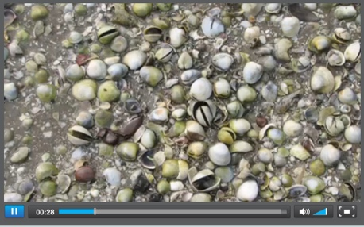 | 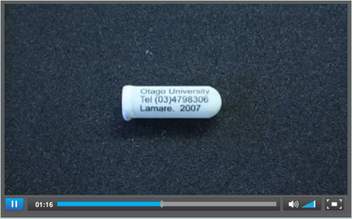 | 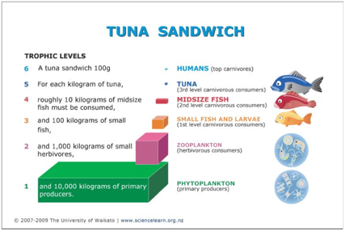

- Video > Impact of freshwater on cockles

- Article > Understanding food webs in Fiordland

- Video > Why tag a starfish?

- Article > Tagging sea stars

- Diagram > Tuna sandwich

Activities – use these activities to expand on the focus question:

- Trails and Trials of Marine Toxins

- Fisheries role play

New Zealand Marine Studies Centre field trips (available in Otago & Nelson) include explorations of the coastal environment, laboratory sessions, boat trips and aquarium adventures.

Experiencing the theme
W: www.marine.ac.nz

- Supper in the Sea
- Seashore scramble
- Sharks, inside and out
- The Marine Road Show

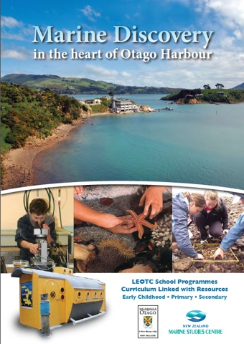 | 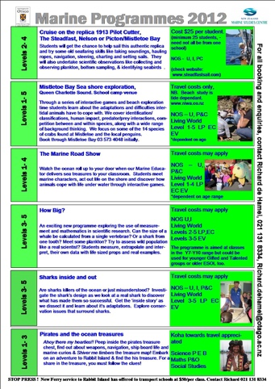

This resource supports NZC Science Level 3/4

The New Zealand Marine Studies Centre, University of Otago, offers marine education programmes and resources for primary and secondary schools in southern New Zealand.  T: 03 479 5826  E: marine-studies@otago.ac.nz  W: www.marine.ac.nz | The Science Learning Hub is a national project funded by the New Zealand Government to make examples of New Zealand science, technology and engineering more accessible to school teachers and students.  E: enquiries@sciencelearn.org.nz  W: www.sciencelearn.org.nz
NATURE OF SCIENCE: UNDERSTANDING ABOUT SCIENCE: Appreciate that science is a way of explaining the world and that science knowledge changes over time.
- LIVING WORLD: ECOLOGY: Explain how living things are suited to their particular habitat and how they respond to environmental changes, both natural and human induced.
- LIVING WORLD: LIFE PROCESSES: Recognise that there are life processes common to all living things and that these occur in different ways.

Contact details

