ACTIVITY: Make an electric motor

Activity idea

This activity will demonstrate electromagnetism operating in a basic electric motor that students build. It can be approached from a science perspective or a technology perspective.

By the end of this activity, students should be able to:
- understand how a simple electrical motor works
- construct a simple electrical motor.

Introduction/background notes
What you need
What to do
Extension ideas
Student handout: Constructing an electric motor

Introduction/background

Three historic discoveries were instrumental in the development of electric motors – the invention of the battery by Alessandro Volta in 1800, the generation of a magnetic field from electric current by Hans Christian Ørsted in 1820 and the invention of the electromagnet by William Sturgeon in 1825. These discoveries were critical for the development of building working electric motors.

Electricity and magnetism are forces caused by the movement of electrons. Electrons are negatively charged particles in atoms that can move through conductors such as copper wire when the wire is connected in a circuit from one battery terminal to the other. The negatively charged electrons in the wire move away from the negative terminal of the battery towards the positive terminal. The movement of electrons through a conductor is called an electric current.

A magnet is formed when atoms of certain materials are lined up so that the negatively charged electrons all spin in the same direction. The magnetic field is the area around the magnet where the force is active. Stronger magnets have larger magnetic fields. A magnet can be created by electricity. Wrapping a wire around metal and running an electric current through it creates a magnetic force. This is called electromagnetism.

This activity will demonstrate electromagnetism operating in a basic electric motor that students build. It can be approached from a science perspective or a technology perspective.

This YouTube clip shows a young boy explaining how to build a simple electrical motor:
https://www.youtube.com/watch?v=0qaXv1zT1JA

For a more detailed explanation of how an electric motor works and how to build a simple model, watch this YouTube clip: https://www.youtube.com/watch?v=elFUJNodXps

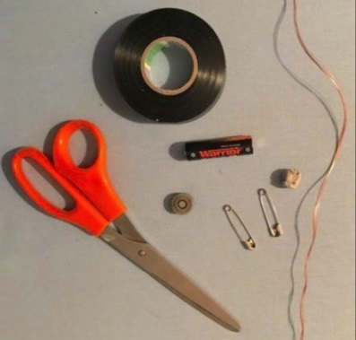
What you need

- Two large metal safety pins
- Enamelled copper wire 0.25–0.5 mm
- Strong magnet
- Size AA battery
- Scissors
- Insulation tape
- Blu-Tack

What to do

- As a class discuss the student handout Constructing an electric motor.

- Assist students to gather the materials they need and construct their motors.

- Discuss the results:
- Did they get their motor going?
- What did they have to adjust or troubleshoot?
- What did they observe?
- What science do you need to understand in order to explain how an electric motor works?
- How does this simple technology scale up to generate enough power to make a car go?

Extension ideas

- Explore other uses of electromagnets, for example, speakers.
- Investigate how to boost the power of the motor.
- Find out more about the magnetic fields of the Earth.
- Find out more about the light phenomena in the sky when earthquakes occur.

Student handout: Constructing an electric motor

- Make a copper wire coil by wrapping the copper wire 10–15 times around the battery (or anything tubular like your finger or pencil). |  | 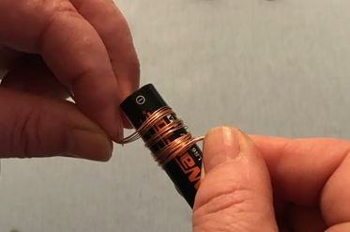
- Wrap the two ends around the coil so that they are opposite each other and facing outwards. | 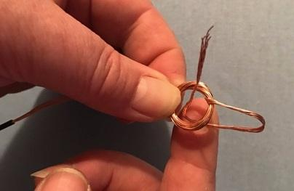 | 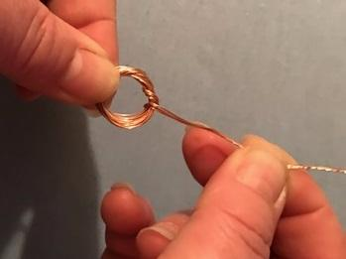
- Using scissors or a knife, scrape off half of the diameter of the copper wire insulation from the same side of both the coil ends. If this is too difficult, use a permanent marker and colour half the wire. Make sure it is the same half on both sides. |  | 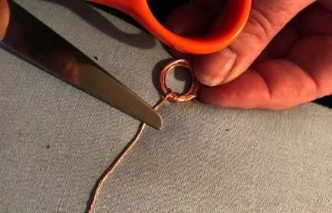
- Place the large safety pins on each end of the battery terminals as shown. Keep in place using insulation tape. Use the Blu-Tack to stabilise the battery. |  | 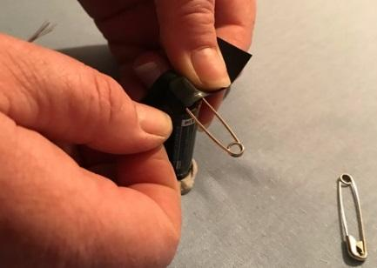
- Place the magnet on the body of the battery.  - Balance the ends of the copper wire coil by inserting them through the rings in the safety pins.  - Flick the coil and watch it continue to spin. Some adjusting of the clips and coil may be required.  Safety note: When complete, electricity will be running through the coil. It will get hot and may burn if touched. Use a pen to push the magnet off the battery and let the coil cool before adjusting the set-up or dismantling. |  | 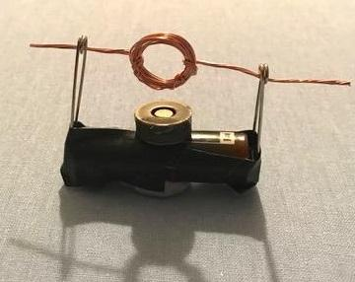

Troubleshooting:
If your coil is not spinning:
- the coil may have too many loops of wire or not enough – try experimenting with a different number of turns in the coil
- readjust the end wires – they need to be straight and even to work effectively
- check the battery terminals are clean
- try different types and sizes of batteries
- check that the scraped sides of the ends of the coil are facing the same way.

