Lesson 4: Instigate:
What’s the solution?
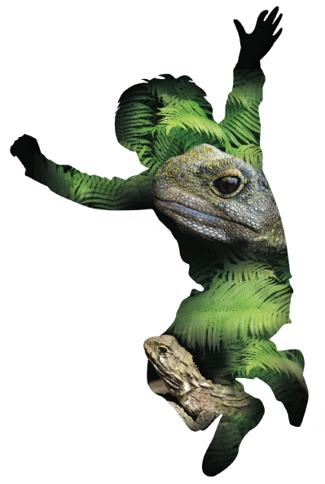
Overview:

Lesson Number: | 4 of 5
Key Competencies: | Thinking; Using language, symbols, and texts; Managing self; Relating to others; Participating and contributing.
Unit/Topic: | Primary focus: Science  Secondary focus: Technology
Te Reo/Tikanga Māori: | Names of animals in Māori. Pre-European Māori world view
Values: | Excellence; Innovation, inquiry, curiosity; Diversity; Equity; Community and participation; Ecological sustainability; Integrity; Respect.
Science Strand: | Nature of Science  Living World
Level: | 3
Achievement Objectives:  Nature of Science: | Students will:  Understanding science:  - Identify ways in which scientists work together and provide evidence to support their ideas.
Achievement Objectives:  Living World | Students will:  Ecology:  - Explain how living things are suited to their particular habitat and how they respond to environmental changes, both natural and human induced.
Technology Strand: | Nature of Technology:
Achievement Objectives:  Nature of Technology: | Students will:  Characteristics of technological outcomes:  - Understand that technological outcomes are developed through technological practice and have related physical and functional natures.
Lesson Objective: | Students will use data they have collected to analyse a trend. From this trend they will suggest an action plan and its desired outcome for their community.
Resources:

- Vocabulary list in English (lesson one) and Māori (see He Tikanga lesson).
- Laminates of NZ fauna and pests. (from lesson one).
- iPads/ tablets with pre-installed apps (NatureWatchNZ or iNaturalist).
- Gotcha Traps ink refills if required.
- A3 laminates of school map showing tracking tunnel locations and current data, from iNaturalist.
- Wooden trap boxes can be obtained from:
Haines Pallet Co. Ltd.
T| 04 568 6898
F| 04 5686480
E| haines.pallets@paradise.net.nz
- Health and Safety Guidelines for Tracking and Trapping (RAMS).
- Trap Setting Guidelines.
Resources online:

- http://www.gotchatraps.co.nz/html/contact_us.html contact for Gotcha Traps ink pads.
- http://www.predatortraps.com/downloads/ratkillsystem1.pdf template for trap box construction.
- http://www.pestdetective.org.nz/ helpful website for identifying footprints.
- http://www.mpi.govt.nz/document-vault/8521 assessing welfare performance of restraining and kill traps (NAWAC).
- http://www.landcareresearch.co.nz/science/plants-animals-fungi/animals/vertebrate-pests/traps
- https://www.trap.nz
- DOC Skillable YouTube clips to help with setting traps:
- DOC200
http://www.youtube.com/watch?v=_8Xwo-w0-MI
http://www.youtube.com/watch?v=kABskKb1NzE
- Victor professional
http://www.youtube.com/watch?v=aql_gFGRGoI
- Goodnature A24
http://www.goodnature.co.nz/videos/#c340

Resources to set up:

- Laptop and data projector.
- iNaturalist log in for the class.
- Trap.NZ log in for class, if a larger trapping project is being undertaken.
- A selection of different kinds of trap. The following traps are recommended, as they have been tested against the National Animal Welfare Advisory Committee (NAWAC) guidelines: Rat Victor Professional, DOC 200 & Goodnature A24 rat and stoat trap (contact your local DOC office or council for advice about traps and suppliers).
- Means of ‘housing’ the traps e.g. wooden box as per Haines.
Your local DOC office or council may be able to provide you with a demonstration or let you borrow some basic traps to use in you school. Otherwise get in touch with your local pest control agencies.
Lesson Structure:

Introduction and overview 10min
Recap with your class what information they have gathered so far:
- How have they recorded evidence?
- Show laminated maps of their tracking tunnel locations. You can use coloured stickers to show results. In addition, you can use the map to show all of the current observations in the ZEALANDIA WWF Outreach project on iNaturalist.
- Are there any connections between presence of prints and locations e.g. in the bush, out in the open, by the compost?
- Can your students see any patterns emerging?
At this point you may want to consider using the Maths/Statistics lesson.
Theme and content 40min
Using the data you have recorded from your tracking tunnels, students will now look for patterns and suggest a solution to the ‘pest problem’. You may choose to do this activity in groups.
Students will present to the class what they think the data means, what it shows and what they suggest as a solution. From this, as a group they will propose what would be an appropriate action to take and which sites are the most suitable for any proposed action.
The second group activity is investigating the options we currently have to manage predators. Each group will be assigned a trapping system: Victor Professionals rat trap, Goodnature A24 etc.
They will present:
- The pros and cons of each trap. This will include the animals’ welfare, cost, design etc.
- Where could each be used?
- How easy are they to use?
The main trap to highlight currently is the Victor Professional trap if your school is using these. Demonstrate how to set it, place in trap box and place box so that rodents can see through the box – i.e. parallel to a wall or fence.
Stress the importance of:
- Placing the traps inside wooden trap boxes or similar, to reduce the risk of injury to animals other than target species.
- Ensuring that the target species are killed humanely.
- Ensuring the target species can only go over the trap in one direction.
- Preventing people getting hurt by uncovered traps.
See resources for design of trap boxes and manufacturer contact details
Wrap 10min
As a class summarise the suggestions and decide on a course of action for the school.
This needs to include the following:
- Where you will place the traps?
- Do you need more traps/different traps?
- When will you put these out?
- Who will check them?
- When will you check them?
- Where will you dispose of the carcasses?
Make sure that any pests you catch are recorded on the ZEALANDIA WWF Outreach project on iNaturalist.
Where your school is looking to set up and run a large ongoing trapping project, you can also use trap.nz to plot the location of your traps, and keep records of your catches. This will give you easy access to displaying maps of where the pests are caught, numbers and timings of catches.
When and where you place these traps out is up to you.
NB: Traps will need to be set prior to the final session.

Points for Next Session:

Evaluation:

Points to Improve:

© 1986 Panda Symbol WWF – World Wide Fund For Nature (Formerly World Wildlife Fund)
® “WWF” is a WWF Registered Trademark

