Lesson 5: Evaluate:
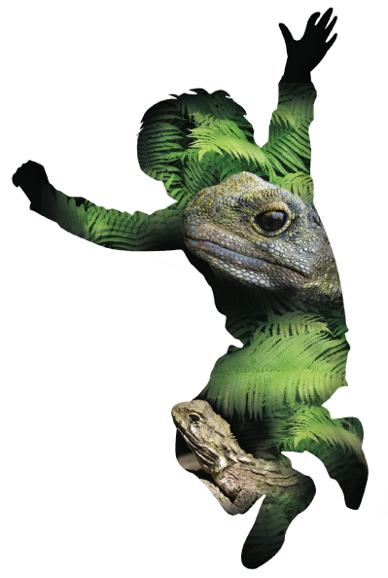
So what?

Overview:

Lesson Number: | 5 of 5
Key Competencies: | Thinking; Using language, symbols, and texts; Managing self; Relating to others; Participating and contributing.
Unit/Topic: | Primary focus: Science  Secondary focus: Health and Physical Education  Social Sciences
Te Reo/Tikanga Māori: | Names of animals in Māori. Pre European Māori world view. (see separate lesson plan)
Values: | Excellence; Innovation, inquiry, curiosity; Diversity; Equity; Community and participation; Ecological sustainability; Integrity; Respect.
Level: | 3
Science Strand: | Nature of Science  Living World
Achievement Objective:  Nature of Science: | Students will:  Understanding science:  - Identify ways in which scientists work together and provide evidence to support their ideas.
Achievement Objective:  Living world: | Students will:  Ecology:  - Explain how living things are suited to their particular habitat and how they respond to environmental changes, both natural and human induced.
Heath and Physical Education Strand: | Healthy Communities and Environments
Achievement Objective:  Healthy Communities and Environments: | Students will:  People and the environment:  - Plan and implement a programme to enhance an identified social or physical aspect of their classroom or school environment.
Social Sciences Strand:  Achievement Objective: | Students will:  - Understand how people make decisions about access to and use of resources.
Lesson Objective: | Students will be able to identify the unique nature of the flora and fauna in NZ. They will also be able to suggest feasible ways in which they and their community can contribute positively towards preserving and restoring our ecosystem.
Resources in folder:

- Laminates of New Zealand fauna and introduced pest species (from lesson one).
- Pre/post assessment test of knowledge, with marking rubric.
- Vocabulary list English (lesson one) and Māori (see He Tikanga lesson).
- ‘Numbers and patterns: how do they help?’ (see lesson plan part two)
Resources online:

- http://www.naturespace.org.nz/community-notices
- http://predatorfreenz.org/the-big-picture/
- http://www.kcc.org.nz/wildlife-and-wild-places
- https://www.trap.nz

Resources to set up:

- iPads or tablets with pre-installed iNaturalist application (both iOS and Android apps are available).
- Laptop to connect to projector.
- Up-to-date observations from the ZEALANDIA WWF Outreach project on iNaturalist.
- Up-to-date records and report maps from trap.nz

Lesson Structure:

Introduction and overview 10min
Context:
For your students, school and community it is important to set the results of your investigation in the context of a longer time frame. Ideally this programme will have the most success if it is set up with the intention of maintaining it on an ongoing basis i.e. over a number of years.
Before starting this session you may want your students to track and trap at home as per sessions two, three and four at home. This will involve students taking tracking tunnels and traps home, and will need parental permission and good communication with home for this to be successful.
Getting your students to do this will allow you to extend the range of the data gathered and gain support from your local community.
Consider running a parent evening where students present their findings and you can gauge support (if you choose) for:
- Extending the programme into the community.
- Setting up a longer term project with community support and/or sponsorship.
For your class: Outline the statistics of the class’ contribution to date in terms of:
- All observations (including general species observations).
- Tracking tunnel recordings.
- Predators killed etc.
Discuss how they have started the process of taking action to solve a problem.
Note: Initially any changes in endemic species numbers may be small. Getting your students to note the increase in the insect prints will help them to notice early changes due to the removal of pest species.
Later classes can evaluate data around weta and lizard prints.
Use trap.nz to show interactive maps of trap coverage, kills of different species and changes over time.
Students will be able to compare the data they collect with prior years, different seasons and other classes within their school as well as any community data collected.
Any data collected and action taken forms part of a larger picture – small changes contribute to the larger goal of making New Zealand pest-free.

Theme and content 40min
This can be done in two sections:
- Using the second session in the Maths/Statistics unit ‘Collecting and displaying data to analyse and to effect real world outcomes (see resource folder).
- Completing the post assessment test. Students will repeat the pre-test but should now be able to articulate more in-depth conclusions, based on their new learning.
Wrap 10min
Have a class discussion about:
- ‘Where to next?’ as a school and as individuals?
- Can we make our community pest-free?
- How can we involve our parents and community in ongoing action to protect our New Zealand flora and fauna?
- What systems can we put in place to keep up our positive work? Will we continue to track and trap? How long for?
- How will we monitor whether our pest eradication has had a positive effect on our school environment? e.g. ongoing bird monitoring, choosing a species like fantails (a good indicator species) to monitor
- What can we do to enhance the habitat of our New Zealand species?
As a class, choose one of the above aspects and formulate a plan for impacting your community with what you have learnt.
As part of your planning, make sure you set out your SMART goals, thinking as a teacher about how you will maintain your students’ enthusiasm and motivation.

Points for Next Session:

Evaluation:

Points to Improve:

© 1986 Panda Symbol WWF – World Wide Fund For Nature (Formerly World Wildlife Fund)
® “WWF” is a WWF Registered Trademark

