ACTIVITY: Making a thermometer

Activity idea

In this activity, students will construct a simple thermometer.

By the end of this activity, students should be able to:
- build a simple thermometer
- collect data using their thermometer
- interpret and make meaning of their data
- discuss the reliability of their data.

Background information for teachers
Equipment required
Student instructions
Extension ideas/prompting questions

Background information for teachers

Thermometers measure temperature. Daniel Fahrenheit is credited with the invention of the first thermometer, which was constructed using glass and mercury.

In this activity, students will construct a simple thermometer using water inside a straw.

This activity is part of a set of five activities supporting students to collect and interpret data about their world. Although each of these activities may be used within a variety of topics, they were designed to tie together under the topic of weather. The other activities are:
- Making a barometer
- Making a rain gauge
- Making a weather vane and compass
- Making an anemometer

They support the professional learning and development sessions Delving into data and Making sense of data. They support the development of the science capabilities, especially ‘Gather and interpret data’, Use evidence’ and ‘Critique evidence’. The activity Investigating heat absorption might extend your student’s thinking.

Equipment required

- Small plastic drink bottle
- Water
- A straw (long enough to poke out the top of the bottle)
- Plasticine or Blu-Tack
- Food colouring
- Card or ice cream container lid
- Glue or tape
- Ice

Student instructions

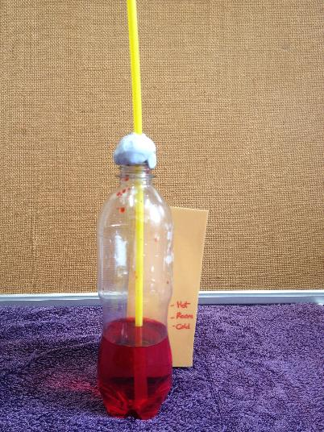
- Put 100 ml of water into the bottom of the drink bottle and add a few drops of food colouring.

- Put the straw into the bottle so that the bottom is in the water and the top of the straw is sticking out of the bottle.

- Seal the bottle with the plasticine or Blu-Tack so it is airtight.

- Glue or tape the card or a strip cut out of the ice cream container lid onto the back of the drink bottle.

- Mark the level of the water in the straw onto the backing card.

- Put the bottle into some hot water from the tap (or in the Sun) for 5–10 minutes and mark the level of the water in the straw onto the backing card. This is the ‘hot’ mark.

- Put the bottle into some ice for 5–10 minutes. Look very carefully for the level of water in the straw, and mark the level onto the backing card. This is the ‘cold’ mark.

Extension ideas/prompting questions

- How might the accuracy of the temperature scale be improved?

- Discuss what constitutes cold, cool, warm and hot. These levels could be recorded on the thermometer scale, making it easier to record the data collected.

- Use existing temperature data or a standard thermometer to calibrate the thermometer:
- Put the bottle into a variety of situations where the temperature is already known.
- Leave the bottle sitting in each situation for 5–10 minutes and mark the backing card at the level of the water in the straw in each case.
- Label the backing card with the known temperature at each mark.

- Experiment with other liquids instead of water. (As water has a high heat capacity, it isn’t ideally suited, but it is safe for younger students to use.) Do other liquids behave in the same way?

- Create a challenge to construct the most accurate thermometer.

- How reliable was the method used for collecting and processing the data?

- What are some of the challenges in getting accurate temperature readings?

- If comparisons in temperature data are being made, does the thermometer design matter? Why or why not?

- Is it important to collect temperature at the same places and times?

- How could the design or method be improved?

- Is the temperature the same in different locations around the school, on different days, at different times of the day?

- How do the temperature results we collect compare with official statistics? How can any differences be explained?

- Collect data over a length of time and compare. Data can be collected and processed in tables and graphs. Are there any patterns in the data?

- What causes the changes in the level of the liquid in the thermometer? Explain how the thermometer works.

- Can any patterns be seen in relating the temperature data to other weather information/data that may have been collected such as observations, using a weather vane, wind speed (anemometer), air pressure (barometer), rain (rain gauge).

- Write a weather report that outlines any findings and predictions.

