ACTIVITY: Eliciting prior knowledge

Activity idea

In this activity, students are given an opportunity to share what they know about the whio. Two methods of eliciting prior knowledge are modelled. Although whio/blue duck is the focus in this example, these methods are easily adapted to any context. The second part of the activity moves from eliciting prior knowledge to formulating questions that may become the basis of a student inquiry into whio.

By the end of this activity, students should be able to:
- share their prior knowledge about the whio
- share experiences they have had regarding conservation
- formulate questions for research and inquiry that will extend their current understandings.

Background information for teachers
Equipment required
Student instructions
Extension ideas/prompting questions for teachers

Background information for teachers

The activity is designed to support students to demonstrate their prior knowledge, experience and understanding about the whio. Both parts of the activity can be easily modified to apply to any context. By tapping into prior knowledge and student experience, teachers can support students to build connections between what they already know and new ideas, building on their current understandings.

Gathering prior knowledge and acknowledging student experience is a way in which teachers can be culturally responsive. It offers an opportunity to tailor teaching and learning to suit the needs, interests and experiences of students. It also allows teachers to identify any misconceptions that may hinder development of science ideas.

Part A is a whole-class activity where students move around the room finding other people who have the answers to the questions. As this is a Word document, the questions on the bingo card can be easily modified to suit the level(s) of your students and your purpose.

Part B is an individual student activity designed to process students’ current understandings and use these as a basis for asking questions that form the basis of an inquiry about whio.

You may wish to provide some more stimulus material about the whio, such as videos, posters and so on to reinforce and extend student ideas. The Whio Forever project, created in partnership between the Department of Conservation and Genesis Energy has developed a set of resources you could use for this purpose. There are also several other videos and articles you could look at to learn more about whio, for example, Spare a thought for the blue duck and Remote Blue Duck Station is haven for whio, kiwi and bats.

Equipment required

- Bingo card for each student
- Copies of whio question templates – these are available to download directly from the Whio Forever resource, by copying page 15 of the junior resource if you have a hard copy or by using the template provided here
- Pens/pencils
- Wall space for display with headings ‘What do we already know?’ and ‘What would we like to find out?’

Student instructions

Part A: Whio Bingo

- With your own Whio Bingo card, move around the room, finding other people who can answer the questions on the card. Write the answers to the questions in the boxes on the card and the name of the person who gave you the answer to each question. If you can, find someone different to answer each question.

- Once you have your card complete, sit with a partner and share your answers.
- Are all the answers the same?
- What have you learned?
- What have you learned about your classmates?
- How do you know the answers are right?
- Check your answers with your teacher, classmates or the resources you have been given.

Part B: Ideas wall

- Write one thing you know about whio onto a copy of the “I know that whio:” whio picture. Use as many of the pictures as you need, writing one idea onto each one.

- Onto a copy of the “I wonder…” whio picture, write what you would like to know about whio. Use as many of the pictures as you need to until you run out of things you would like to find out.

- Display your ducks under these headings:
- What do we already know?
- What would we like to find out?

WHIO BINGO

What is something special about whio? | Where do whio live? | What is another name for whio?
What country do whio live in? | What is a whio? | Who has seen a whio?
What do whio eat? | Why are whio important? | Who has visited a river?
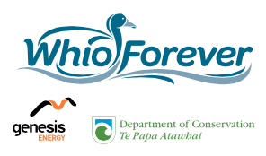
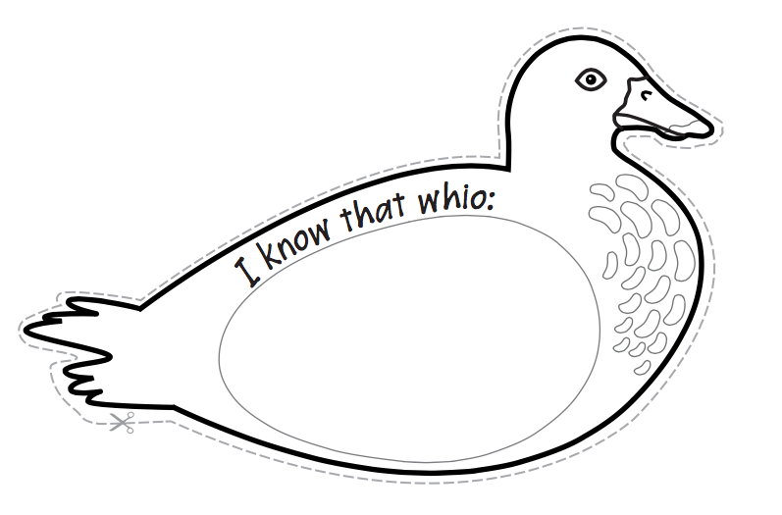

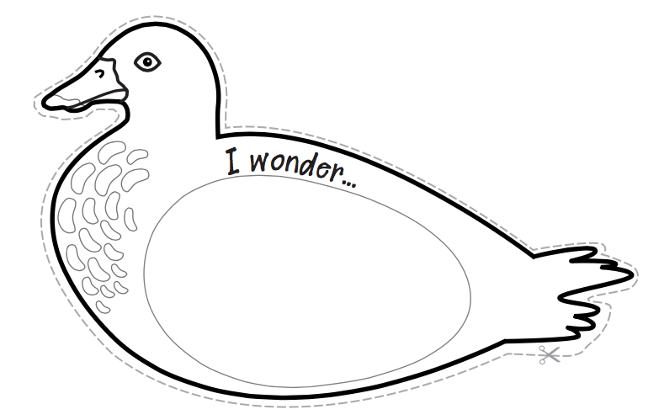

Extension ideas/prompting questions for teachers

Although this activity was designed to elicit prior knowledge, it could also be easily adapted to check on what has been learned at any stage during a unit.

Make it into a competition.

Ask students to create a new bingo card to use with their classmates.

Use the activities as before and after exercises to demonstrate learning.

