ACTIVITY: Investigating car safety features

Activity idea

In this activity, students build model cars to investigate the function of safety features such as seatbelts and crumple zones.

By the end of this activity, younger students should be able to:
- demonstrate how seatbelts prevent the wearer from continuing to move forward during a car crash
- explain why it’s important to wear a seatbelt when in a car
- discuss the use of models in science – how their car represents aspects of reality.

In addition, older students should be able to:
- explain that seatbelts exert a force, preventing the wearer from moving forward
- demonstrate how crumple zones absorb energy
- make connections between car crashes, forces and Newton’s laws
- make connections between car crashes and kinetic energy transformation
- demonstrate how kinetic energy is reliant on the mass of an object and the velocity at which it moves.

Background information for teachers
Equipment required
Student instructions
Extension ideas/prompting questions for teachers

Background information for teachers

Modern cars have many safety features designed to protect the passengers inside. Many of these features are useful for demonstrating physics fundamentals.

This activity is suitable for primary and secondary students – build on the complexity of the physics fundamentals to meet students’ needs. The design aspect is also up to teacher discretion. Younger students can use toy cars or make their own models. Consider creating design briefs or adding extra challenges for older students.

Physics fundamentals – Newton’s laws of motion

When a vehicle accelerates, the passengers accelerate, too. The car and passengers are travelling at the same speed, so passengers don’t always feel as if they are moving. When the vehicle stops suddenly, passengers continue to move due to inertia – the tendency of an object to continue in a straight line until an external force is applied – as explained in Newton’s first law of motion.

Newton’s third law of motion explains what happens next. A passenger wearing a seatbelt exerts a force on the seatbelt, and the seatbelt exerts a force back on the passenger. For people or objects not secured by a seatbelt, the windscreen or other hard surface will likely be the force that stops the forward motion. (The How Stuff Works article How Seatbelts Work explains the physics and mechanics of seatbelts.)

Newton’s second law of motion – force equals mass times acceleration (F=ma) – is also pertinent to car crashes. Mass and speed determine the amount of force in a collision. The faster a car is travelling, the greater the force in the crash, or the heavier (bigger) the vehicle, the greater the force – or both.

This is why road safety campaigns use slogans like, “The faster you go, the bigger the mess.”

Physics fundamentals – kinetic energy

All moving objects have kinetic energy. When a moving object collides with something else, the kinetic energy is transformed (transferred). With a car crash, the kinetic energy is transformed via the heat, sound and the deformation (crumpling) of the vehicle.

Car safety features are designed to absorb the energy from the collision, so less energy is transferred to the passengers inside. Energy is equal to force times distance. If a passenger is wearing a seatbelt, the energy is transferred over a larger distance, which means less force is applied to the passenger. This same principle applies to airbags and crumple zones.

Increased mass and speed increase kinetic energy – so bumping into an object at 5 kph will transfer less energy and cause less damage to the car’s front end than when travelling at 50 kph. In student-friendly terms, imagine being hit by a cricket ball being slowly rolled along the ground compared with a cricket ball that has been hit with a bat. Which one has the potential to do more damage?

Building model cars

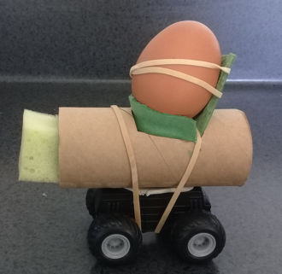
The instructions in this activity focus on a single car design. However, the activity is just as effective using students’ original designs, provided each car has the following:
- A secure seat. The seat must be glued to the car or firmly attached with a rubber band. (Younger students can use a glue gun to firmly attach the seat to the car body. Older students can use the seat to trace an outline on the car body.) Consider how seats (including many children’s booster seats) are bolted into car frames.
- A high-backed seat. Consider how seats have evolved in the last few decades to include higher backs and headrests.
- Seat belts. Use two rubber bands to replicate a lap belt and shoulder belt.
- A compressible bumper to act as a crumple zone – if discussing kinetic energy or crumple zones.

Students can also design their own cars. Using parts from existing toys or LEGO sets shortens the build time and makes a more stable model for younger students. Older students can put additional effort into making and testing their crumple zone materials.

Equipment required

- Empty cardboard potato chip container
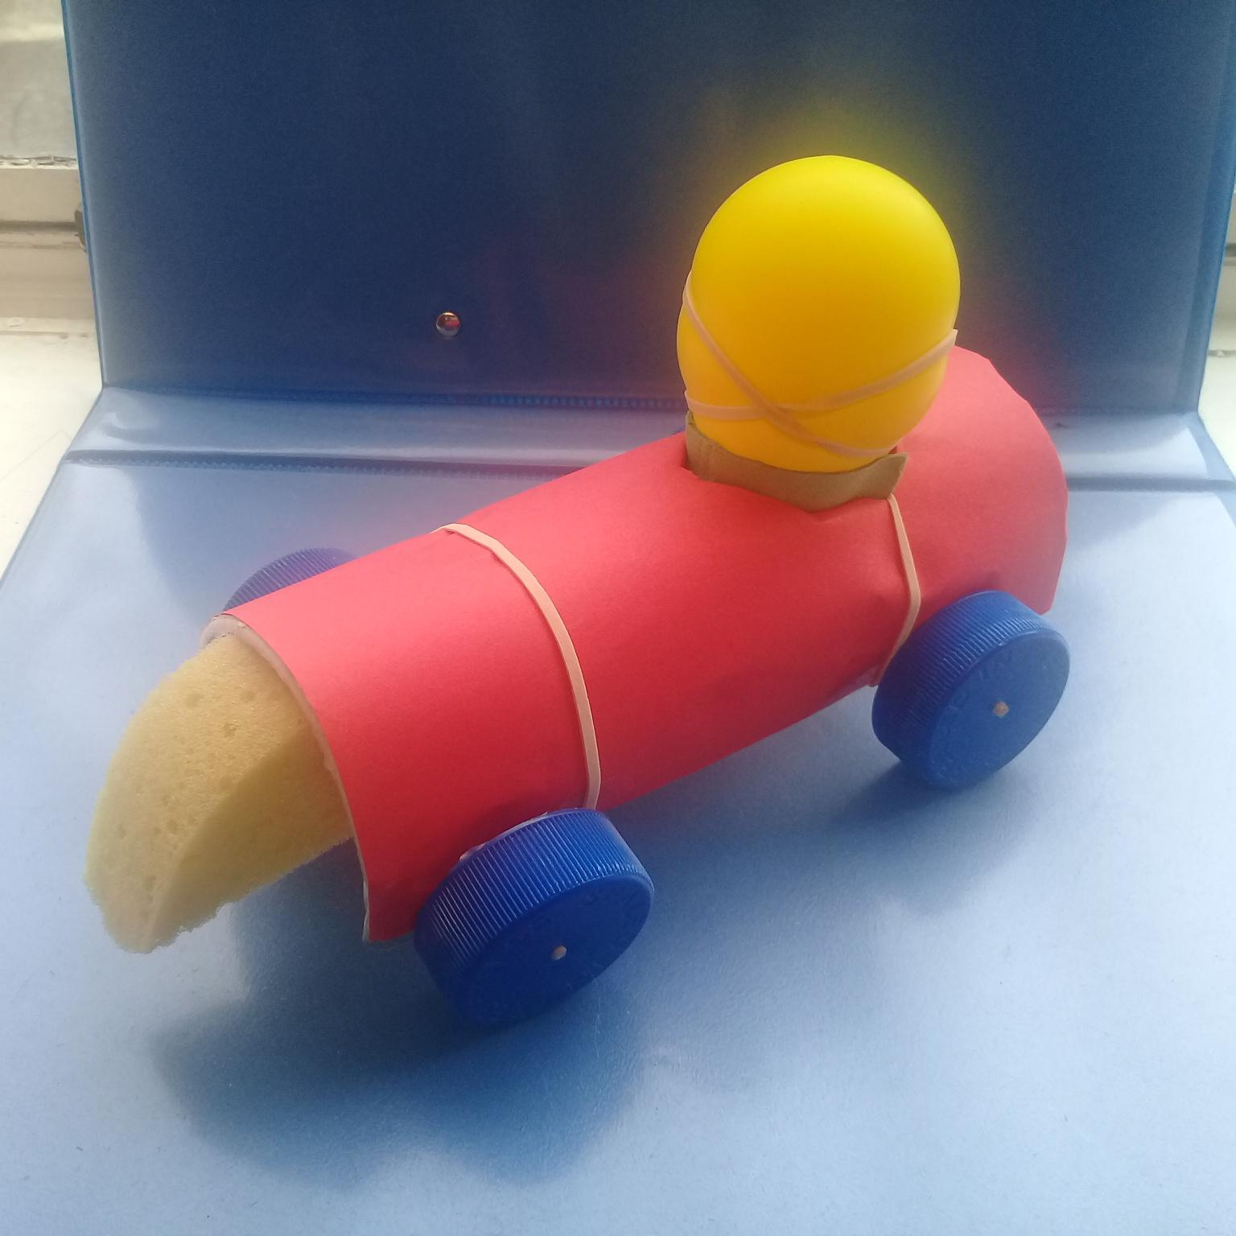
- Egg carton
- 2 straws, cut to 8 cm lengths
- 2 bamboo skewers, cut to 9 cm lengths
- 4 milk bottle tops
- Rubber bands
- Small piece of sponge
- Hardboiled egg or small water balloon
- Small plastic bag
- Tape
- Felt pen
- Ruler
- Scissors
- Metal skewer or nail
- Hot glue gun
- Camera
- Aluminium foil (optional)

Student instructions

- Use the ruler and felt to mark a horizontal line along the length of the container.

- Cut the container in half lengthwise (one container makes two cars). Trim the sides of the container, if necessary, so that it sits level when placed on a flat surface.

- Shorten the length of the container/car body to approximately 15 cm.

- Wrap pieces of tape or rubber bands around the container to stabilise the body.

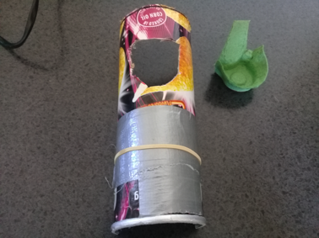
- Cut a ‘bucket seat’ out of an egg carton.

- Attach the seat approximately 3 cm from the end of the container. Cut out the seat well and insert the seat into the body. Use hot glue or rubber bands to keep the seat in place.

- Use the metal skewer or nail to make a hole in the centre of each bottle top.

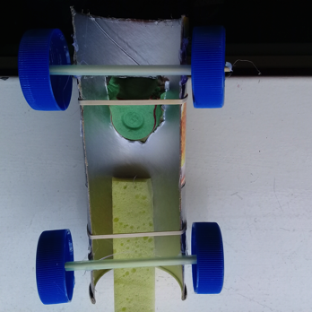
- Insert the skewers through the straws to form the wheel axles. Poke the ends of the skewers through the holes in the bottle tops. Use a hot glue gun to seal the skewer ends to the bottle tops, if necessary.

- Use a hot glue gun to attach the straw axles to the edges of the car body.

- Attach a piece of sponge to the front of the car to act as a bumper.

- Practice rolling the car a few times to make sure it rolls easily. Use tape or rubber bands to balance the body if needed.

Testing seatbelts

- Place the hardboiled egg or water balloon in the passenger seat. (If desired, wrap the egg or balloon in a small plastic bag to minimise the mess.)

- Push the car into a wall to simulate a car crash. Photograph the outcome or measure how far the passenger has been thrown from the car.

- Use two rubber bands to secure the hardboiled egg or water balloon to the seat. One rubber band crosses the passenger as a lap belt, the other as the shoulder harness.

- Push the car into the wall, trying to use the same amount of force as before.

- Observe what happens. Photograph and record the outcome as before.

- Repeat the action, using greater amounts of force (representing faster speeds) both with and without the seatbelt, if desired. Record the results.

Extension ideas/prompting questions for teachers
- This is a scientific model. How do the different parts of the model car represent aspects of an actual vehicle?
- Why are we using models to test car safety features rather than real cars?
- What happens when a vehicle comes to a sudden stop or crashes?
- What happens to the people and items in a vehicle when it comes to a sudden stop?
- How do seat belts protect passengers?
- What difference does speed make when a car crashes?
- What are the connections between car crashes, forces and Newton’s laws of motion?
- How does a car crash demonstrate the transfer of kinetic energy?

Observing crumple zones (optional)

- Have students push the car bumper first into the wall, observing how it bounces backwards, then push the car rear first into the wall, observing the difference in the way it does or does not bounce back.
- Explain that the foam bumper deforms and reforms to its original shape too quickly for us to see.
- To better observe how a crumple zone works, replace the foam bumper with a loosely wadded ball of aluminium foil. Push the car crumple zone first into the wall. View any deformation to the foil ball.
- How do crumple zones – like the bumper and the foil ball – protect passengers?
- Encourage students to experiment with other materials to see how well they absorb and transform the kinetic energy.

