ACTIVITY: Melting glacial ice

Activity idea

In this activity, students investigate the effect that contact with water has on melting ice.

By the end of this activity, students should be able to:
- observe that ice melts faster when in contact with water
- discuss how the activity models the effect that contact with water has on glaciers
- observe and discuss basic energy transfer between the air, water and ice.

Background information for teachers
Equipment required
Teacher instructions
Extension ideas/prompting questions for teachers

Background information for teachers

Climate change causes variations in both temperature and snowfall. Warming temperatures cause glaciers to melt faster than they can accumulate new ice. Warming temperatures also mean some areas will get rain, rather than snow, further lessening ice accumulation. When glaciers lose more ice in the warmer months than they gain in the colder months, they retreat or recede.

As a glacier melts, a river or lake may form at its end. Contact with the water causes the ice to melt more quickly. It can also cause ice cliffs to calve.
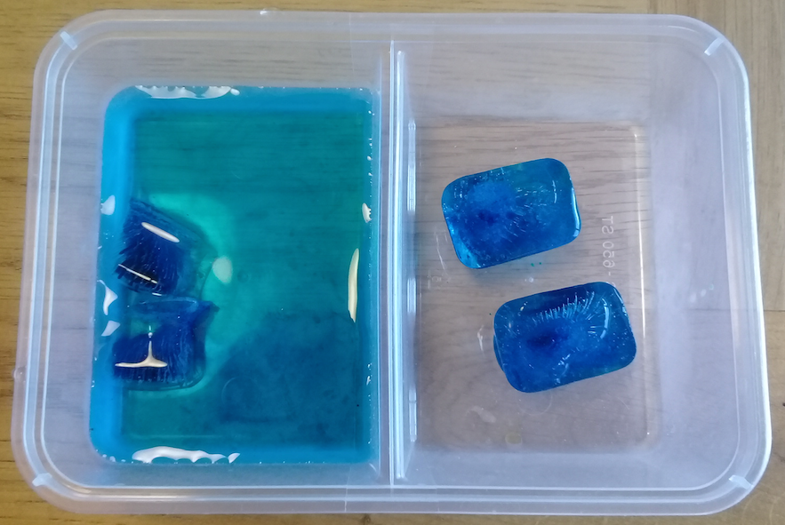
Why ice melts

Changes of state always involve a transfer of energy. Ice melts when heat energy causes the frozen water molecules to move faster. When ice comes into contact with warmer air or water, it absorbs the surrounding energy (heat). The air and water molecules bump against the ice molecules and transfer some of their energy. The increased energy causes the ice molecules to break away, and the water changes state from a solid to a liquid.

Ice melts more quickly in water than air because water is denser – has a greater concentration of molecules – than air. When ice is in water, more molecules bump against it and transfer more heat energy.

New Zealand’s glaciers

New Zealand has over 3,100 known glaciers – 18 are on Mt Ruapehu with the rest in the South Island. From the 1970s to the 1990s, small glacial lakes began to form at the terminus of the big glaciers. These lakes increase ice loss as ice at the front of the glacier calves (breaks off) into them.

Many glaciers – such as the Tasman and Murchison Glaciers – are losing ice as their lakes grow. Tasman Lake began as small meltwater ponds in the 1970s, and it is now more than 7 km long.

The articles Glaciers, Disappearing glaciers and Climate change, melting ice and sea level rise have additional background information.

Equipment required

- Two identical plastic containers or one divided container
- Ice cubes
- Water (room temperature)
- Food colouring (optional)
- Timer or stopwatch

Teacher instructions

- Place an equal number of ice cubes in each container. You can use either regular ice cubes or ice cubes made with coloured water. (Colouring makes no difference to melting. It simply makes it easier to see the ice as it melts. If you use coloured ice, explain why to the students.)

- Add a small amount of water to one of the containers.

- Set the timer or stopwatch. Visit the containers every few minutes to see what is happening.

- While the ice is melting, view videos of glacier melting or collapses (for example, Chasing Ice, Part of Perito Moreno glacier collapses or Franz Josef timelapse retreat).

- Record the time it takes for the ice in each container to melt.

- Use the discussion/prompting questions while introducing the activity, as the ice melts and/or at its completion.

Extension ideas/prompting questions for teachers

- As we set up the activity, what parts are set up the same?
The containers, the amount of ice and the temperature of the air and water.

- What part of the activity set-up is different?
Room temperature water is added to one container.

- Why do you think we have changed this one thing (a variable)?
To make it a fair test and to demonstrate the differing effects of air and water on ice melt.

- We are using the equipment to model how contact with water causes glaciers to melt more quickly. What do the different parts of the model represent – the container, the ice and water?
Container – a part of the world. Ice – a glacier. Water – a stream, river or lake at the terminus of a glacier.

- What do you think will happen in each model?
Answers will vary.

- Were the predictions correct?
Answers will vary.

- What difference does contact with water make to either ice cubes or much larger masses of ice like glaciers and ice shelves?
Contact with water causes ice to melt more quickly.

- Why does ice melt faster when it is in contact with water than with air?
When ice comes into contact with warmer air or water, it absorbs the surrounding energy (heat). Water is denser than air, so its molecules transfer heat at a faster rate than air.

- What impacts do melting glaciers have for New Zealand? (Consider irrigation, tourism, hydroelectricity production and sea level rise.) As glacier ice mass declines, less melt water is available for irrigation and/or hydroelectricity production. Tourists visit glaciers, so glacier loss will impact locations like Franz Josef or Fox Glacier. Freshwater melt from glaciers and ice sheets will cause sea level rise.

- In the article Disappearing glaciers, it says, “Most glaciers are now out of balance with the climate system, and they would continue to retreat even if climate remained stable.” What does this mean? Glacial lakes – like those in front of New Zealand’s Tasman and Murchison Glaciers, increase glacial ice loss. Glaciers require ice accumulation to balance ice melt. Even if the present climate remains stable, it may not be enough to slow ice loss.

