ACTIVITY: Investigating sea level rise

Activity idea

In this activity, students build simple models to demonstrate the differing impacts of melting land ice and sea ice on sea level rise.

By the end of this activity, students should be able to:
- identify that ice floating in water does not change the volume of water when it melts
- discuss how the activity models the link between melting land ice and sea level rise
- make predictions about the potential impacts of melting land ice and sea ice.

Background information for teachers
Equipment required
Student instructions
Extension ideas/prompting questions for teachers

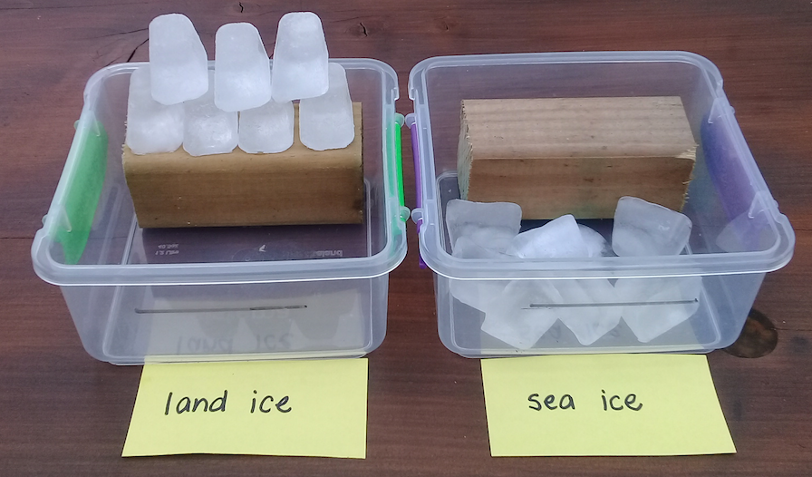
Background information for teachers

One implication of climate change is sea level rise. Although warmer global temperatures are impacting both land ice and sea ice, melting land ice is primarily responsible for sea level rise.

Glaciers, ice shelves and ice sheets are land ice. When meltwater moves from the land to the sea, it increases the volume of water in the sea.
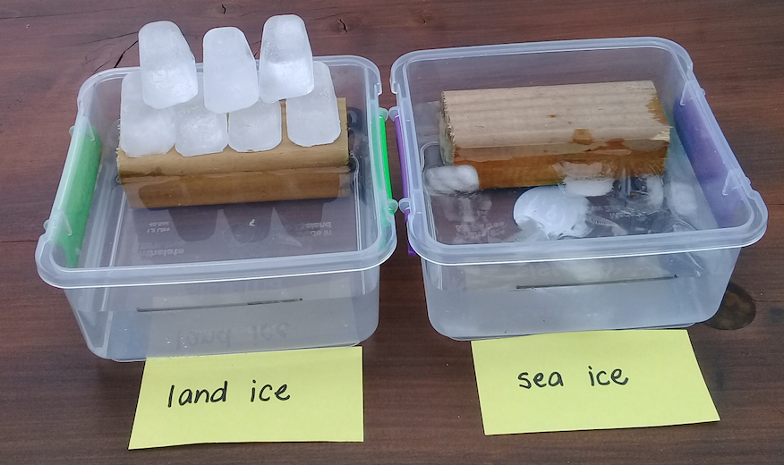
Sea ice forms, grows and melts in the sea. Because sea ice is already floating in the sea, it causes minimal change to the total volume of seawater.

Scientists estimate that, in the 10-year period between 1994 and 2004, melting sea ice was responsible for just 1.6% of sea level rise.

Consider using this activity in conjunction with the articles Disappearing glaciers and Climate change, melting ice and sea level rise and the activities Melting glacial ice and Temperature, salinity and water density.

Equipment required

- 2 plastic containers
- Wooden blocks (or LEGO bricks)
- Paper to label the containers
- Blu-Tack or similar
- Ruler
- Whiteboard felt
- Ice cubes
- Jug of water
- Camera (optional)

Student instructions

- Place Blu-Tack on the bottom and back of each wooden block and press them down in the containers. The Blu-Tack keeps the blocks from floating when the water is added.

- Use the ruler and whiteboard felt to measure and mark identical fill lines on the plastic containers. Mark the line about 1 cm below the level of the wooden block ‘land masses’.

- Add an equal number of ice cubes to each container. Ice cubes sitting on the wooden block in the first container represent a glacier or other form of land ice. Ice cubes in the open part of the second container represent sea ice. Label both containers appropriately.

- Fill both trays with water to the fill line.

- Watch what happens to both the ice and the water levels.

- Take photos of the models as melting takes place, if desired.

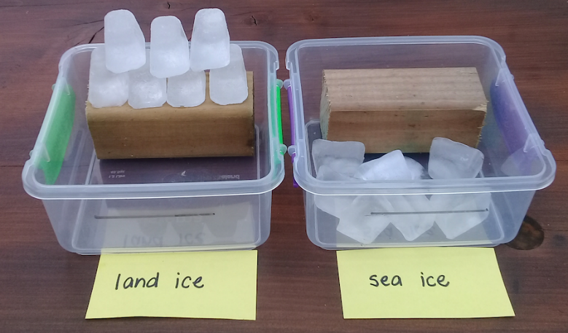

Extension ideas/prompting questions for teachers
- As we set up the activity, what parts are set up the same?
The trays, wooden blocks (land masses), number of ice cubes and initial water levels.

- What part of the activity set-up is different?
Ice cubes representing the land ice are on the wooden block (land). Ice cubes representing the sea ice are in the open part of the container (the sea).

- Why do you think we have changed this one thing (a variable)?
Fair test. To demonstrate the difference between land ice and sea ice.

- We are using the equipment to model the impact of melting land ice and sea ice on the sea level. What do the different parts of the model represent – the trays, the wooden blocks, the water level and the ice?
Tray – a part of the world. Wooden block – a landmass like the coast. Water level – sea level. Ice on land could represent glaciers or the ice sheets. Ice in the water could represent icebergs or floating sea ice.

- What is land ice? Where might we find it?
Land ice is frozen freshwater. Glaciers, ice shelves or ice sheets are land ice. Glaciers are found on all continents except Australia. In New Zealand, there are a few glaciers round Mt Ruapehu but most are in the South Island. Ice shelves are found in Antarctica, Greenland and the Arctic. Ice sheets are only found in Antarctica and Greenland.

- What is sea ice? Where might we find it?
Sea ice is frozen seawater. Sea ice is found in both the Arctic and Antarctic regions.

- What do you think will happen with each model?
Answers will vary.

- Were the predictions correct?
Answers will vary.

- What difference did the melting ice make to the sea level in each container?
Melting land ice should have raised the water level above the marked line, and it may have covered some of the land (wooden block). With melting sea ice, the difference is minimal if noticeable at all.

- What impacts do you think the melted ice will have on the land? On the sea? On the future climate?
Melting glaciers are sources of freshwater. If they grow smaller, less meltwater may be available during the warmer months. Rising sea levels may cause coastal erosion. Melting freshwater may impact the ocean’s chemical and physical properties. Melting sea ice may expose the darker ocean surface, absorbing more solar energy. Both will impact future climate.

- Does New Zealand have land ice? What impacts do you think melting land ice might have for New Zealand? Yes. Melting/disappearing glaciers may impact/limit freshwater sources for irrigation and hydroelectricity production.

- Does New Zealand have sea ice? What impacts do you think melting sea ice might have for New Zealand? No, but melting sea ice in the Southern Ocean will impact New Zealand.

- Are there actions we can take to slow ice melt?
We can all take individual actions to reduce our carbon footprint and potentially slow climate change.

