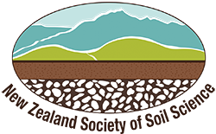
Soil theme: Nutrients

Agricultural exports form a sizeable part of New Zealand’s economy. Our farms are dependent on healthy, fertile soils. The cycling of nitrogen and phosphorus is fully dependent on soil processes. We also increase soil fertility through the use of fertilisers and clover. Adding nutrients allows for more intensified farming, but the nutrients need careful management to avoid environmental impacts.

This topic planner offers a suggested pathway through Science Learning Hub education resources. Click on the links below to create you own personalised teaching unit. Please note that most articles have accompanying videos (see the Related Content box on the right-hand side of each article). Feel free to use this material in any combination or order.

Soil nutrients

Focus questions: What are nutrients? How do they get into the soil?

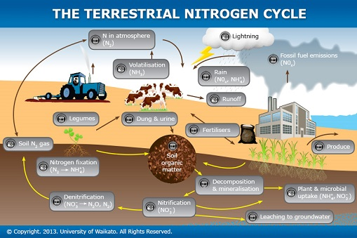 | 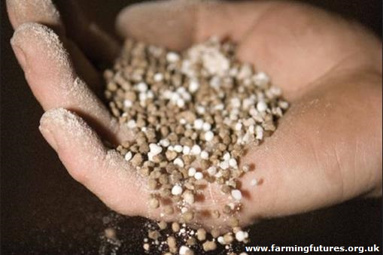

Images from www.sciencelearn.org.nz.

- Article > The nitrogen cycle

- Article > The phosphorus cycle

- Article > Fertiliser

- Article > The role of clover
Activities – use these activities to expand on the focus questions:

- Interactive nitrogen cycle:
The terrestrial nitrogen cycle
- Observe clover nodules to see if they are fixing nitrogen:
Clover and nitrogen fixation
- Follow some of the processes of the nitrogen cycle in a jar of sand:
Nitrification and denitrification
Environmental impacts

Focus questions: Why are nutrients a concern? How do they impact on the environment?

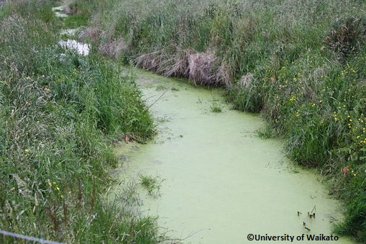 | 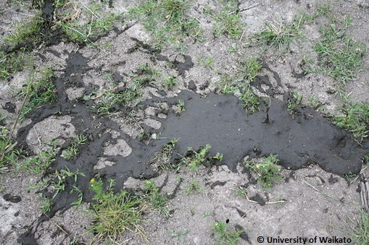

- Article > Farming and environmental pollution
- Video > Nutrient leaching

Activities – use these activities to expand on the focus questions:

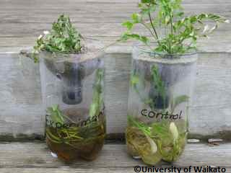 | 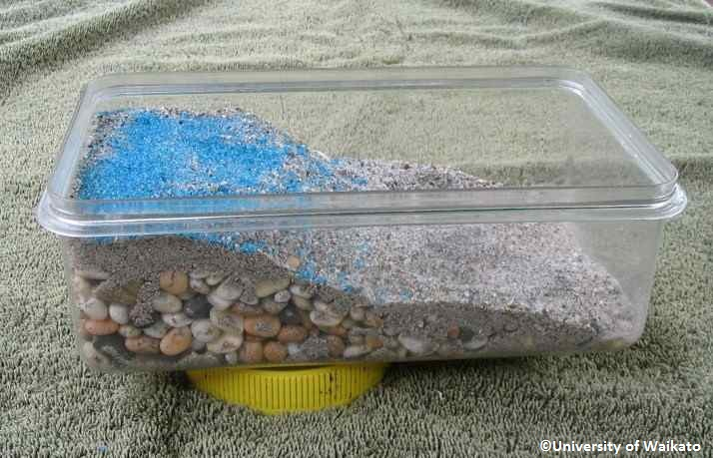

- Simulate the link between land use and water quality
Nutrient impact experiment
- Build an aquifer model to look at point source and non-point source pollution:
Groundwater contamination

Nutrient management

Focus question: How can we manage nutrients to minimise environmental impacts?

- Article > Managing nutrients

- Article > Farm management practices
- Article > Inhibiting nitrous oxide emissions
- Article > Focusing on phosphorus
- Article > Denitrification beds – a creative approach

Activities – use these activities to expand on the focus question:

Revisit the Nutrient impact experiment and the Groundwater contamination activities. Use information from the articles to discuss or devise ways of preventing the nutrients from impacting on water quality.

This resource supports NZC Science levels 2/3/4

NATURE OF SCIENCE: INVESTIGATING IN SCIENCE: Extend experiences and personal explanations of the natural world; explore simple models to develop simple explanations.
- PLANET EARTH AND BEYOND: EARTH SYSTEMS: Explore and describe natural features and resources.
- PLANET EARTH AND BEYOND: INTERACTING SYSTEMS: Describe how natural features are changed and resources affected by natural events, the water cycle and human actions.

Contact details

The Science Learning Hub is a national project funded by the New Zealand Government to make examples of New Zealand science, technology and engineering more accessible to school teachers and students.  E: enquiries@sciencelearn.org.nz  W: www.sciencelearn.org.nz | The New Zealand Society of Soil Science is a professional society to encourage the advancement of soil science. One of its goals is to promote the study of soils at all educational levels.  W: nzsss.science.org.nz

