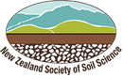
Soil theme: Is all soil the same?

The New Zealand landscape is amazingly diverse. As the landscape changes, so do the underlying types of soil. These changes are due to how the soil was formed. As a result, there are significant differences in the appearance of soils, their chemical and physical properties and how we use the land. If you thought soil is the same across the country – think again!

This topic planner offers a suggested pathway through Science Learning Hub education resources and makes links with the NZ Soils website. Click on the links below to create your own personalised teaching unit. Feel free to use this material in any combination or order.

Exploring the theme

Focus questions: These photos show different landscapes around New Zealand. What makes one landscape different from another? Are they also different under the ground?

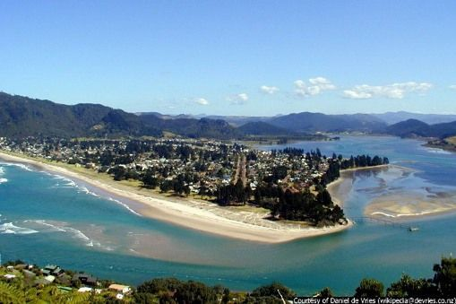 | 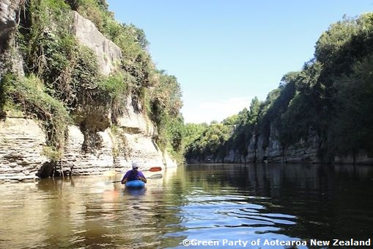 | 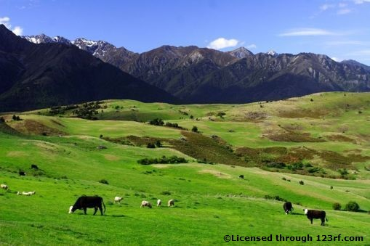 | 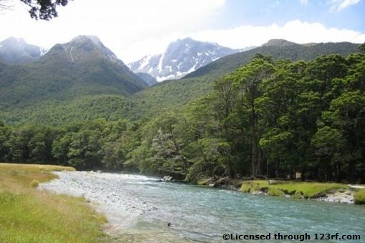

Images from https://www.sciencelearn.org.nz/.

- https://www.sciencelearn.org.nz/images/136-pauanui
- https://www.sciencelearn.org.nz/images/479-mokau-river-gorge
- https://www.sciencelearn.org.nz/images/1237-new-zealand-countryside
- https://www.sciencelearn.org.nz/images/1771-river-edge

Understanding the theme

Focus questions: Why does the soil vary from one landscape to another? How is soil formed?

- Article > Soil formation
- Article > Soil properties
- Video > Soil formation
- NZ Soils article > Soil formation
- NZ Soils article > Why and how are soils different?

Applying the theme

Focus question: What types of soils are there in my area?

- Article > Soil names
- NZ Soils interactive map > Soil orders of New Zealand
- NZ Soils > Regional soils records (See PDF document at the bottom of the page.)
- NZ Soils > Soils picture resource
Experiencing the theme

Activities – use these activities to expand on the focus questions:

- Making a core sample
- Visual soil assessment

This resource supports NZC Science levels 2/3/4

      - NATURE OF SCIENCE: INVESTIGATING IN SCIENCE: Extend experiences and personal explanations of the natural world; explore simple models to develop simple explanations.
- PLANET EARTH AND BEYOND: EARTH SYSTEMS: Explore and describe natural features and resources.
- PLANET EARTH AND BEYOND: INTERACTING SYSTEMS: Describe how natural features are changed and resources affected by natural events, the water cycle and human actions.

Contact details

The Science Learning Hub is a national project funded by the New Zealand Government to make examples of New Zealand science, technology and engineering more accessible to school teachers and students.  E: enquiries@sciencelearn.org.nz  W: www.sciencelearn.org.nz | The New Zealand Society of Soil Science is a professional society to encourage the advancement of soil science. One of its goals is to promote the study of soils at all educational levels.  W: nzsss.science.org.nz

