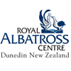
Flight theme: Albatross

Birds that fly have wings. They also have streamlined bodies, light internal or external skeletons, a large heart and strong flight muscles.

This topic planner offers a suggested pathway through Science Learning Hub education resources and connects to relevant programmes offered by the Royal Albatross Centre. Click on the links below to create your own personalised teaching unit. Feel free to use this material in any combination or order.

Flight and feathers

Focus question: Albatross fly more than 1000 km a day. What special features do birds have for flight, and how are albatross similar and different to other birds?

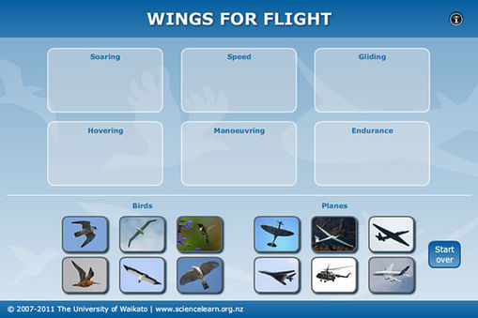
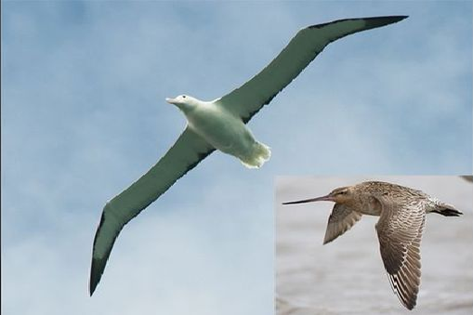

Images from https://www.sciencelearn.org.nz/

- Article > How birds fly
- Article > Principles of flight
- Video > Godwits in flight
- Video > How do they do it?

Activities – use these activities to expand on the focus question:

- Compare the flight capabilities of planes with birds, matching those that are the most similar.
Wings for flight interactive

- Learn to make an aerofoil wing shape (found on planes and birds) and experiment with flying paper planes.
Aerofoils and paper planes

Adaptations for flight

Flight and Feathers

Focus question: Albatross feathers are like other bird feathers. How are different types of feathers designed for flight?
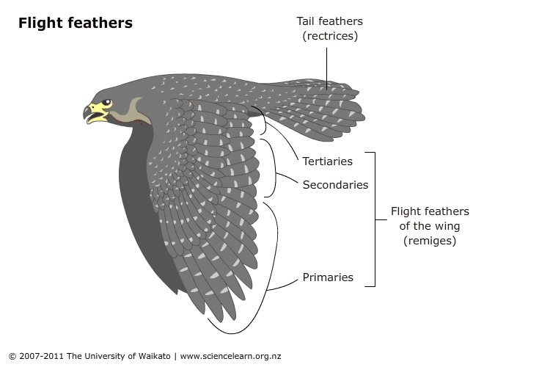
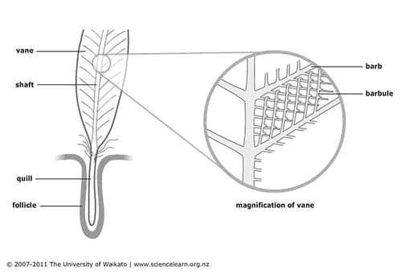

Images from https://www.sciencelearn.org.nz/

- Article > Feathers and flight

- Article > Wings with feathers

Activities – use these activities to expand on the focus question:
- RAC – Flight and Feathers student worksheet.

- RAC – Getting to know the Royal Albatross worksheet.

Flight patterns

Focus question: Albatross are known to travel to Chile and godwits are known to have one of the longest migratory distances of any bird. How can we follow the flight pattern of different migratory birds?

- Article > Tracking godwits
- Video > Satellite tagging
- Video > The impact of transmitters
- Video > The longest flight

Activities – use these activities to expand on the focus question:

- Explore the migratory path of a godwit.
Tracking E7

This resource supports NZC Science Level 3/4

NATURE OF SCIENCE: UNDERSTANDING ABOUT SCIENCE: Appreciate that science is a way of explaining the world and that science knowledge changes over time.

- LIVING WORLD: ECOLOGY: Explain how living things are suited to their particular habitat and how they respond to environmental changes, both natural and human induced.

- LIVING WORLD: LIFE PROCESSES: Recognise that there are life processes common to all living things and that these occur in different ways.

Contact details

The Royal Albatross Centre on Otago Peninsula offers field trips, programmes and resources for learning about flight, ecology and conservation of New Zealand seabirds for primary and secondary schools in southern New Zealand.  T: 03 478-0499  E: education@albatross.org.nz  W: www.school.albatross.org.nz | The Science Learning Hub is a national project funded by the New Zealand Government to make examples of New Zealand science, technology and engineering more accessible to school teachers and students.  E: enquiries@sciencelearn.org.nz  W: www.sciencelearn.org.nz

