ACTIVITY: Labelling the heart

Activity idea

The heart is a muscular organ that pumps blood through the blood vessels of the circulatory system. Blood transports oxygen and nutrients to the body. It is also involved in the removal of metabolic wastes.

In this activity, students use online and paper resources to identify and label the main parts of the heart.

By the end of this activity, students should be able to:
- identify the main parts of a heart
- describe the functions of the different parts of the heart.

Background information for teachers
Student instructions
Activity answers

Background information for teachers

The human body requires oxygen and nutrients to reach every living cell. It does this through a complex circulatory system made up of blood vessels. This network contains large vessels – arteries and veins – down to very small capillaries that deliver oxygen to cells and carry away cellular waste products. The structure of the human heart is designed to pump 60–90 ml of blood out of the heart each minute (moving 5–7 litres around the body) and beats on average 70 times per minute.

Use the following resources to support your students’ learning about the heart.
- Video animation The beating heart
- Video animation How blood flows through the heart
- Interactive Label the heart

The interactive can also be used as a formative or summative tool for learning.

Student instructions

- Watch the video animation How blood flows through the heart.

- Cut up and label the parts of the heart on the Label the heart diagram.

- Cut up the function descriptions below and match them with the parts of the heart.

- Draw arrows on the diagram showing the direction of blood flow through the heart.

- Cut up the descriptions of how blood flows through the heart below and match them with the arrows you have drawn.

- Use the interactive Label the heart to check your learning.

Function descriptions

Carries blood from the lungs | Region of the heart that pumps blood to the lungs | Segment of the heart that receives deoxygenated blood
Receives oxygenated blood from the lungs | The main artery carrying blood to all parts of the body | Carries blood to the lungs
Region of the heart that pumps blood to the body | Flaps that prevent backflow of blood | Carries deoxygenated blood from the body to the heart

How blood flows through the heart

Blood leaves the heart through the pulmonic valve into the pulmonary artery and flows to the lungs. | Blood flows from the right atrium into the right ventricle through the tricuspid valve. When the ventricle is full, the tricuspid valve shuts to prevent blood flowing backwards into the atrium.
Blood enters the heart through two large veins – the posterior (inferior) and the anterior (superior) vena cava – carrying deoxygenated blood from the body into the right atrium. | Blood flows from the left atrium into the left ventricle through the open mitral valve. When the ventricle is full, the mitral valve shuts to prevent blood from flowing backwards into the atrium.
Blood leaves the heart through the aortic valve into the aorta and to the rest of the body. | The pulmonary vein carries oxygen-rich blood from the lungs into the left atrium.

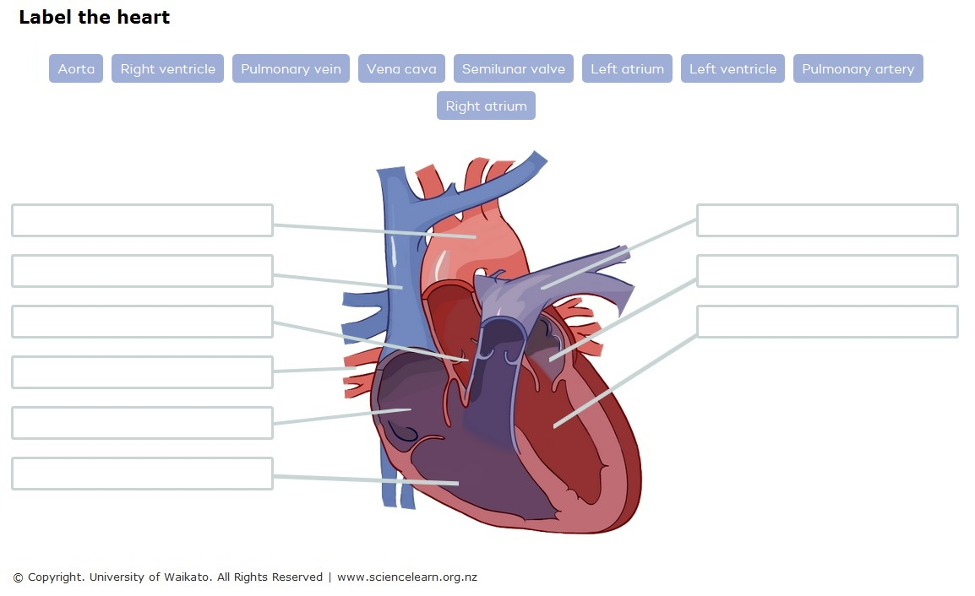
Activity answers

