ACTIVITY: Whio feathers – what are they for?

Activity idea

In this activity, students will use their observation skills and some resource materials to classify feathers into the three different types. They will also explore some of the properties of the feathers. Although this activity focuses on whio feathers, it can easily be adapted to other birds.

By the end of this activity, students should be able to:
- identify and distinguish the three different types of feathers
- explain the relationship between the structure and function of the types of feathers
- explain how the oils on feathers help with waterproofing
- explain how feathers retain warmth.

Background information for teachers
Equipment required
Student instructions
Extension ideas/prompting questions for teachers

Background information for teachers

Ducks have three main types of feathers: flight, contour and down feathers. Each type of feather provides a different function:
- Flight feathers are long and strong and are precisely aligned with the help of tiny barbs that hold the feathers securely in place during flight.
- Contour feathers provide the bird’s shape and colour. They also have barbs and overlap to help create a waterproof coat, with air pockets trapped underneath for buoyancy and warmth.
- Down feathers are fluffy and soft for warmth and have no barbs.
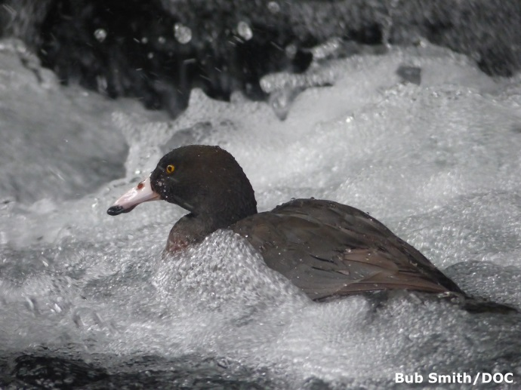
As whio live in very cold water, the insulating and waterproofing properties of feathers are very important. Preening is important for whio as this works natural waterproofing oils into the birds’ feathers. The article Fantastic whio feathers has further background information.

You may ask or help the students to create a table to record their observations in addition to or instead of the Venn diagram provided.

As this is a Word document, it is easily modified to suit your students.

Equipment required

Per group:
- A selection of bird feathers (make sure you have feathers that represent all three types)
- Duck feathers diagram
- Magnifying glass
- Printed Venn diagram (A3 size)
- Oil (1–2 ml)
- Toothpick
- Small paint brush
- Basin of water

Student instructions

Part 1: Sorting

- In your groups, look carefully at the feathers you have been given. By carefully observing, using the duck feathers diagram and discussing your ideas with each other, sort the feathers into the three different types – contour, flight and down feathers.

- Discuss these questions:
- What criteria/observations did you use to make your decisions?
- Are you sure your decisions are correct?
- Did everyone agree?
- What skills did you use while sorting the feathers?

Part 2: Experimenting

Feather observations

For each of the different types of feathers, carry out the following investigations to explore the similarities and differences. Record your observations onto the Venn diagram and/or in a table.

- Look at the feathers carefully through the magnifying glass.
- What colour are they?
- What other things do you notice about the different types of feathers?
- How do they feel?

- Drop the feathers and see how they fall.

- Put them into water and observe how they behave.
- How waterproof are they?
- How well do they float?

- Drop water on them while holding them by the quill.

How do ducks waterproof their feathers?

- Use a toothpick to put a drop of oil onto the quill of the different types of feathers. Use a little paintbrush to ‘preen’ the feather – spreading the oil thinly over the surface.

- Put the feathers in water and record your observations.
- Do you think the oil makes each feather more or less waterproof?
- Does it make a difference to the way each feather floats?
- Does the oil have the same effect on all three different types of feathers? Why do you think this may be?
- Do you think the oil used in this investigation is the same as the oils produced by the preening gland at the base of a duck’s tail?

Part 3: Thinking

- Look at the duck feathers diagram and identify what role each of the feathers has.

- Look carefully again at the feathers and, using the information from your Venn diagram and/or table, discuss these questions:
- How is a down feather designed to do its job?
- How is a flight feather designed to do its job?
- How is a contour feather designed to do its job?
- Do you think that all the feather types could do all these jobs? Why or why not?
- How do feathers keep whio warm?
