ACTIVITY: Which duck is which?

Activity idea

In this activity, students will use resource materials to identify the features of a variety of New Zealand duck species.

By the end of this activity, students should be able to:
- use their observation skills to identify similarities and differences between some species of New Zealand ducks
- use their literacy skills to identify key words and phrases related to the identification of some New Zealand ducks
- use a Venn diagram to classify the identified similarities and differences.

Background information for teachers
Equipment required
Student instructions
Extension ideas/prompting questions for teachers

Background information for teachers
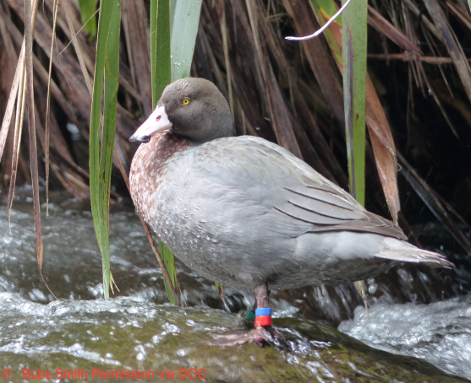
New Zealand is home to a wide variety of water birds, including many species of ducks. Most of these are native, many endemic, while others have naturalised here or have been introduced. The conservation status of many of our ducks is not ideal: at least seven native New Zealand duck species are extinct and several are endangered.

Many people mistake ducks of different species. For example, the grey duck/pārera is often mistaken for the mallard, and although it is endangered, it remains on the game bird list due to people being unable to distinguish between the two species.

In order to engage students in conservation ideas, it is important that they know what organisms are involved and build an understanding of their features and needs.
Building an understanding that all ducks are not the same lends itself to discussions about classification, whakapapa, relationships, ecosystems, ecological niche, habitats and adaptations, endemic versus native etc.

This is one of a set of three activities designed to support students to identify the differences between different duck species. This activity is designed to be adapted to meet student needs, and the questions and instructions can be altered depending on your students’ interests, experience, prior knowledge and age.

Part A is designed for more junior students and is primarily an observation activity, asking students to identify similarities and differences between different ducks.

Part B is primarily a literacy activity designed for older students asking them to elicit simple keywords and phrases from the information cards they are given.

Both parts of the activity ask students to use a Venn diagram to classify the similarities and differences between different duck species.

You may need to clarify the difference between the terms endemic, native, naturalised and introduced with your students.
- Endemic – a species that is native to only one location. For example, species endemic to New Zealand naturally occur only in New Zealand but may have been introduced elsewhere in the world.
- Native – a species that lives naturally in a country as opposed to species that have been introduced by the activity of humans. Species can be a native of more than one country, for example, mānuka is native to both New Zealand and Australia.
- Naturalised – a species that has established a population naturally in a country other than where it originated. These species, once established, are considered native.
- Introduced – an animal or plant that has been transferred by humans, either intentionally or by accident, to somewhere it does not live naturally.

Equipment required

Part A:
- New Zealand ducks – photo cards (one per group)
- Similarities and differences chart
- Similarities and differences: native and introduced ducks (one per pair)
Part B:
- Duck information cards (PDF) (one set per group)
- Similarities and differences: native and introduced ducks (one per pair)

Student instructions

Part A: Spot the difference – observation

- As a group, look carefully at the New Zealand ducks photo card.

- In pairs, discuss these questions:
- What do the ducks have in common?
- How are they different?

- Write your ideas into the Similarities and differences chart.

- The mallard duck is the only non-native duck on the New Zealand ducks photo card. Choose one of the native ducks and label the Similarities and differences: native and introduced ducks Venn diagram with mallard on one side and your chosen native duck on the other side.

- Look carefully at the photo of your chosen duck and see how it compares to the mallard.

- Put your ideas into the Venn diagram, writing the similarities in the centre and the differences in the appropriate sides of the diagram.

- Share your ideas with another group and discuss these questions:
- Could you tell these ducks apart if you saw them?
- What are the main identifying features for each species?
- What skills did you use during this activity?

Part B: Spot the difference – literacy

- As a group, read the Duck information cards PDF and sort them into two groups – introduced or native.

- In pairs, choose one introduced duck and one native duck and fill in the Similarities and differences: native and introduced ducks Venn diagram with their names.

- Read the two cards you have chosen and discuss with each other what the similarities and differences are between your ducks. Using the information on the cards, put as many ideas as you can into the Venn diagram, with similarities in the centre and the differences in the appropriate sides of the diagram.

- Share your ideas with another group and discuss these questions:
- Could you tell these ducks apart if you saw them?
- What are the main identifying features for each species?
- Why could being able to identify different ducks be important?
- What skills did you use during this activity?

New Zealand ducks – photo cards
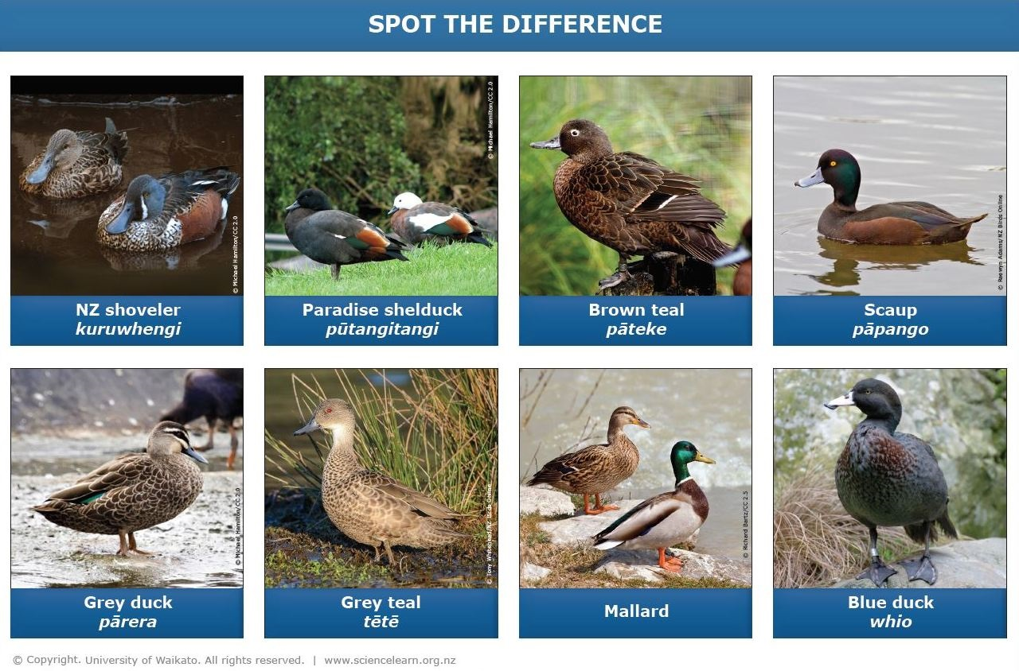

Similarities and differences chart

Similarities:  What do the ducks have in common? | Differences:  How are the ducks different? | What are you not sure about?

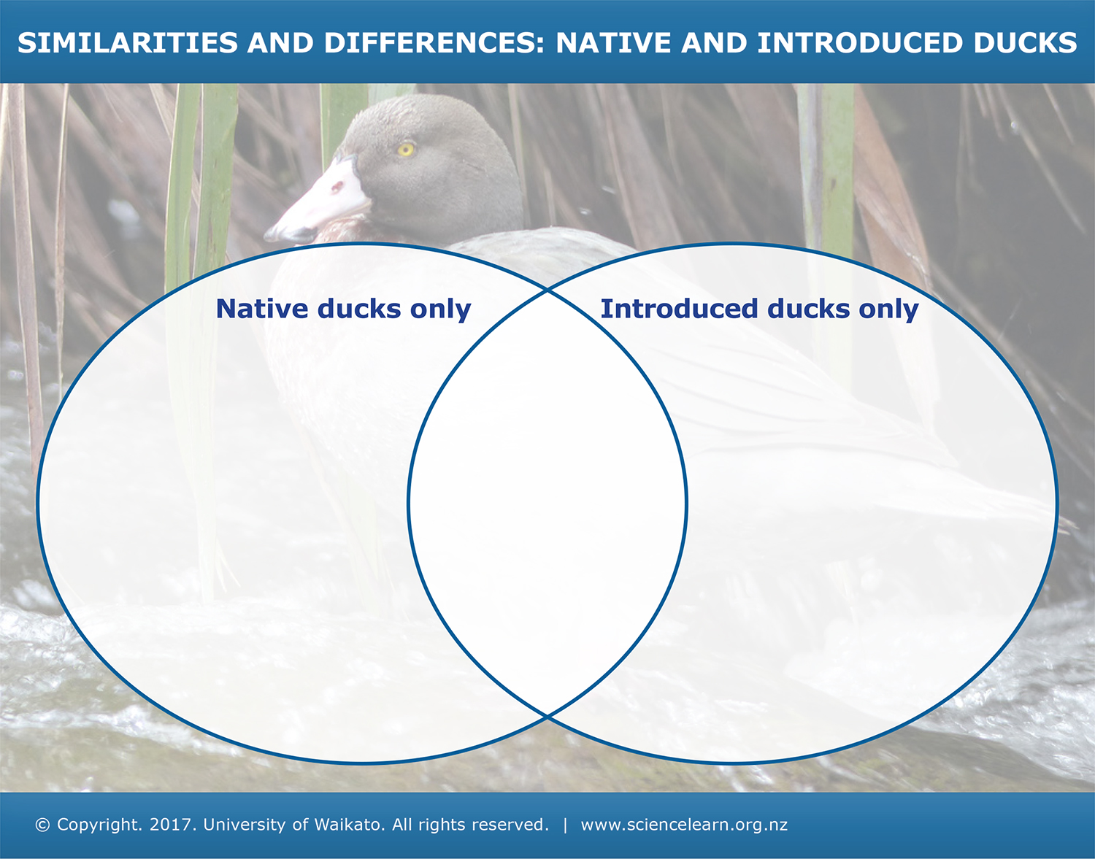

Extension ideas/prompting questions for teachers

You may use a reduced/selected variety of duck cards, depending on the context. For example:
- two easily mistaken ducks are the grey duck/pārera and the mallard, and you may choose to use just these two species
- mallards are common and blue ducks/whio are uncommon, so you may choose to simply focus on these two.

You may want to encourage your students to extend their research to:
- explore what conservation threat levels mean
- find out more about particular ducks
- explore duck habitats, adaptations or ecosystems.

