ACTIVITY: Whio habitats and conservation

Activity idea

In this science literacy activity, students will use resource materials to build their understandings of the whio/blue duck.

By the end of this activity, students should be able to:
- describe the habitat of the whio/blue duck
- identify the conservation threat level of a range of New Zealand ducks, including the whio/blue duck
- interpret the information provided in graph form.

Background information for teachers
Equipment required
Student instructions
Extension ideas/prompting questions for teachers

Background information for teachers

The conservation status of many New Zealand ducks is not ideal. At least seven native New Zealand duck species are extinct, and several are still endangered. One of the most endangered species is the whio/blue duck. One of the main reasons for the decline in whio/blue duck numbers is loss of habitat.

This is a science literacy activity designed to support students to develop their skills in reading and interpreting information presented in a variety of formats. In this activity, students will use resource materials to build their understandings about the whio/blue duck habitat and conservation threat level.

The activity is designed to be easily adapted by teachers to meet student requirements, age, level and ability.

Both parts of the activity are designed to be done as pairs but can be carried out as individuals or in groups:
- The first part asks students to use a New Zealand conservation threat level chart and duck information cards to rank the ducks in order of conservation status.
- The second part asks students to match photos with written information to identify and describe whio/blue duck habitat.

These activities can lead to conversations about classification, whakapapa, relationships, ecosystems, ecological niche, habitats and adaptations, endemic versus native and so on and can form the basis of a conservation inquiry. They may also prompt discussions about how scientists prioritise action.

Equipment required (per pair)

- New Zealand duck names
- A set of Duck information cards or Duck fact cards depending on the literacy level of your students – these are downloadable as separate documents
- New Zealand conservation threat level worksheet
- New Zealand Threat Classification System chart
- Habitat cards
- Scissors
- Glue
Student instructions

New Zealand conservation threat level

- Look at the duck names sheet and cut them out.

- Read the duck information provided by your teacher.

- Discuss the conservation status of each duck species and arrange the duck names from most endangered to least endangered.

- Place the names where you think they fit onto the New Zealand conservation threat level worksheet.

- Use the New Zealand Threat Classification System chart to check your answers and glue the names onto the worksheet.

- Answer these questions.
- Which duck is the most endangered?
- Which duck is the least endangered?
- Why do you think some of these ducks are endangered? How could you find out?
- Which ducks were the most difficult to classify? Why?
- Why do you think it is important to be able to classify how threatened a species of duck is?

Whio habitats

- In your pairs, look for the information provided about the blue duck/whio and read it.

- Look for information that describes the habitat of the blue duck/whio.

- Look at the habitat cards and select any that you think match the description of the places blue duck/whio like to live.

- Answer these questions:
- Explain why you chose each card you selected.
- Discuss why each of the other cards represented a habitat in which the whio/blue duck couldn’t live.
- What makes the whio/blue duck well adapted to this habitat?
- Explain why any of the other ducks described in the information provided couldn’t live in the habitat you chose.
- What aspects of the habitat can’t easily be seen in the habitat photos but are very important for the survival of the whio/blue duck?
- Why do you think the whio are endangered?

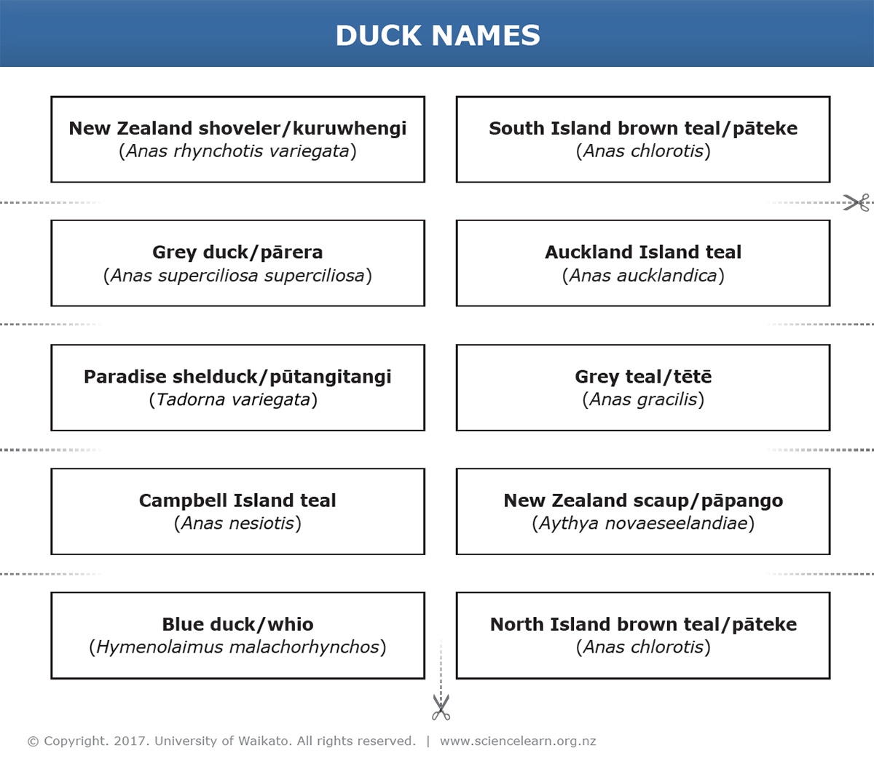

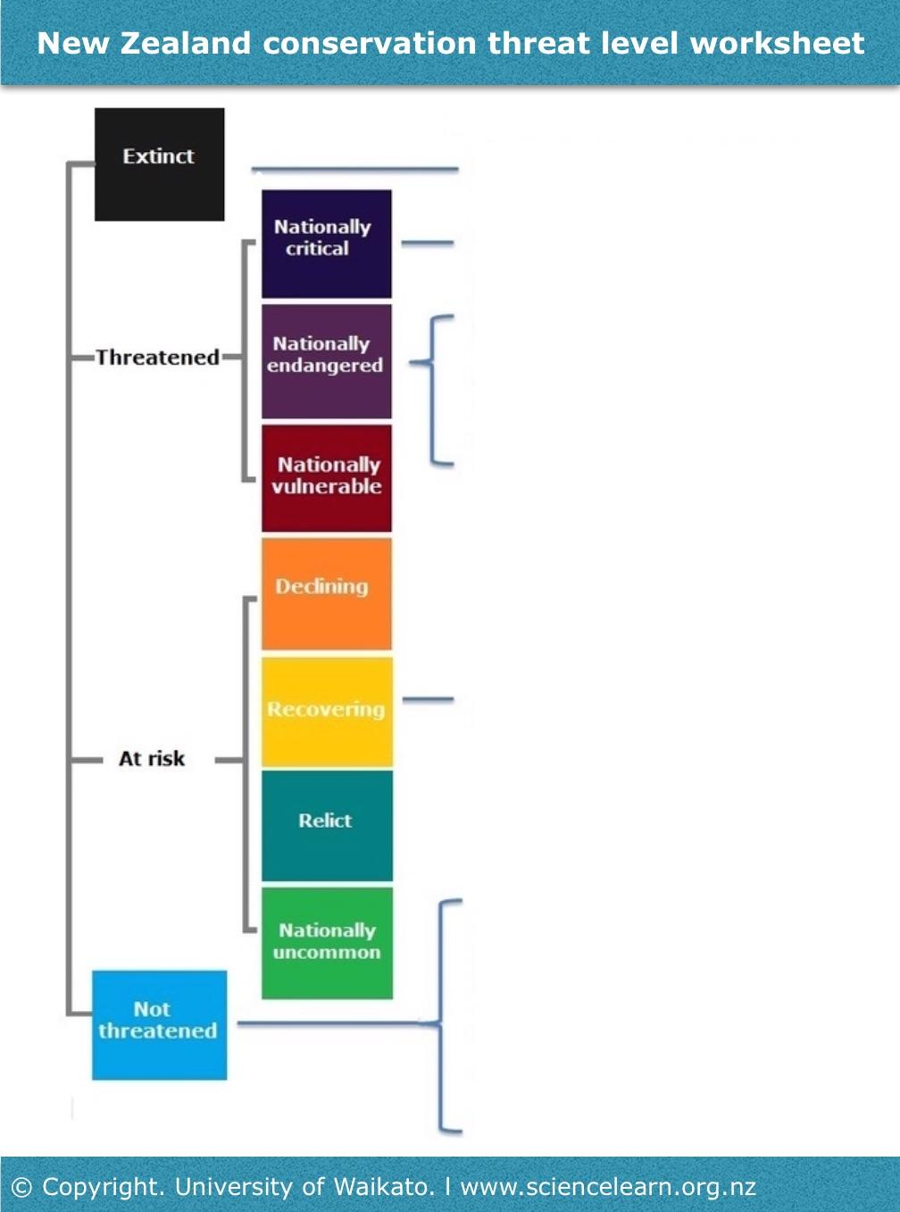

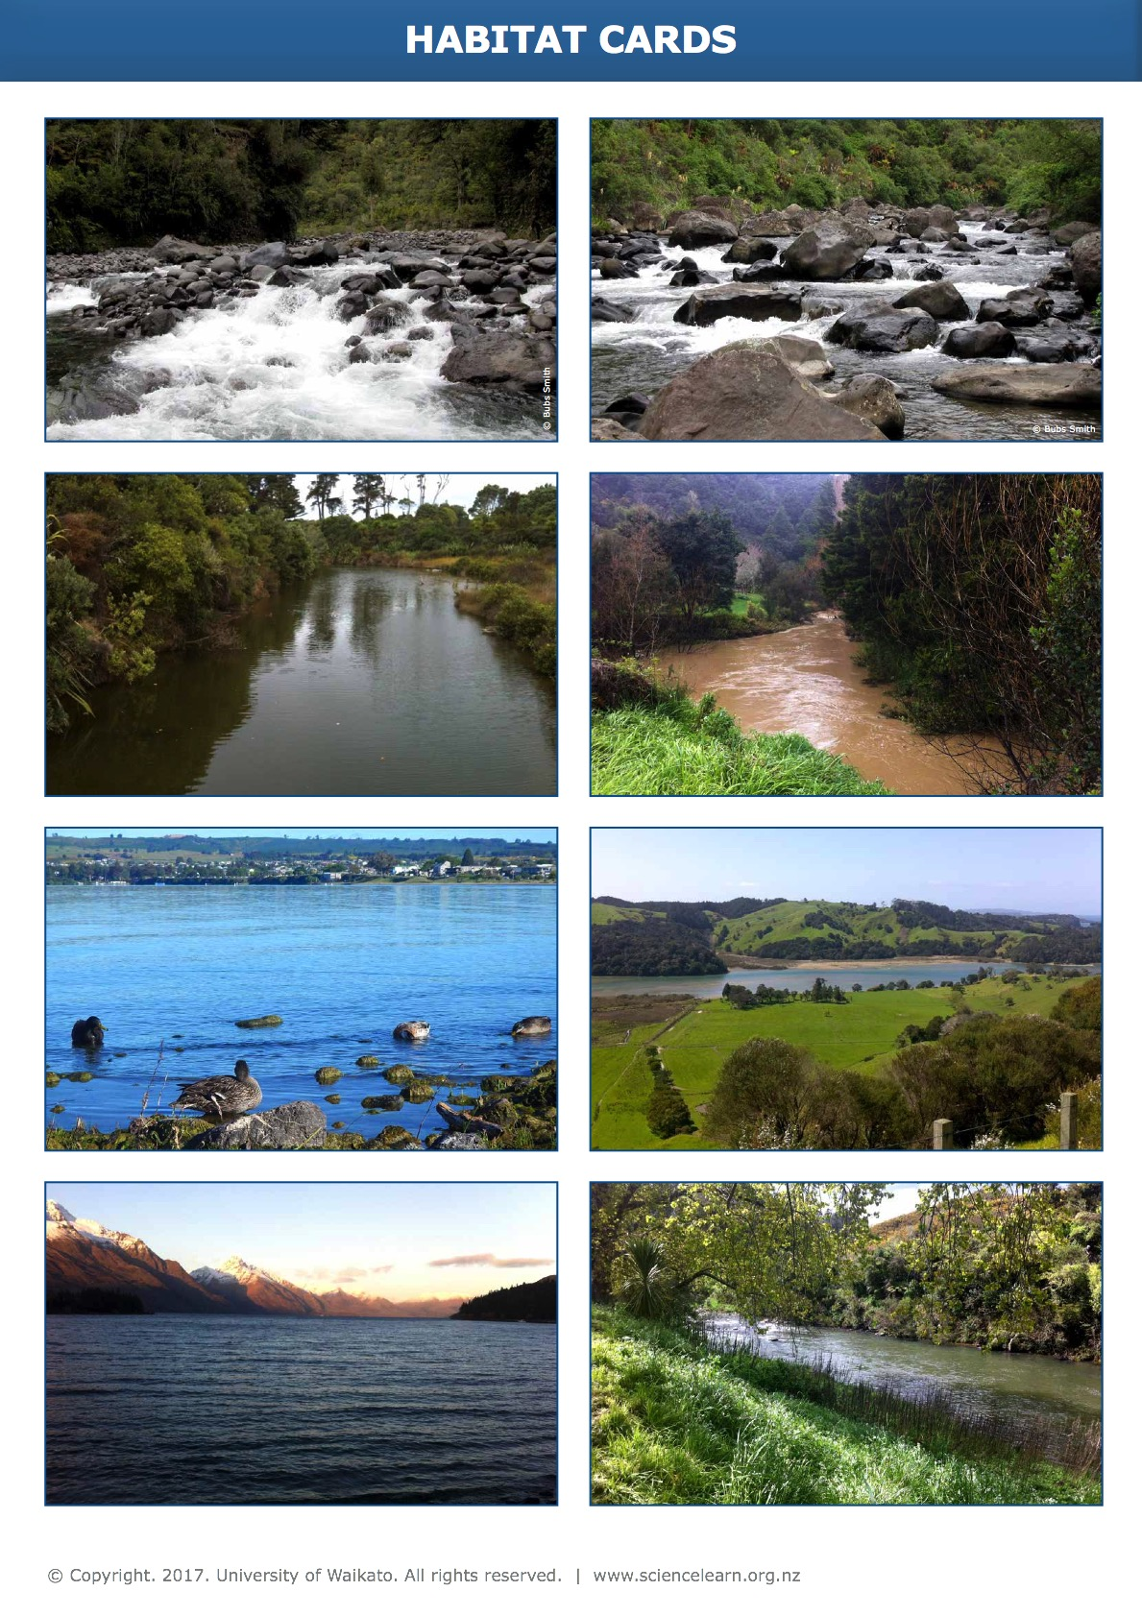

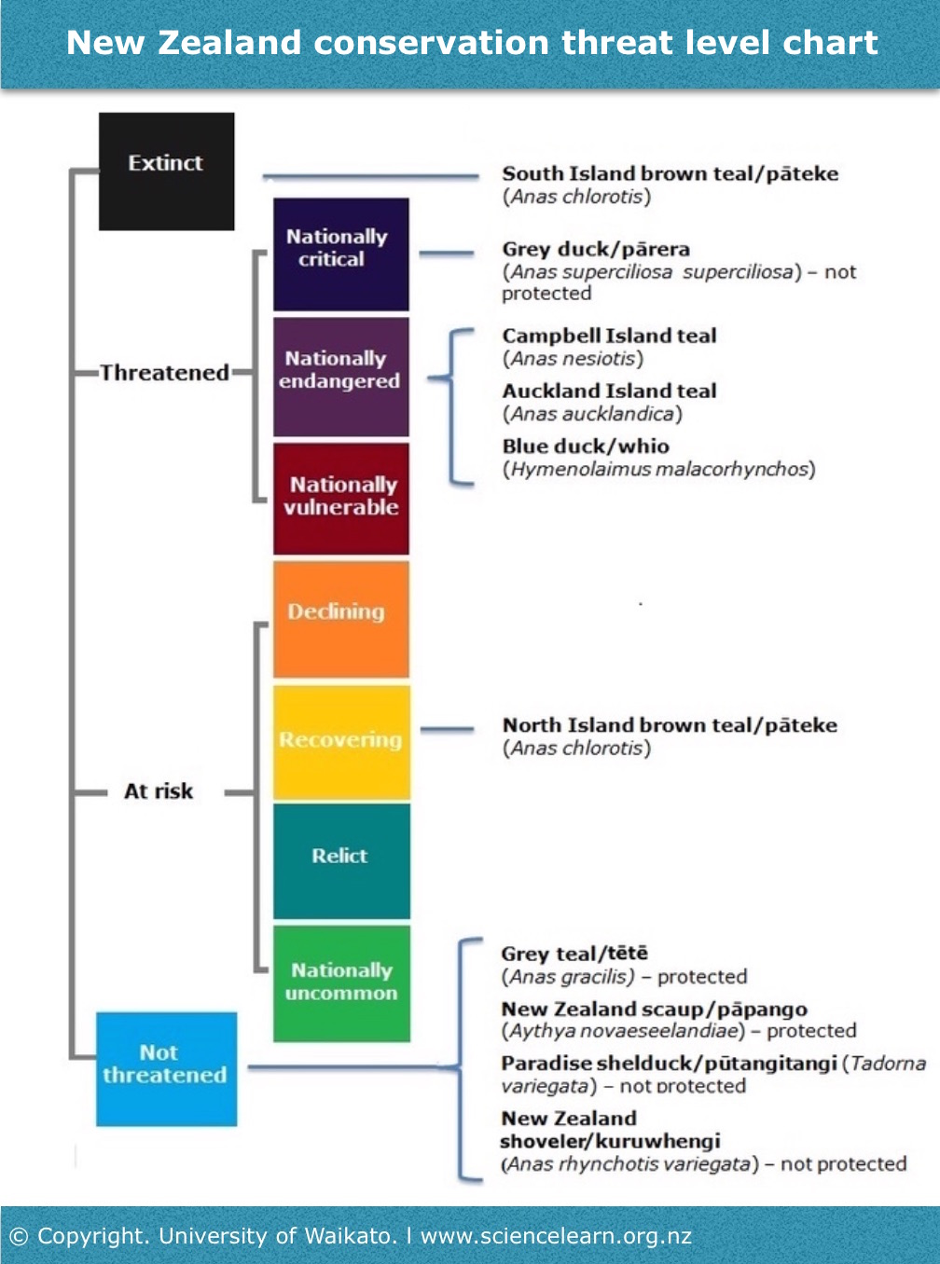

Extension ideas/prompting questions for teachers

- Use these websites to explore the difference between the different threat levels: Conservation status and Threatened species categories.
- Look at the ICUN website and search for New Zealand species that are listed. How does our list compare with the ICUN list? Are their categories the same? Are there any New Zealand ducks on the list?

