ACTIVITY: Piecing it all together

Activity idea

In this activity, students are given different pieces of a jigsaw and are asked to work through a process of observation, discussion, collaboration and deduction to determine what the picture shows. The activity is designed to help students learn about the nature of science – in particular, the collaborative nature of science and the ways in which scientists work with evidence and each other to understand the world.

By the end of this activity, students should be able to:
- draw inferences and make predictions about the complete picture
- identify the value of working together and sharing information and ideas
- use the jigsaw as an analogy for explaining some of the important aspects of the nature of science such as collaboration, observation and inference.

Background information for teachers
Equipment required
Student instructions

Background information for teachers

In this activity, students use different pieces of a jigsaw and work through a process of observation, discussion, collaboration and deduction to determine what the picture shows.

Students look at pieces of a jigsaw and discuss what the complete picture might be. Through teacher prompting and questioning, students are encouraged to draw parallels with aspects of the nature of science, for instance, the way scientists work together, sharing discussing and comparing data and evidence to build shared understandings. Students use collaboration, observational and inferential skills. This activity will also support students to build their understandings about the value of analysing different pieces of data or evidence to build their understandings. Discussing the pieces can represent how scientists turn data into evidence or ideas into an explanation or coming up with a model, theory or law.

Collaboration is an important aspect of current New Zealand scientific research. This whakataukī is about the value of collaboration:

Nā tō rourou, nā taku rourou ka ora ai te iwi.
With your food basket and my food basket, our people will flourish.

The activity is designed to explicitly teach ideas about the nature of science. The story of Joan Wiffen, our most prominent citizen scientist, is used as a context, as the pieces of evidence she discovered and how she connected the pieces into theories changed the way we think about the geological history of New Zealand.

The student instructions are in Word, allowing you to change the document to be used with students of any level.
By changing the jigsaw picture, the activity can be used in any context. You can make jigsaws using a number of online tools, such as www.jigsawplanet.com, use ready-made jigsaws or laminate and cut out pictures relevant to your context.

Equipment required

- Copy of photo 1 for each group
- Copy of photo 2 for each group – to be given out after step one is complete
- Copy of About Joan Wiffen or access to the online article Joan Wiffen
Student instructions

- In your groups, look at photo 1. Discuss what the complete picture might show, thinking about these questions as:
- What clues can you see on the pieces?
- Is there anything that is hidden?
- Would it help if you could see all of each piece?
- What do you think the complete picture might show?
- Why do you think that?

- In your groups, look at photo 2. Discuss these questions:
- What did you get right?
- Were there any surprises in the picture?
- How well did you do?
- What would have helped you make a better guess?

- Read About Joan Wiffen or look at the online article Joan Wiffen.

- Discuss these questions:
- What did Joan believe about land dinosaurs in New Zealand?
- Why do you think she believed that?
- What are some of the things Joan had to do to prove that land dinosaurs existed in New Zealand?
- What scientific skills did she use?

- Think about the jigsaw activity and Joan’s story. Discuss these questions:
- What do you think the jigsaw pieces could represent?
- What were the missing pieces of evidence about New Zealand’s history that Joan found?
- How did having these pieces change the way we think about our past?

Photo 1
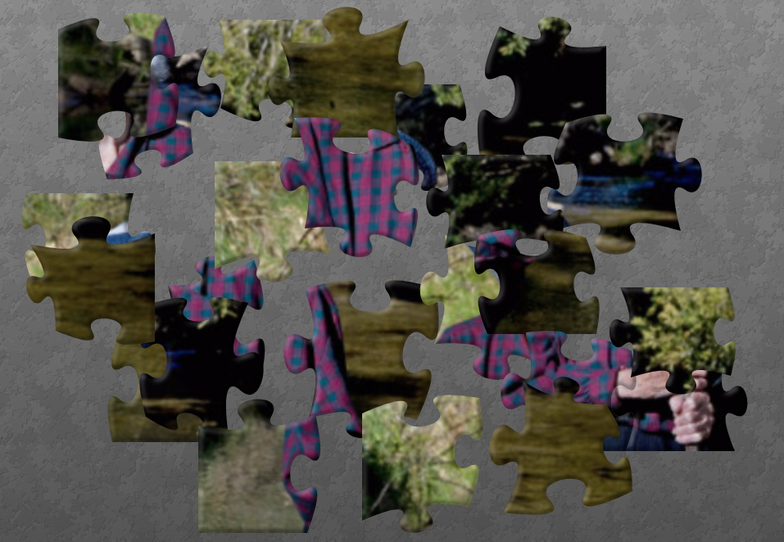

Photo 2: Joan Wiffen
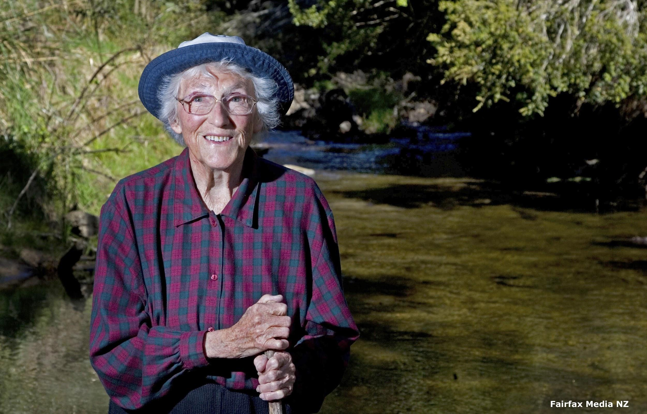

About Joan Wiffen

Joan Wiffen was a citizen scientist in New Zealand – an amateur palaeontologist. She is famous because her ideas and the evidence she gathered changed the way we think about New Zealand’s past.

She loved hunting for fossils and was convinced that land dinosaurs must have lived in New Zealand in the past. At this time, there was no evidence of land dinosaurs, although fossils of aquatic dinosaurs were quite common, and at first, these were all she found. However, for 35 years, she continued to hunt for fossils and finally came upon some that no-one had seen before in New Zealand. She believed they were dinosaur fossils. With no formal scientific training, Joan learned by experience – how to spot fossils, how to extract them from very hard rock, how to identify them and how to use the fossils to put together a picture of ancient New Zealand. She enlisted the help of dinosaur experts abroad (there were none in this country at the time) to carry out identifications and present findings in scientific journals and at conferences.

Finally, it became clear that the fossil evidence she found proved that land dinosaurs had lived in New Zealand.

