Mobile forensic kit - unit plan

Overview
Students develop a mobile evidence collection system to collect forensic evidence from a crime scene in a reliable, repeatable way. They are provided with some material for gathering evidence, and their task is to research and design a mobile evidence-gathering kit that provides not only instructions for use but also a suggested sequence that should be followed.

This unit plan was trialled with year 10 students, and this case study is described below.

Purpose
- To develop an understanding of the process of collecting evidence so that a collection system can be developed.

Suggestions for a scenario
The school skeleton has been found in the glasshouse of St Trinian’s College on Monday morning by the caretaker. It seems that the culprit had to break the window of the shed to gain entrance. Not only did the culprit leave behind a drop of blood but also remnants of clothing. Further clues were left behind. There seems to have been a party in the shed as a half empty glass was left and some hairs attached to the skeleton. Furthermore, a footprint was left on the doorstep. It appears that the alarm didn’t go off and only two people have access in the weekend. They are the school reception staff.

Where's the biotechnology?
Forensic science is the application of science to law. It is based on the premise that there is no such thing as a clean contact between two objects, i.e. every contact leaves a trace. Forensic biologists collect biological samples, for example blood, hair, semen, saliva, teeth, bone, tissue. Blood is a rich source of evidence not only to work out how the crime was committed (for example, by tracing blood splatter) but also for blood typing and DNA analysis. Hair provides a good source of evidence that can be examined microscopically as well as being a source of DNA evidence.

DNA fingerprinting is often the prime source of evidence, and the DNA ‘fingerprints’ from the crime sample can be compared to the national DNA database. A forensic biologist collects data from the crime scene, carries out biological screening and sampling, carries out DNA testing on samples and presents the evidence in court. Biotechnologists work with a team, providing an important component of the evidence for a case.

Curriculum focus
Technology
Forensic science involves groups of experts working as a team to assemble a diverse and complex range of evidence that is presented in court. Evidence must be collected systematically, analysed and stored securely. Such requirements require the development of protocols and systems that protect the rights of the individual.

Science
Interpretation of biological evidence is based on the inherent variability of characteristics found within species. This variability is particularly evident in DNA analysis.

Focus of skill and strategy
This unit provides the reasoning behind the decisions for the type of collection strategies used as well as the sequence. There is a strong underpinning of science concepts. The unit demonstrates the need for integration of science knowledge and its adaptation into technological practice.

Health and safety
It is important that no human tissue is used. Artificial blood can be provided for blood typing and food colouring or cordial can be used to set up the blood-splattering scenarios.

UNIT PLAN: MOBILE FORENSIC KIT
Suggested learning intentions |  | Suggested learning experiences  The following learning experiences will provide you with starting points for an exploration of this topic. You may decide to narrow your focus to one component or include most of the ideas in a unit that incorporates science and/or technology themes. |  | Possible teaching/assessment activities
Introduction  Permissible evidence is the result of systematic collection and an audit system that accounts for sample storage and analysis. |  | - Introduction of the unit to identify the end point (i.e. a design for an evidence-collecting kit) that will be developed as a result of working through a detective game. A generic end point is provided and this will provide the basis for developing briefs.  - The scene of the crime is described, and students have an opportunity to see photos and/or make a preliminary visit.  - Visit the crime scene and identify the evidence that you will need to collect. Start planning the range of data collection techniques you will need to research for your data-gathering kit, as well as the sequence of data-collection strategies. |  | Develop a chart that indicates the dimensions of the evidence-collecting exercise and provides justification for the diversity of evidence collection (for example, blood samples, hair samples, fibre samples, fingerprints, footprints or blood splatter patterns).  Develop a series of questions and answers about gathering and storage of evidence and provide an audit trail.
Developing expertise  The diversity of evidence collected provides triangulation for the accurate analysis and interpretation of data. For example, fingerprints, soil footprints, statements, microscopic examination of hair and fibres provide evidence to narrow down the list of suspects that could be asked to provide blood/cell DNA samples. |  | - Organise the class into groups of six. Each member of the group will be responsible for collecting one component of the evidence and become the expert for that area. They will make sure the rest of the group understands the information and significance of the evidence and contribute their information to the group solution (home and away exercise). Provide packs of information for identified groups, e.g. blood typing, fingerprints, etc.  - Analyse the scenario for the clues that have been indicated. Introduce the range of data-gathering techniques available. The class joins specialist groupings who read the information and plan how they will collect the evidence for taking statements (notes provided), blood typing (practical), fingerprint collection and interpretation (OHT) and assembling equipment, microscope examination of hair and fibres and discussion of ways of recording information, soil typing and appropriate experiments, evidence collected from a glass (acidity, colour).  - What are the criteria for useful evidence that can be presented in court? Contact with the community of practice (Police, lawyer, forensic scientist) – in this case, a forensic scientist from ESR. The focus of the talk and question and answer session is to develop an understanding of the types of evidence, procedures used and techniques to prevent contamination.  - Template development that provides the basis for later brief development.  See case study session 1. |  | Develop the criteria for reliable evidence. For example collection methods, range of collection methods and why, storage and tracking. Organise these criteria for inclusion into the initial brief specifications (template).
Planning for practice  The community of practice has identified protocols for evidence collection, analysis and storage founded on an understanding of significant areas of variability important in distinguishing differences between specimens. |  | - Planning within expert groups (equipment, technique and sequencing of evidence collection).  - Development of a table that identifies areas of evidence and proposed technique and sequence.  - Expert groups negotiate evidence-gathering sequence.  - Generic brief development.  See case study sessions 2–3. |  | Develop the specifications for a brief from a generic list, e.g. must contain all equipment needed to gather evidence within a container, have a list of equipment with instructions for use, include a sequence for gathering evidence and indicate the strategy for transportation and storage.
Developing and adapting the evidence-collecting kit |  | - Trial collection of evidence and initial testing and analysis of the evidence (blood typing, DNA profile analysis, plaster cast of footprint, examination of hair and fibre left at the scene).  - Reflection of the system (within expert groups then in class discussion). Evaluation of the process (strong and weak aspects).  - Societal issues – the importance of contamination-free evidence. Class discussion of newsworthy cases and problematic evidence. Implications of sloppy evidence collection.  - Writing specifications for brief.  See case study session 4. |  | Development and adaptation of the brief by using the analysis sequence:  - What were you trying to do?  - What went well?  - What didn’t go so well?  - What improvements will you make?
Testing the kit and sequence  The specificity of the design of the collection system will occur as the sensitivity of the analysis increases. For example, when smaller samples of DNA can be utilised, it is important to make sure there is no possibility of cross-contamination. |  | - Kit assembled and sequence worked out according to brief.  - Revisiting the crime scene to collect data.  - Evaluation of the brief and evidence collection.  - Analysis of the process and redefining the kit and sequence.  See case study sessions 5–8.
Presentation of the mobile evidence-collecting system |  | - Experts join the original group and contribute to the presentation of the evidence collection system where sequencing and justification are presented in photographic and poster form.  - Presentation of the solution that includes adapted brief, contents of the kit with instructions for use and a justified sequence displayed in poster form.  See case study session 9. |  | Develop a presentation of the final evidence collection kit that shows the equipment and instructions (annotated) as well as the sequence of evidence gathering, with reasons.
CASE STUDY: MOBILE FORENSIC KIT
Focus | Classroom activity |  | Commentary
Session 1:  - Introduction and organisation  - Identification of a need | 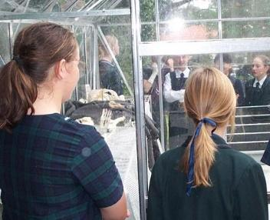  - The task was presented to the students, i.e. the scenario was presented, predicted technological outcomes were discussed, and methods and materials were determined.  - The teacher related the task to TV programmes, novels and newspaper headlines.  - The students selected their own problem-solving groups (six students in each). Each member was responsible for collecting one component of the evidence, and became the expert in that area. The group identified possible roles and outcomes.  - Each problem-solving group was issued with an A3 sheet to record brainstorming of types of evidence to be gathered.  - The students visited the scene of the crime.  - The teacher led discussion of the steps in gathering evidence (sequencing). |  | 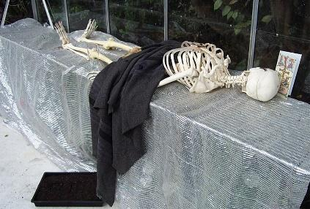  - Prior to this session, the teacher had developed a trail of clues that led to two suspects (two teachers in the school who had been provided with stories/alibis that accounted for their movements during the weekend in question).  - Clues at the scene included cat’s hair and human hair on the rug, a wine glass with fingerprints and a lipstick print, broken glass with ‘blood’ (red cordial), a postcard signifying travel, coloured fibre from a cardigan and a footprint from a gumboot in the soil box.  - Students assessed the crime scene from the outside, noted a range of clues and commented on the evidence they might collect, e.g. “How do you make a mould of footprints?”  - The teacher noted that the students were using their tacit knowledge, e.g. “You know in CSI they always go in with plastic bags and gloves and tweezers.”  - The allocation of expert status provided each student with a focus for the type of evidence they would be collecting.
Session 2:  - Group organisation and developing expertise | - The teacher recapped the scenario and focused students on the intended learning outcome: to develop a mobile forensic kit.  - The teacher related evidence gathering to a real-life situation (a story from a friend in Police).  - Group members chose their roles as experts – blood typing, DNA profiling, fingerprinting and footprint analysis, and fibre and hair analysis.  - Expert groups were issued with information packs for their particular expert area and discussed other sources of information.  - Students were challenged to find extra information.  - A poster of the crime scene was displayed.  - Expert groups met to begin to develop a knowledge base. |  | 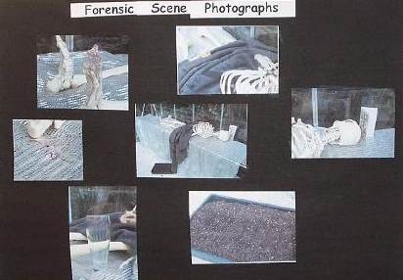  - The students were unable to revisit the crime scene as it had been disassembled. However, they could look at the photos of scene.  - The expert groups were expected to predict what type of equipment would be required for efficient collection of evidence.  - The hair and fibre expert group looked at hair types under the microscope and started asking questions such as “Would we be able to tell the difference between my hair and Marianne’s hair? A dog and human hair?” When they saw the bulbous nature of the hair follicle, they suggested that it would be useful to the DNA group. They had started to make links. The DNA group worked on making sense of the information. The footprint group discussed how they would make a mould and suggested plasticine and plaster of Paris.  - The teacher noted that a visit by a forensic scientist would give purpose to the unit.
Session 3:  - Visit and talk by a forensic scientist - providing a link with the community of practice | A forensic scientist working in the Crime Sample Database at Environmental Science and Research (ESR) gave a talk to the students. The talk covered:  - forensic science was defined as the “application of science to law”  - the client (NZ Police)  - traceable materials (fingerprints, fibres, shoeprints, cellular material like DNA)  - an emphasis on the need for a variety of evidence  - DNA in forensic science  - examples of New Zealand cases. |  | - A forensic scientist from ESR gave a talk to the class that provided information about how evidence is collected. He also gave tips on keeping the crime scene relatively free of contamination by developing footpaths through the area.  - He provided information about sequencing (setting up an order of collection of data). He identified sources of biological evidence and described the steps involved in DNA analysis. He talked about the national DNA databank, which has two databases of individuals and ‘crime sample’/unsolved crimes.  - This discussion provided links with later discussions about the ethics and how the DNA profiling results are expressed (in terms of probability) and used in conjunction with other evidence.  - His overriding message was that collection of evidence must be methodical and meticulous.
Session 4:  - Planning the system for collecting evidence  - Developing technological practice | - The teacher worked with expert groups to plan equipment and strategies for collecting evidence.  - The teacher presented the class with a generic brief and focus for brief development.  - Problem-solving groups (i.e. with a representative expert from each expert group) assembled and started to develop a list of equipment that they recorded on a mobile forensic kit equipment sheet.  FORENSIC SCIENCE  Brief: Design a mobile forensic kit to gather evidence from a crime scene. The kit must contain:  - all the equipment needed to gather evidence  - container for the equipment  - list of equipment needed with instructions for use  - sequence for gathering evidence  - systems to safely transport evidence to those using it.  Trial 1: Go to the crime scene and test the effectiveness of your evidence-gathering kit and systems.  Analysis: Assess the effectiveness of your kit by asking the following:  - What were you trying to do?  - What went well?  - What didn’t go so well?  - What improvements will you make? |  | - In this session, the expert groups were upskilled through carrying out laboratory work or providing routes for accessing information. For example, the DNA group accessed information via the web in the computer suite with the teacher helping them refine their search, and the hair and fibre group searched for web-based information on animal hair.  - The teacher gave the groups direction on brief development so they could particularise their brief.  - The teacher felt that the groups needed to develop thinking skills and decided that would be part of her ongoing programme of development for the class. She then set up a situation so that students could trial data gathering and then analyse the process.  - The teacher put out a range of materials for the students to use in order to help them make their brief more specific.
Session 5:  - Trialling stage – testing the evidence collection system | 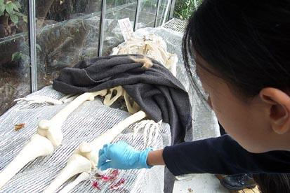  - Students referred to their lists of equipment generated by each problem-solving group in the previous session. They then carried out a trial gathering of evidence from the crime scene.  - Groups collected evidence at the glasshouse. Included were samples of blood, hair and fibre. |  | 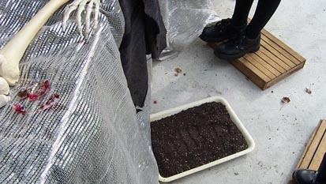  - The session was organised to refocus the class on the task of developing a mobile forensic kit rather than solving the crime.  - As a practical session, it was intended to provide material for the next session where students would be analysing how they collected data. Students collected equipment and organised themselves to collect evidence. Students used the concept of developing footpaths (introduced by the forensic scientist) and used steps to keep off the floor.  - The teacher noted at the end of the session that they had little idea about their plan of action and that they were “all over the place”. The teacher decided that they would spend the next session analysing this trial by using Mrs Potter’s questions.
Session 6:  - Reflecting on the evidence collection system  - Analysis  - Consideration of societal issues | - The teacher led discussion using Mrs Potter’s questions:  - What were you trying to do?  - What did you do well?  - What did you not do so well?  - What things could you improve?  - What things are you going to do differently next time?  - Discussion of why this analysis is important.  - Discussion about why it is important to gather data carefully without contamination.  - The teacher directed class to adapt their plan and equipment list for second trial tomorrow. |  | - Students spent time in expert groups discussing what they did ‘wrong’ and then reformed into their problem-solving groups to plan the next session.  - The DNA group had examples of DNA sequences obtained from the ESR lab and spent time with the teacher interpreting the peaks on the sheets (these sheets were illustrative rather than central to the process as this class were not solving the crime).  - The fingerprint group were given a new glass that had fingerprints and they spent a lot of time dusting and analysing the print.  S1: We think the person is left-handed as they have their thumb on one side and three fingers on the other and their little pinkie underneath it supporting it on the bottom.  S1: Three there…  S2: And there is quite a long one on the bottom… and it goes a long way out.  - The class were starting to become aware of the societal implications of obtaining contaminant free evidence:  S4: So that you don’t contaminate it … making other people look guilty…  S2: Or leave fingerprints … more likely by a detective … you would be made to look like an idiot by the defence lawyer.  S3: Or if you were a witness or something you might go and walk around … and the Police might come and you might say, “Well I was just a witness,” and the Police might come and find you guilty … and if you have your fingerprints there, they might convict you.
Session 7:  - Considering the social implications of sloppy evidence collection | - The teacher led discussion of the social and ethical implications of evidence convicting and wrongly convicting people. She included:  - cases from the newspaper, e.g. David Dougherty and the implications of sloppy procedure  - stories from a crime novel by author Ken Follet  - stories that she had picked up elsewhere, e.g. two twin brothers having matching DNA from the crime scene  - the forensic scientist’s explanation of the databank sample of criminals and databank of material from unsolved crimes and the role of governments in requesting and storing information  - the role of DNA fingerprinting in other situations, e.g. pre-screening and the ethics of collecting samples from the whole population.  - The teacher led discussion of the brief with instructions on how to particularise it for each expert group. |  | This session focused on the social implications of the role of forensic science and DNA profiling. Students needed to get more information and one student collated questions to be asked:  - How do you become a forensic scientist?  - How much of the time does a forensic scientist spend at the crime scene, and how much time is spent in the labs examining the evidence?  - In general, what is the most useful and reliable source of evidence?  - What safety precautions are taken for handling blood, saliva etc?  - Where do forensic scientists look for small or hard-to-see evidence such as saliva?  In this case, an email was compiled and sent via the teacher to the forensic scientist who had visited the class.
Session 8:  - Refocusing  - Analysis and identification of the outcome  - Working towards the technological solution | - The teacher directed the class to the outcome of this unit using a problem sheet that identified all the components to be included in a final presentation of a mobile forensic kit along with the following components:  - Brief (adaptation of generic brief).  - Explanation of changes made to generic brief.  - Instructions for how and why all equipment contained in the kit is to be used.  - Sequencing of evidence collection, with reasons.  - Students worked in problem-solving groups to present material as a poster: they had decided that they needed a visual display to talk to.  - The teacher read out the forensic scientist’s response to the class. |  | - Students compartmentalised boxes and made instruction lists.  - Students photographed their mobile forensic kit and used them in an annotated diagram on their posters.  - Students worked in groups with each member choosing their own task (not focused on their expert roles, but task oriented, e.g. brief adaptation, itemisation of the box contents, organisation of the box, instructions for use and sequence with justification for data collection).
Session 9:  - Presentation of each mobile forensic kit  - Final analysis | - Groups presented their kits, justifications for their changes to the brief and the order in which they collected the evidence. |  | Each group organised their presentation on two A3 sheets of cardboard. They identified the adapted brief, contents and organisation of the box with instructions for use. They also explained the reasons for the sequence they had used to gather the evidence.  