ACTIVITY: Measuring humidity and temperature with a Raspberry Pi

Activity idea

In this activity, students use electronic components to measure temperature and humidity levels in homes modelled from ice cream containers. They use data from the sensors to determine whether ventilation helps to reduce dampness.

By the end of this activity, students should be able to:
- build model houses with simple materials
- discuss why scientists use models
- discuss the use of a control in an experiment
- follow instructions to assemble and test electronic systems
- use the sensors to collect data
- use, interpret and make sense of the data collected
- make recommendations about home ventilation based on the data
- develop their own code to operate the electronic system (optional).

Background information for teachers
Equipment required
Teacher instructions
Student instructions
Extension activity

Background information for teachers

We know that cold, damp homes are not good for our health, as explained in the article Damp homes and health risks. Ventilation is one way to prevent dampness from accumulating, as explained in the interactive Moisture sources in our homes.

This activity uses simple model homes made from ice cream containers. A damp sponge in each container represents moisture sources. One container has holes to simulate open windows and ventilation. Learn more about why scientists use models in the article Scientific modelling.

This activity also enables students to assemble and test an electronic system and use sensors to measure humidity and temperature. Learn more about how sensors work in the article Electricity and sensors.

If students would like to develop their own software to use a Raspberry Pi to run the sensors, the extension activity uses open source software to get things started. Students will need to be familiar with the Python programming language.

Equipment required

- 2 x 2L ice cream containers
- 2 small sponges
- Scissors or craft knife
- Plastic food wrap
- 2 rubber bands
- Blu-Tack
- Micro USB wall charger
- Raspberry Pi
- 2 temperature and humidity sensor modules (for example, DHT11 Duinotech sensors)
- Breadboard
- Minimum of 10 male-female leads (more may be needed to daisy chain/lengthen the leads)
- Micro SD card
- Micro SD card to SD adapter
- USB compatible keyboard
- Mouse
- HDMI cable
- Science Learning Hub Sensor Suite software (download from the Measuring temperature and humidity with a Raspberry Pi web page). Note that this is a 1.6 GB file.

Teacher instructions

- Before doing the activity with the students, image the micro SD card with the Science Learning Hub Sensor Suite software. Ask the school’s IT specialists for help if you do not know how. Alternatively, email the Hub at enquiries@sciencelearn.org.nz for help with this or any other aspect of the activity.

- Read and discuss the article Damp homes and health risks.

- Use the interactive Moisture sources in our homes to find out what causes moisture and how to minimise and remove it.

- Ask students to construct the model houses.

- Discuss the role of models in science. Prompting questions include:
- How do the different parts of the model house represent aspects of an actual house?
- What role does the damp sponge play?
- Why are we using models to investigate ventilation rather than actual houses?
- Do you think we would be able to replicate this activity using real houses?
- Discuss the role of a control in an investigation and the need to keep all variables the same, except for the windows/ventilation.
- Work through the student handout to construct the model homes and to set up the Raspberry Pi and temperature and humidity sensors.

- The sensors, like all scientific instruments, have a margin of error. The sensors may show slightly different readings. Consider this as an opportunity to discuss systematic and random biases.

- Use the data from the sensors to compare the effects of ventilation on temperature and humidity levels. You may need to process the data gathered and graph it to identify any trends or differences. Prompting questions include:
- What does the data show?
- Are there any differences between the two models?
- Using the data, what conclusions can you make about ventilation and a healthy home?

- Critique your investigation:
- Did the investigation go as planned? If not, why? What adjustments were required?
- Were the results what you expected? Why?
- What would you change if you repeated this investigation? Why?
- What did you learn about the process of using technology to gather data?
- How else could you have gathered this data?

- Discuss how these findings might relate to real-world housing and the implications.

Student instructions

Construct the model houses

- Cut holes in one ice cream container to represent open windows and ventilation.

- Place a damp sponge in each container to represent sources of moisture. For a fair test, keep the size of the sponge and the volume of water added the same in each container.

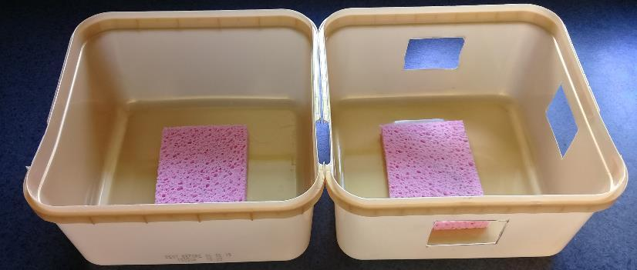

Set up the humidity and temperature sensors

- Insert the micro SD card (imaged with the Science Learning Hub Sensor Suite software) into the Raspberry Pi.

- Connect the keyboard and the mouse into the Raspberry Pi’s USB ports.

- Connect the Raspberry Pi and monitor, using the HDMI cable. Turn on the monitor.

- Connect the positive and negative pins on the Raspberry Pi to the breadboard:
- Connect the first pin (positive) on the top row of the Raspberry Pi to position E1 on the breadboard – as shown by the red lead in the photo.
- Connect the third (negative) pin on the top row of the Raspberry Pi to position E3 on the breadboard – as shown by the black lead in the photo.

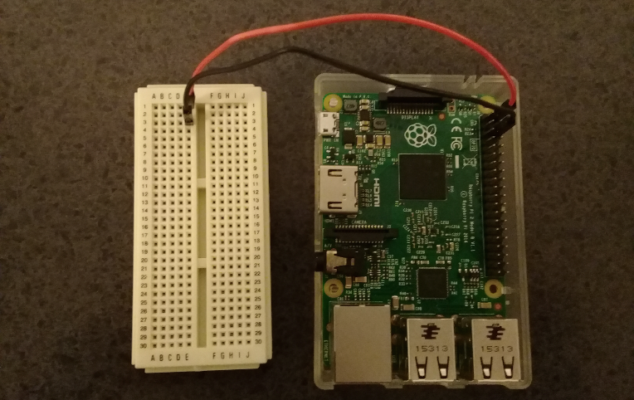

- Connect the first humidity and temperature sensor:
- Connect a lead from the second pin on the bottom row on the Raspberry Pi to position E5 on the breadboard – as shown by the orange lead in the photo.
- Connect a lead from the sensor’s left pin to position A5 on the breadboard – as shown by the purple lead in the photo.
- Connect a lead from the sensor’s centre pin to position A1 on the breadboard – as shown by the yellow lead in the photo.
- Connect a lead from the sensor’s right pin to position A3 on the breadboard – as shown by the blue lead in the photo.

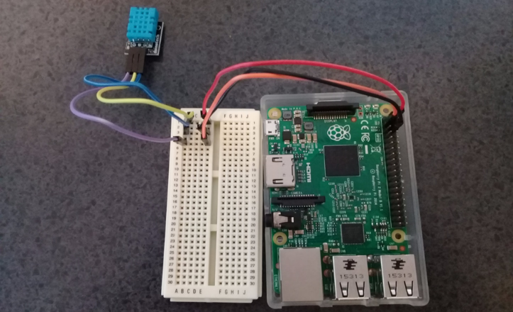

- Connect the second humidity and temperature sensor:
- Connect the third pin on the bottom row on the Raspberry Pi to position E7 on the breadboard – as shown by the green lead in the photo.
- Connect a lead from the sensor’s left pin to position B7 on the breadboard – as shown by the brown lead in the photo.
- Connect a lead from the sensor’s centre pin to position C1 on the breadboard – as shown by the white lead.
- Connect a lead from the sensor’s right pin to position C3 on the breadboard – as shown by the red lead in the photo.

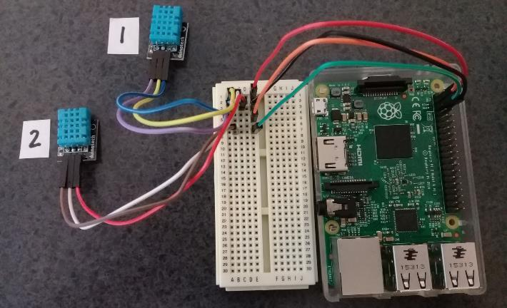

The monitor screen will boot up after a brief pause. The screen will resemble a desktop background with two or more icons. If the screen remains blank, try unplugging the Raspberry Pi’s power cable and plugging it back in again. (If the Raspberry Pi is turned on before the monitor, it will not connect with monitor.)

- Check the Raspberry Pi and breadboard connections are correctly set up by double clicking the Continuous.py icon. If the connections are correct, a pop up will ask you what you want to do – select Execute in Terminal. If nothing pops up, go through steps 6–8 to check the connections are correct. If there is a hot or smoky smell, unplug the sensors immediately. Go through steps 6–8 again

Test the sensors work

- A black screen will pop up asking how many sensors you wish to test. Enter in 2.

- Sensor data regarding humidity and temperature will appear. If the numbers appear sensible – reading between 10° and 25° – the connections for the sensors are correct. The sensors, like all scientific instruments, have a margin of error. The sensors may show slightly different readings.

- Place a temperature and humidity sensor in each of the model homes. Lengthen the lead wires by daisy chaining (connecting multiple) wires if necessary. Use Blu-Tack to attach the sensors to the walls.

- Use food wrap to cover the top of each ice cream container. Secure the plastic wrap with rubber bands. Take care not to loosen the leads in the process.

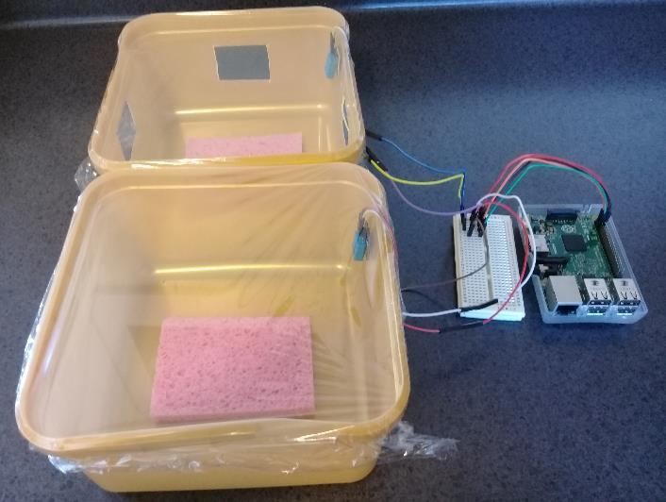

- Open the Measurement.py icon.
- Select Execute in Terminal.
- Enter the number of sensors you are using: 2.
- Enter the title you want to use for the output files. Two files will be created in the Documents folder: Title-temperature.csv and Title-humidity.csv.

- The program is designed to run for 24 hours.

- After the 24-hour run period, disconnect the sensors from the Raspberry Pi.

- Remove the micro SD card from the Raspberry Pi and plug it into a computer.
- Open the 7.7GB volume drive.
- Open the Home folder.
- Open the Pi folder.
- Open the Documents folder to find the two CSV files.
- 7.7GB drive>Home folder>Pi folder>Documents folder

- Copy the data to Excel.

- Graph the data to observe the differences in temperature and humidity between the two ‘houses’.

Extension activity

If you are familiar with the Python programming language and want to develop your own code to run the sensors, here is one way to get the process started.

You will need a USB wifi adapter for the Raspberry Pi.

You will need to install the following open source software:
- Raspbian https://www.raspberrypi.org/downloads/raspbian/
- Git
- Adafruit DHT11 library
- Build-essential package
- Python-dev package

Instructions

- Download and install Raspbian, Raspberry Pi’s official supported operating system, to a micro SD card. Insert the micro SD card into the Raspberry Pi.

- Plug in the mouse, keyboard, USB wifi adapter and power source to the Raspberry Pi. Use an HDMI cable to connect the Raspberry Pi to the monitor.

- Connect the Raspberry Pi to the internet with the wifi adapter. Double click on the no wifi symbol in the top left corner on the monitor screen, then follow the prompts.

- Use CTRL-ALT-T to open a terminal on the Raspberry Pi.

- Type the command: sudo apt-get install git-core into the terminal. This will install Git. The terminal will ask for a password for the pi account. The default password is raspberry.

- Type the command git clone https://github.com/adafruit/Adafruit_Python_DHT.git to download the Adafruit DHT11 library.

- Type the command cd Adafruit_Python_DHT to change the directory.

- Type the command sudo apt-get install build-essential python-dev to install the tools to install the Adafruit DHT11 library.

- Install the library with the command sudo python setup.py install.

- Examine this sample code for using the Adafruit DHT11 library in Python:
#!/usr/bin/python
import sys
import Adafruit_DHT
#pin 3 is the first on the bottom row, 4 is second on bottom, 5 is third on bottom
pin = 3
while True:
humidity, temperature = Adafruit_DHT.read_retry(11, pin)
print ‘Temp: {0:0.1f} C Humidity: {1:0.1f} %'.format(temperature, humidity)

- Design your own code to run to the sensor model. Consider how often you want to take humidity and temperature measurements and how you want to output the data.

- Use this code in place of the SLH Sensor Suite software to conduct the activity.

