ACTIVITY: Plastic – reuse, recycle or rubbish game

Activity idea

In this activity, students play an active game to sort plastics into three categories: reuse, recycle and rubbish.

By the end of this activity, students should be able to:
- consider whether plastic items can be reused or recycled
- justify their reasons for choosing to reuse, recycle or landfill a plastic item
- locate and identify RIC numbers on plastic items.

Background information for teachers
Equipment required
Teacher instructions

Background information for teachers

This is an active game in which groups of students consider whether individual plastic items are suitable for reuse, recycling or to be put in the rubbish.

The activity encourages students to observe and consider how they use and reuse plastics in their everyday lives. It also provides insight into students’ attitudes and prior knowledge regarding recycling.

Teams race to see who can sort plastic items into three different bins labelled reuse, recycle and rubbish.

The bins are set at intervals – reuse bin is closest to the starting line, the recycle bin is midway and the rubbish bin is furthest away.

Use a variety of clean plastic items – encourage students to bring a selection from home. Items can include small toys, single-use packaging, cutlery, jars, milk containers, soft drink bottles, dishwashing or hand wash bottles, plastic wrap, carry bags and so on.

Pedagogical adaptations and follow-up activities

Adapt the game to suit your pedagogical purpose:
- Play the game as an introductory activity to establish students’ thinking and prior knowledge about recycling and reuse.
- Develop teamwork skills by giving student groups time to discuss and identify which items go in which bin.
- As a formative assessment task, remove the time component and focus on correctly placing the items in the most appropriate bins.

Follow up the game with an investigation about the types of plastics that can be recycled in your local area (use the link in the article Plastics and recycling).

Keep the plastic items for reuse in the student activity DIY plastic recycling plant, if desired.

Equipment required

- Large open space
- Rope or chalk to mark the starting line
- Plastic carry bags with a variety of plastic items for each team
- 3 boxes or bins labelled reuse, recycle and rubbish
- Plastic recycling identification code number chart (optional)

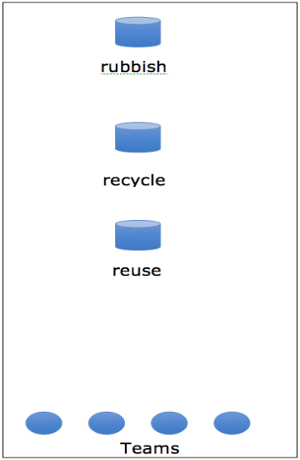
Teacher instructions

- Set up the game as shown.

- Give each team a bag of plastic items.

- At the start signal, the first person in line takes a plastic item from the bag, runs to the bin they think is appropriate for the item and places it in the bin.

- The runner returns to their team and tags the next person in line.

- Continue, one runner at a time, until the team’s bag is empty. Team members sit down when all items are distributed in bins.

- The game finishes when all teams are seated.

- Take the bins back to the classroom.

- Either in groups or as a whole class, look at the plastic items in each of the bins and discuss:
- Why were the bins placed at different lengths from the starting line?
- Did varying the distances make you think about which bin to choose?
- Do you agree with choices people made about what they put in the reuse, recycle and rubbish bins? Why do you think that?
- What are some ways you can reuse the plastic items in the reuse bin?
- Where can you find the RIC number on a plastic item?
- Are we able to recycle all of the items in the recycling bin?
- Which types of plastics can we recycle locally? (RIC numbers identify these.)
- Are there more environmentally friendly items we can substitute for some of the single-use plastic items?
- If we played this game again, are there items you would place in a different bin? Why?
- The game does not have reduce or refuse bins. Which of the items do you think would belong in these bins?
- How can we encourage businesses to reduce or replace plastic packaging?
- How can you and your family reduce or replace plastic packaging?

