ACTIVITY: DIY plastic recycling plant

Activity idea

In this activity, students use Hub resources to design and operate their own PET plastic wash and recycling plant, loosely based on the Flight Plastics process.

By the end of this activity, students should be able to:
- use written and visual resources to gain information about the plastic recycling process
- discuss some of the steps involved in processing/recycling a PET plastic item
- place the steps in the order they are likely to happen
- design a model of the recycling process using familiar, everyday materials
- discuss how the model represents the actual steps in the recycling process
- consider how recycling fits into the use and reuse of plastics.

Background information for teachers
Equipment required
Teacher instructions
Student instructions

Background information for teachers

In 2017, Lower Hutt business Flight Plastics opened New Zealand’s first PET plastic wash and recycling plant. (PET has the recycling identification number 1.) Flight Plastics turns recycled plastic into RPET flakes and uses the flakes to make new PET food-grade packaging. Read about the process in the article Flight Plastics recycling technology and view the plant in the video Flight Plastics recycling plant in action.

Students use these resources to help them design, build and operate their own PET wash and recycling plant simulation. The activity has two components:
- Identifying the steps in the recycling process – from the recycling bin to a new PET package. (This is a simplified process, loosely based on the Flight Plastics process.)
- A hands-on wash, recycling and manufacturing plant simulation.

Modify the activity to meet the needs/abilities of your students and to suit your programme. The student worksheets are in Word, so you can modify them as desired.

Suggestions for the hands-on simulation

Bring the Flight Plastics recycling process to life with a classroom simulation. Using a model is an example of the nature of science Investigating in science strand. It also helps students to visualise the multi-step process. Discussion will assist with connecting the model components to the actual process.

Ideally, the students will design much of the simulation themselves, but here are a few ideas to get you started:
- Designate areas of the classroom or outdoor area to represent the various locations of the recycling and manufacturing process.
- Begin the simulation with a bin of recyclables.
- Try to mimic your local situation by either having one or several toy trucks remove the recyclables to the sorting station.
- Sort the items by material.
- Squash and bale the items (with rubber bands) and use the trucks to send the different materials on their way.
- PET items go to the wash plant. (For more information about what happens to recyclable materials other than PET, visit Fight the landfill.)
- Use a sink or bucket to remove labels and glue. Flight repeats this process several times – some glues and labels are hard to remove.
- Separate lids, springs or other components. Pass a magnet over the material to remove metal items.
- Move to the recycling area. Cut the items into smaller pieces and lay them on a tray. Use a straw to blow non-PET or coloured pieces of plastic away so only clear pieces – representing RPET – are left.
- At the manufacturing area, swap the tray of RPET with a clean PET container to model the newly made package.
- Use the truck to take the container to a fruit processing factory and add a few grapes or similar.
- Share the fruit and put the PET container in the recycling bin for another round!

Students can design the process first and then bring items from home for the simulation.

Additional information and resources

The website recycle.co.nz has information about the types of plastics collected by local and regional councils in New Zealand.

Consider using the activity Plastic – reuse, recycle or rubbish game prior to designing and making your recycling plant. The activity encourages students to observe and consider how they use and reuse plastics in their everyday lives. The plastic items used in the game can also be used in the this activity.

Equipment required

- Paper and felts to make signs designating the various recycling/processing locations
- Recyclable items (paper, metal, plastics – including PET)
- Toy truck(s)
- Rubber bands for baling items
- Sink or bucket
- Dish soap and dish brush
- Scissors
- Magnet(s)
- Tray(s)
- Straws
- Clean PET package to hold fruit
- Fruit – grapes or similar to share with the students
- Other items as determined by student planning

Teacher instructions

- Discuss what the students know about plastic recycling to establish prior knowledge. If necessary, consult the recycle.co.nz website for information about recycling in your local area.

- Watch the video Flight Plastics recycling plant in action. Discuss what happens to a PET product before it arrives at Flight Plastics.

- Read the article Flight Plastics recycling technology to learn more about the wash plant and how Flight separates and sorts non-PET materials from the mix.

- Use information from the video to discuss how Flight uses the RPET flakes to make new food-grade packaging and what might happen to the packaging after it leaves the factory.

- Hand out the first page of the student instructions – What happens to my plastic bottle? – and have students use order the steps of the recycling process.

- Hand out the second page of the student instructions – Design your own PET plastic wash and recycling plant – and discuss how to design and model a similar recycling process/simulation in the classroom.

- If time and resources allow, create the model wash, recycling and manufacturing plant. Discuss each step of the process, drawing parallels to the technology used by Flight Plastics.

- After the simulation, discuss how to dispose of the wash water and the non-PET items you could not recycle. Refer to how Flight Plastics deals with the wastes it produces.

- Discuss how recycling fits into the other Rs: refuse, reduce, reuse and rubbish. Use PET products like a water bottle and single-use packaging to aid the discussion.

Student instructions

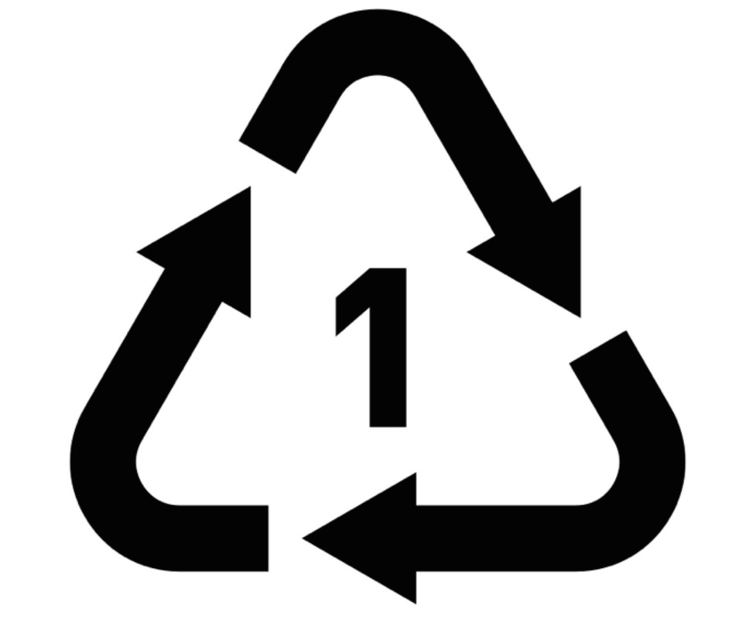
What happens to my plastic bottle?

Cut up the cards and put them in order.

The recyclables are crushed and baled. | Foods like fruit and biscuits get packed into new Flight Plastics containers. | The PET plastics are washed over and over to remove the labels and glue. | A truck picks up the recycling at the kerb or recycling centre.
The recycled items are sorted into groups of the same materials. | Used Flight Plastic containers go into the recycling bin to be recycled again and again. | Sensors check the PET flakes. A jet of air blows non-PET flakes into a bin. | The washed, sorted PET plastic is shredded to make RPET flakes.
The washed PET plastic is sorted to remove metals and other materials. | The recycling goes into a bin. | Bales of PET plastic go to Flight Plastics for recycling. | Flight Plastics uses clean RPET flakes to make new food containers.

Design your own PET plastic wash and recycling plant

Use what you know about Flight Plastics wash, recycling and manufacturing plant to make a model of the recycling process. Record how you can model the steps in your classroom.

DIY PET plastic wash and recycling plant
Steps in the recycling process | How we plan to model the steps
The recycling goes into a bin.

A truck picks up the recycling at the kerb or recycling centre.

The recycled items are sorted into groups of the same materials.

The recyclables are crushed and baled.

Bales of PET plastic go to Flight Plastics for recycling.

The PET plastics are washed over and over to remove the labels and glue.

The washed PET plastic is sorted to remove metals and other materials.

The washed, sorted PET plastic is shredded to make RPET flakes.

Sensors check the RPET flakes. A jet of air blows non-RPET flakes into a bin.

Flight Plastics uses clean RPET flakes to make new food containers.

Foods like fruit and biscuits get packed into new Flight Plastics containers.

Used Flight Plastic containers go into the recycling bin to be recycled again.

