ACTIVITY: Making ice cream

Activity idea

In this activity, students are encouraged to think about the process of making ice cream and to explore the concept of states of matter through simple investigations.

By the end of this activity, students should be able to:
- explain heat transfer in the context of ice cream making
- describe the difference between solids and liquids in terms of particles
- design investigations to answer their questions by altering simple variables in the ice cream making process.

Background information for teachers
Equipment list
Student instructions
Extension ideas/prompting questions for teachers

Background information for teachers

The process of making ice cream offers an opportunity for students to explore the concepts of heat transfer and states of matter.

What happens? The ice cubes absorb heat energy from the milk mixture. This cools the milk mixture, causing it to freeze while also causing the ice to warm up and melt. These two processes occur simultaneously. Depending on your students’ prior knowledge and understanding, you may need to explain these concepts further. For younger students, you may choose to explain what is happening either to the ice or to the milk mixture. The science behind heat transfer and changes of state can be found in the articles Heat energy and States of matter.

This activity is designed for groups of students. However, with younger students, it may be more appropriate to do it as a class demonstration. The science learning will be deepened if students are encouraged to ask critical questions. The activity Question dice game could be used alongside this activity to support students to ask questions throughout the process.

In terms of food hygiene, the ice cream cannot be shared unless it is transferred into individual containers.

Before starting the activity, you might ask the students questions such as:
- What is ice cream made of?
- How is it made? What happens through the process?
- Why does that happen?
- What could affect the process?
- What are the key words we have used?
- Is there anything we need to know before we begin?

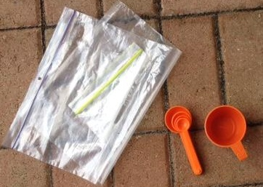
Equipment list

- ½ cup cream
- ½ cup milk
- 1 teaspoon sugar
- 2 ziplock plastic bags – one that will fit comfortably within the other with one cup of ice
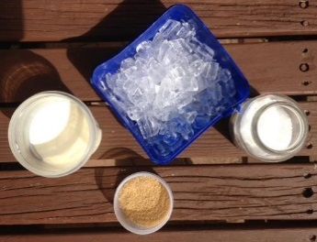
- 1 cup ice
- 2 tablespoons salt
- 1 teaspoon flavouring (e.g. vanilla, chocolate sauce)
- Measuring spoons and measuring cups
- Small mixing bowl

Student instructions
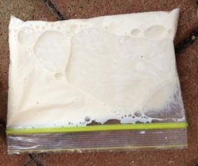
- Measure and then mix the cream, milk, sugar and flavouring together in a small mixing bowl.

- Pour the mixture into the small plastic bag and seal the ziplock.

- Mix the ice and salt in a large ziplock bag.

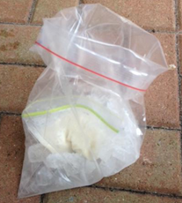
- Place the small plastic bag containing the milk mixture into the large plastic bag and seal the ziplock.

- Shake the bag, moving it enough to make sure the ice surrounds the small plastic bag. Keep gently moving the bags, making sure not to burst either bag.

- Observe any changes you can see and record into a group brainstorm.

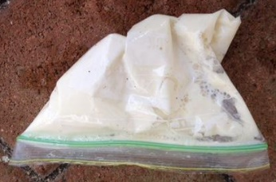
- In your groups, discuss how you will know when the milk mixture has become ice cream.

- When you have decided that the process is finished and you have made ice cream, remove the small bag from the large one and rinse it to remove the salty mixture.

- Discuss these questions in your group:
- What observations did we make? What did we notice?
- What questions did we come up with?
- What happened to the milk mixture?
- What happened to the ice?
- Why did that happen? How did it happen?
- What does the salt do? What if we didn’t add salt?
- What does the ice do?
- What is actually happening scientifically? What is happening to the cream, milk and sugar particles? What is happening to the ice and salt particles ?

Extension ideas/prompting questions for teachers

Students could design simple experiments to explore the variables involved in ice cream making. These might be carried out in groups in class and the results compared. Alternatively, these could be carried out for homework.

Questions to investigate could include:
- Does adding flavouring change the process?
- Does when you add flavouring alter the process?
- Do different flavourings make a difference?
- Does it make a difference if we use different containers?
- What if we didn’t use salt? What if we used sugar or another chemical in the ice instead?
- Does the quantity of milk/cream make a difference?
- Does the proportion of milk/cream make a difference?
- What other ingredients could make good ice cream?

