ACTIVITY: Using concept cartoons to explore students’ scientific thinking

Activity idea

In this activity, students use a concept cartoon to explore a range of viewpoints about a science idea.

By the end of this activity, students should be able to:
- discuss and justify their own scientific ideas
- consider other students’ scientific thinking
- locate information to clarify/support their own scientific thinking
- create their own concept cartoons to explore a scientific idea (optional).

Background information for teachers
Teacher instructions
Student instructions
Concept cartoons – blank templates

Background information for teachers

Concept cartoons are a visual representation of science ideas. The simple cartoon style drawings put forward a range of viewpoints about science ideas in situations that are designed to motivate and engage students and stimulate discussion of their ideas.

A variety of pedagogical methodologies and approaches are listed in the article Using concept cartoons.

The student handouts explore two different scientific concepts: water’s gaseous state and gravity. Both handouts highlight common alternative conceptions students might hold about each concept.

There are also blank templates for you – or your students – to use to create your own concept cartoons.

You may wish to use the Hub’s articles on alternative conceptions as a starting point. Alternatively, use prior knowledge and/or comments from your students to help them work through the concept.

Teacher instructions

- Begin the activity with one of the handouts, or use one of the templates to create your own concept cartoon.

- Briefly discuss the image so everyone is aware of the scientific concept being considered.

- Ask students to examine the cartoon, take time to choose which character they agree with and write it down on a piece of paper.

- Ask each group to discuss the cartoon and try to reach consensus about which character they agree with. Students will need to justify their own thinking and consider the viewpoints of others.

- Provide access to resources if students choose to research the characters’ statements.

- Clarify/extend students’ understanding by asking them to create their own concept cartoons to share with others.

Concept cartoon answers and additional resources

Water’s gaseous state

The accurate character statement is: steam is very, very small water drops.

More information about water as a gas (water vapour):
- Alternative conceptions about water’s states of matter (article)
- Solids, liquids and gases (article)
- Water: solid, liquid and gas (media)

Gravity

The accurate character statement is: gravity pulls things to the centre of the Earth.

More information about gravity:
- Alternative conceptions about gravity (article)
- Gravity and satellite motion (article)
- Nigel Latta Blows Stuff Up Episode 8: Gravity (article)
- Gravity and satellites: true or false? (media)

Student instructions
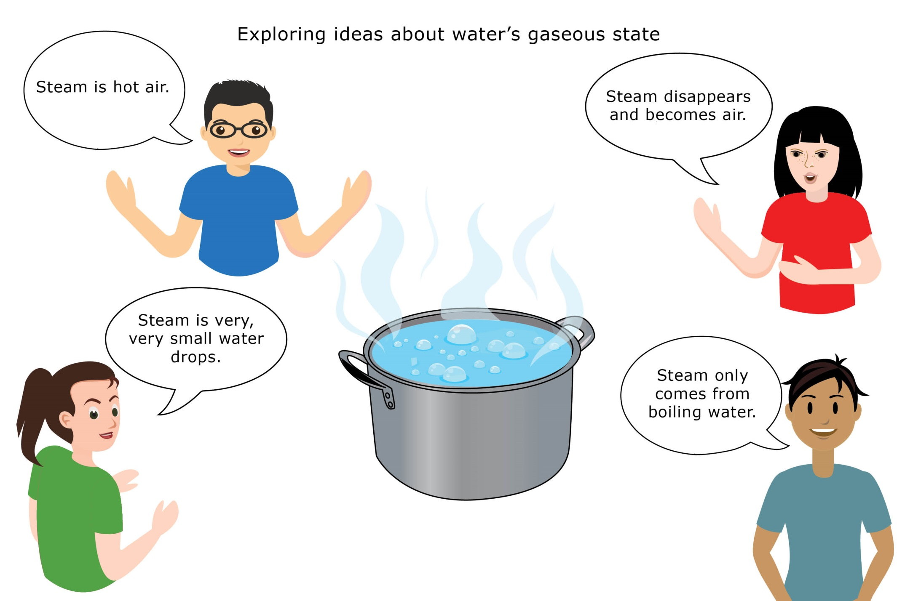
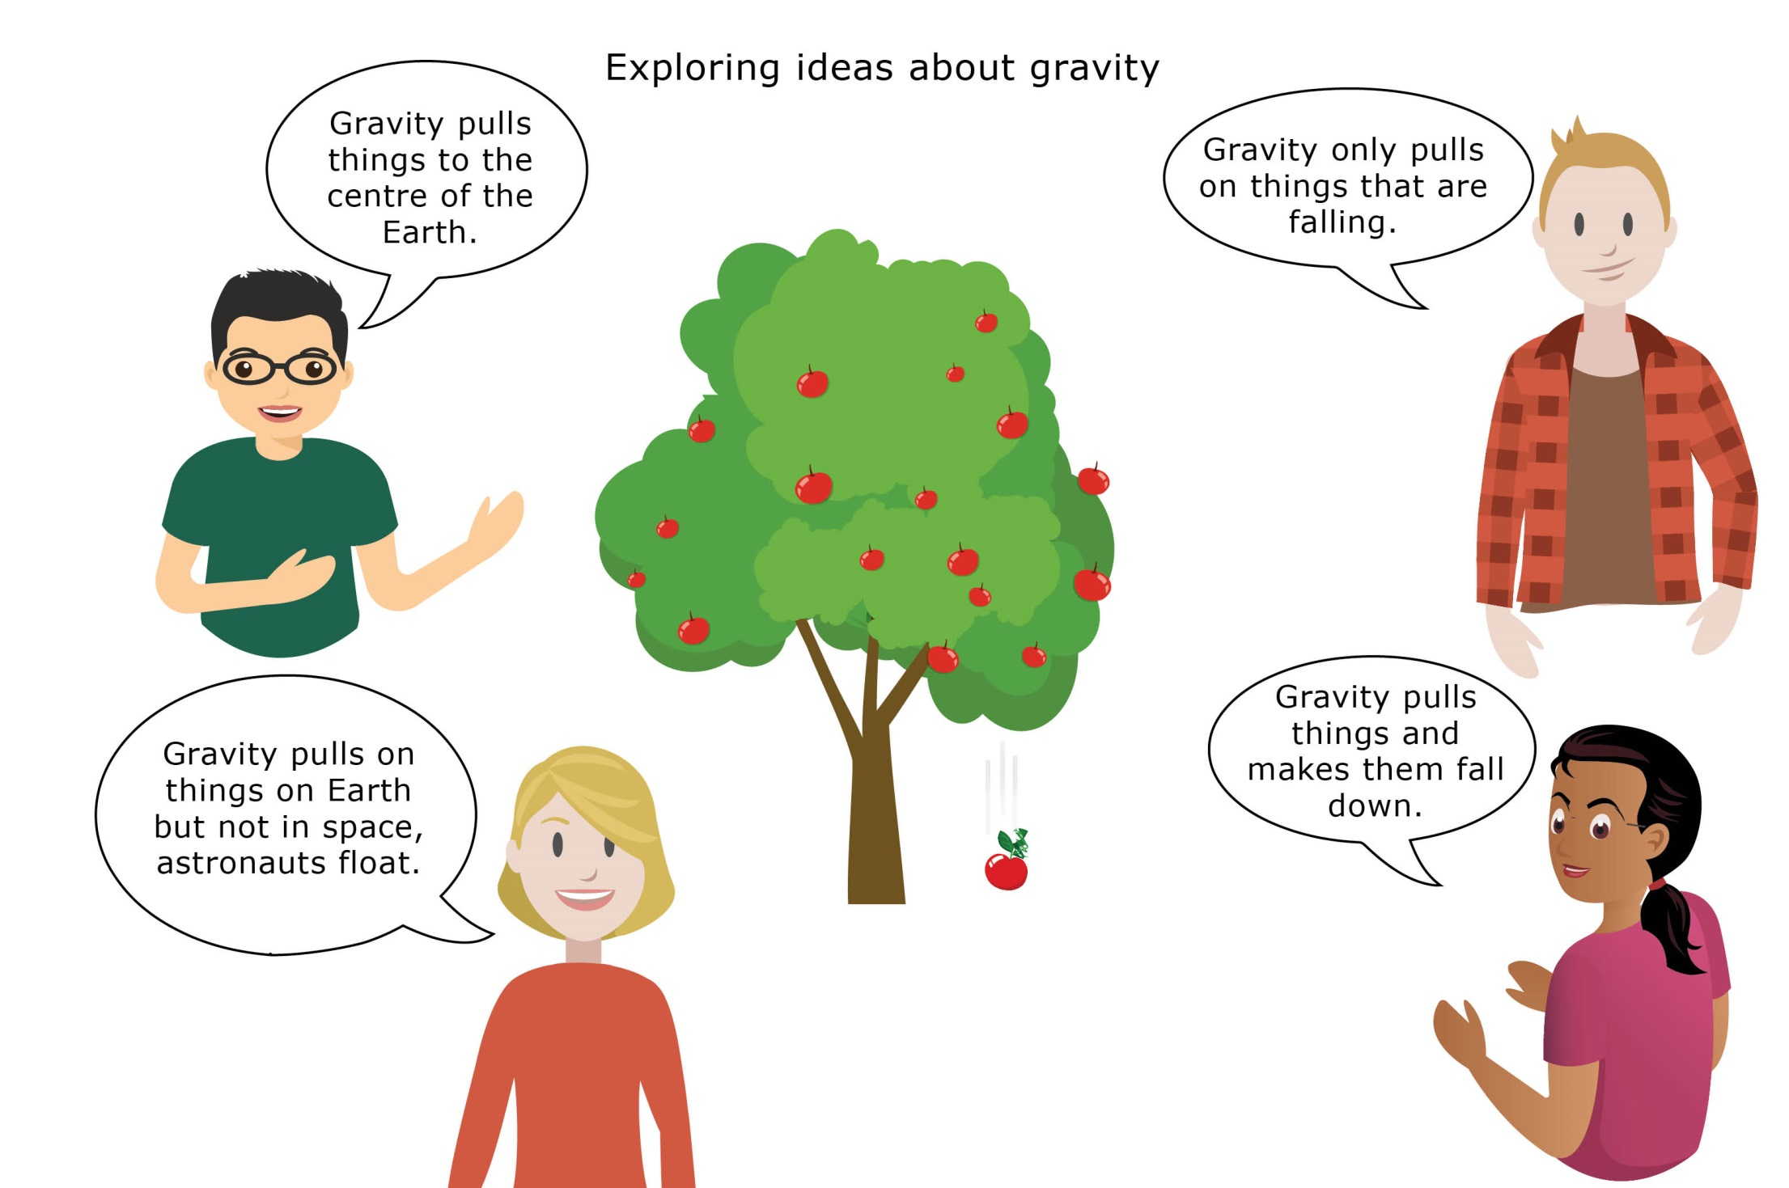
Concept cartoons – blank templates
