ACTIVITY: Carbon cycle quiz

Activity idea

In this activity, students use the interactive carbon cycle diagram to explore the global carbon cycle and to answer questions in an online or paper-based quiz. The quiz combines scientific literacy with reading literacy and provides students with an opportunity to practise the science capability ‘Interpreting representations’.

By the end of this activity, students should be able to:
- use scientific literacy skills to read and interpret features of the carbon cycle diagram
- use reading literacy skills to locate information to answer the quiz questions
- use inference skills to answer some of the quiz questions
- discuss some of the science concepts that underlie the carbon cycle.

Background information for teachers
Student instructions

Background information for teachers

This activity uses the interactive carbon cycle diagram.

The carbon cycle is one the key biogeochemical cycles on Earth. The Earth has a finite amount of carbon, and it is recycled between living and non-living things. Processes like photosynthesis and ocean currents/circulation move and/or cycle carbon through its various transformations. Carbon stores are where carbon-containing compounds are held for an indefinite period of time. Scientists are interested in stored carbon (also known as sinks or sequestrations) because long-term carbon storage in vegetation and soils are two ways of mitigating CO₂ – a greenhouse gas.

In addition to learning about the carbon cycle, this activity is ideal for helping students learn to read and interpret diagrams. Key things to notice while using the carbon cycle diagram are:
- surface features regarding colours and labels – noting that labels identify stores and processes
- arrows and directionality of the processes
- the nature of a cycle – it has no beginning or end.

The quiz covers some of these diagram surface features. In addition, students use their reading skills to answer literal and inferential questions. Students can complete the online quiz or the paper-based quiz. It can be used as an introductory tool to gauge students’ prior knowledge or as a summative assessment.

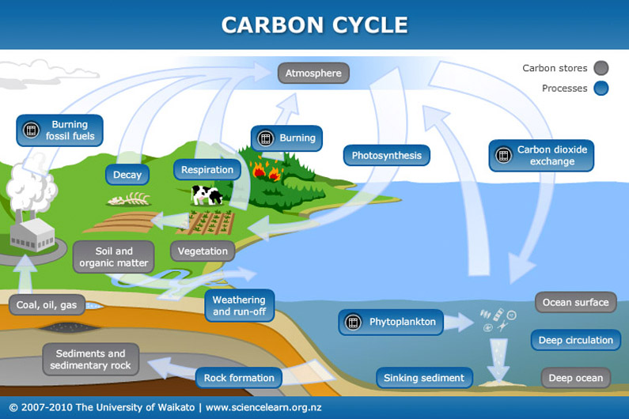
Quiz answers
- A
- B
- C
- B
- A
- B
- B
- A
- C
- C
- C
- B

Student instructions

Use the interactive carbon cycle diagram to answer the questions.

      - A carbon store is a natural or artificial sink that accumulates and stores carbon-containing chemical compounds. Which of the following is not a carbon store?
- Phytoplankton
- Soil and organic matter
- Ocean surface

      - Processes move carbon from one form to another. Which of the following is a process?
- Vegetation
- Rock formation
- Coal, oil and gas

      - Where does the carbon cycle begin?
- The atmosphere
- The ocean surface
- Cycles do not have a beginning

      - Which of the following carbon stores holds the most carbon?
- Atmosphere
- Sediments and sedimentary rock
- Coal, oil and gas

      - Looking at the diagram’s surface features, which of the following processes show the removal of carbon dioxide from the atmosphere?
Photosynthesis and oceanic CO₂ exchange
Photosynthesis and deep ocean currents
Oceanic carbon dioxide exchange and deep ocean currents

      - Most of the mass of the trees around us comes from
- CO₂ in water
- Atmospheric CO₂
- CO₂ released by decomposers

      - How much more CO₂ is in the oceans compared to the atmosphere?
- 30 times as much
- 60 times as much
- 90 times as much

      - The amount of carbon in the atmosphere is:
- Increasing
- Decreasing
- Staying the same

      - Soil erosion carries carbon compounds from the land to the ocean. What other process does the same thing?
- Sediments and sedimentary rock formation
- Vegetation growth
- Weathering and run-off

      - Phytoplankton act as a carbon store when they:
- Breathe in CO₂
- Die and become a food source for other creatures
- Die and move down into the deepest part of the ocean

      - What pushes limestone rock to the surface where it can be weathered?
- The rock cycle
- Formation into gas and oil
- Tectonic Earth movements

      - Even if we stop burning fossil fuels and firewood, will CO₂ still continue to be released into the atmosphere?
- No
- Yes

