ACTIVITY: Sports and physics quiz

Activity idea

In this activity, students explore some of the physics involved in weightlifting and cycling, using an interactive online or paper-based quiz. The quiz combines scientific literacy with reading literacy and provides students with an opportunity to practise the science capability ‘Interpreting representations'. It also demonstrates contextual learning by applying physics conceptual knowledge to real-life applications.

By the end of this activity, students should be able to:
- use scientific literacy skills to read and interpret diagrams
- use reading literacy skills to locate information and answer the quiz questions
- apply physics concepts to sporting contexts.

Background information for teachers
Student instructions

Background information for teachers

Physics is integral to all sports, from archery to skydiving. Force and movement, energy transformations, Newton’s laws of motion, velocity, angular momentum and rotation are just a few concepts that can be studied in a sporting context.

This quiz focuses on two sports – weightlifting and cycling. Challenge students to apply their knowledge of levers to the action of a human arm and the forces and energy behind cycling. In addition to students using their physics knowledge, this activity provides practice in reading and interpreting diagrams.

Students can complete the online quiz or the paper-based quiz.

The following resources provide background information. Students can use the resources to check their answers, revise incorrect answers or extend their knowledge about the physics of weightlifting and cycling.

What levers does your body use?
What is energy?
Forces and speed
Causes of aerodynamic drag
Rolling resistance
Pedal power

Quiz answers

- B
- C
- A
- B
- C
- A
- A
- C
- C
- C
- B
- A

Student instructions

Did you know that physics is part of every sport? Test your physics knowledge as it applies to weightlifting and cycling.

Weightlifting

      - In the human body, muscles and bones act together to form levers. Levers are used
- So that a small force can add speed to a much bigger force
- So that a small force can move a much bigger force
- So that a small force can add endurance to a much bigger force

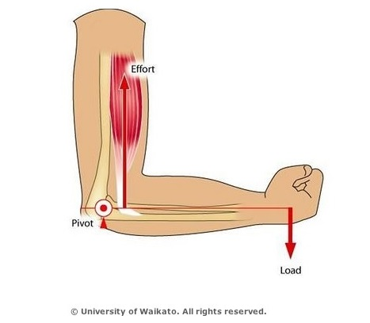
      - In the image above, what part of the human body provides the effort force to move the load?
- Bone
- Joint
- Muscle

      - In the image above, what part of the human body acts as the lever?
- Bone
- Joint
- Muscle

      - In the image above, what part of the human body acts as the pivot?
- Bone
- Joint
- Muscle

      - In the image above, the bent arm acts as a
- Class 1 lever
- Class 2 lever
- Class 3 lever

Cycling

      - The power of a cyclist depends on
- The force and speed pushing the pedals
- The technology used to reduce drag and weight
- The cyclist’s body mass compared to tyre size

      - What kind of energy is used when a cyclist pedals a bike to make it go faster?
- Kinetic energy
- Elastic energy
- Radiant energy

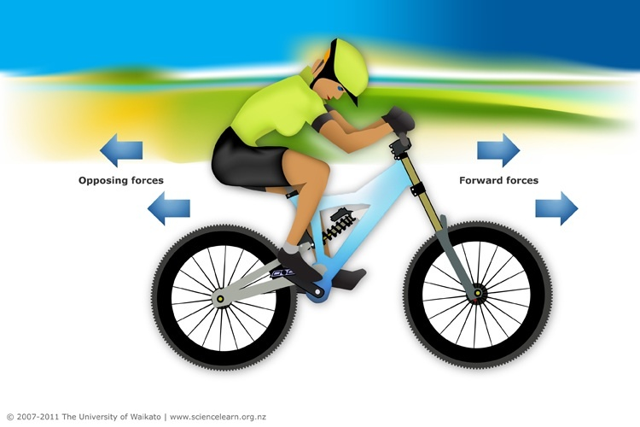

      - Forward forces on a bike come from
- Pushing on the pedals
- Pulling on the pedals
- Both pushing and pulling on the pedals

      - The two main forces that oppose a cyclist’s motion are
- Aerodynamic drag and air resistance
- Aerodynamic drag and weight resistance
- Aerodynamic drag and rolling resistance

      - Cyclists wear tight clothing made of material like Lycra to reduce
- Pressure drag
- Rolling resistance
- Aerodynamic drag

      - Correct tyre pressure helps to reduce
- Pressure drag
- Rolling resistance
- Aerodynamic drag

      - Cyclists ride closely behind each other to reduce
- Pressure drag
- Rolling resistance
- Aerodynamic drag

