ACTIVITY: Native plant leaves – DIY classification system

Activity idea

In this activity, students get a taste of classification without having to work through the complexities of the Linnaean system. Students create their own informal classification systems, using visual or other characteristics, to group native plant leaves found in the local environment. The activity fosters observation skills (gathering and interpreting data) and provides practice in using and critiquing evidence.

By the end of this activity, students should be able to:
- use their senses to observe native plant leaves
- devise and revise their own classification system
- comment on how they used evidence to devise their own classification system
- comment on how they were able to critique evidence to revise their own classification system
- experience why species may be reclassified as new information comes to light.

Background information for teachers
Student instructions

Background information for teachers

This activity begins with a walk through the school grounds to collect native plant leaves. Working in small groups, students arrange the leaves into classification groups using their own selection criteria. After viewing and discussing classification systems designed by other groups, students have the opportunity to revise their original systems.

Informal classification and the nature of science

Classification is one of science’s fundamental concepts. The systematic grouping and naming of living and non-living things has developed over the centuries and aids accurate communication among scientists. Classification is also an example of the tentative nature of science – as technology improves, scientists are able to make more complex observations. Advanced techniques like DNA analysis and electron microscopes provide new information and new interpretations. This has changed how we identify things from insects to crystals and can add controversy to old ways of naming things!

Informal classification and the science capabilities

Whichever technique is used, classification always begins with observation. In this activity, students use their senses (excluding taste) to observe and gather data about the leaves. Students use the data to make inferences (conclusions drawn from the observations) about their criteria for classifying/grouping the leaves. Like real scientists, the students need to back up their groupings using evidence. After viewing how other groups have classified their leaves, students can critique their evidence and revise their classification system. Teachers also have the option to add new information to challenge students’ thinking and selection criteria.

Meeting the needs of students

This activity is a simple way to investigate both the systematic grouping of leaves and the tentative nature of scientific classification. It is suitable for early primary students through to secondary. Feel free to tweak the activity to meet student needs. The student handout is in Word – adapt it as required.

Although the activity suggests using native plant leaves, it may be more appropriate for younger students to collect any type of plant leaf.

Ideas for extending students:
- Challenge them to collect only native plant leaves.
- Move on to formal classification and binomial naming.
- Add a few different plant species/leaves after groups have established their classification system. For example, pass out some fern fronds and ask students to use their selection criteria to fit the new leaves into the chosen groups. Students may need to rethink their criteria based on new information.

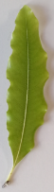
Student instructions

Gathering the leaves

Equipment we need to collect the leaves:

Ways we can collect leaves without damaging the plants:

Observing the leaves

Using our senses to observe each leaf. For example, we can observe how each leaf:
- looks – its colour, shape, size and any markings it has
- feels – whether it is smooth, rough, furry, bumpy or prickly
- smells – and whether the leaf even has a smell
- sounds – perhaps by running a finger around its edge or rubbing it between our fingers.

We will NOT observe any leaves by tasting them.

Our observations:

Discussing the selection criteria

Ways we can group the leaves – our selection criteria:

Classifying the leaves

Names and lists of common characteristics for each group:

Leaf features

One common method for grouping leaves is by their physical features.

Shape | 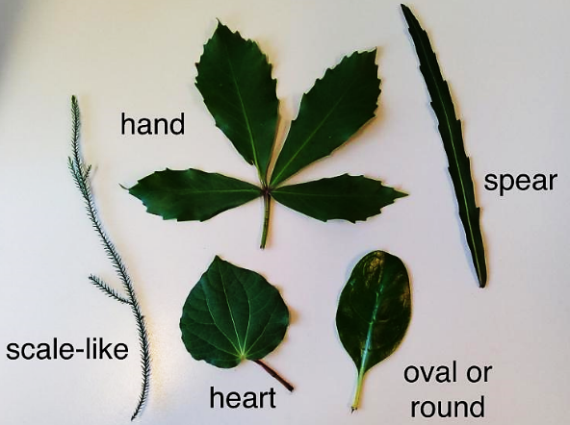
Edges | 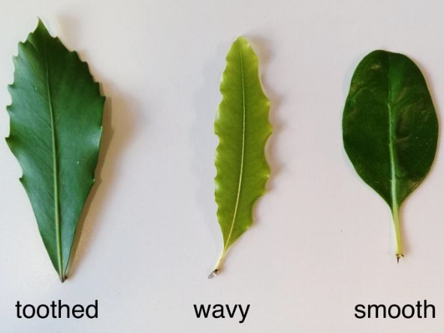
Stem placement | 