ACTIVITY: Making a life-size leaf collection

Activity idea

In this activity, students gather, press and label plant leaves to create a life-size leaf collection. Students laminate the dried leaves for easier handling and storage.

By the end of this activity, students should be able to:
- understand the processes used for collecting, pressing and drying plant leaves
- use resources to identify the plant leaves
- decide what information to include on an identification label
- discuss the value in having a leaf collection.

Background information for teachers
Student instructions

Background information for teachers

Dried and laminated plant leaves serve a number of purposes. They are life size and useful for plant identification when out in the field. They can form a reference collection when documenting a restoration project. Lamination means the leaf can be flipped to study the front and the back. Lamination also means the specimen can be handled in a more robust manner.

The purpose of the leaf collection will guide aspects of the collection and labelling processes. If you are creating a reference collection to monitor plant growth along a transect line, collection, record keeping and labelling will require a greater attention to detail. If the purpose is to gather leaves for observation, labelling need not be as specific.

The student instructions are in Word – alter them to suit your students’ needs.

Resources for plant identification

Andrew Crowe has produced several inexpensive, easy-to-use identification guides: Which Native Forest Plant, A Mini Guide to the Identification of New Zealand Native Trees, Life-Size Guide to Native Trees and A Mini Guide to the Identification of New Zealand Native Ferns.

Online resources include:
- the Department of Conservation’s Experiencing native trees in your green space teaching resource
- Manaaki Whenua Landcare Research’s Key to native plants of schools and marae in New Zealand
- University of Otago’s Flora Finder app
- New Zealand Plant Conservation Network’s Leaves PDF.

Student instructions

Equipment

- Plant identification book
- Camera or cell phone
- Scissors
- Bags for collecting leaves
- Corrugated cardboard (A4 size)
- Newspaper (A4 size)
- 2 pieces of plywood, wooden lattice or ceramic tiles
- Luggage strap
- Identification labels

Collecting the leaves

      - Chose a plant. Use an identification book to find the plant’s name. If possible, photograph the entire plant – its stem or trunk, bark, seeds and so on.

      - Record the details of the plant on the plant information table. Choose how much information you need to record. Handheld GPS units and cell phones give map co-ordinates, if you want this level of detail.

      - Cut the leaf or stem of leaves from the plant and place it in a bag. Choose a sample with flowers, if in season. You can also collect seeds and small pieces of bark, if available. Number the bag to match the plant information table.

      - Continue this process as you collect additional plant leaves.
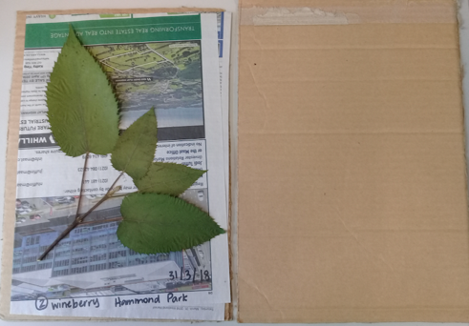
Pressing and preserving the leaves

      - To press a leaf, lay down a piece of corrugated cardboard and top it with a piece of newspaper. Lay the leaf on the newspaper, with the plant name and corresponding number on the newspaper.

      - Cover the leaf with newspaper and cardboard.

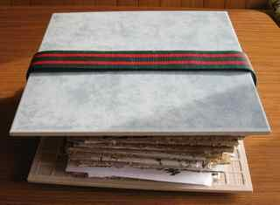
      - Continue stacking the layers of cardboard, newspaper and leaves.

      - Place the collection in a plant press or between two pieces of plywood or tiles.

      - Secure the collection with a luggage strap. The collection needs to be tightly pressed.

      - Place the collection in a dry place. The goal is to dry the leaves as quickly as possible to hold their colour. If possible, change the newspaper daily.

      - Place any seeds or bark in a space to dry. Label the seeds with the plant name and corresponding number.

      - Test if the leaf is dry by holding it up to your cheek. If it feels cold, it is not dry yet.

      - Once dry, museums place the leaves, seeds and bark in a freezer to kill mould spores and insect eggs, but you can omit this step if freezer space is not available.

Creating labels

      - Use the table to create identification labels. You can choose what to include, but at a minimum, the label should contain the plant’s scientific name, common name, Māori name, location and date collected.

Creating the life-size leaf book
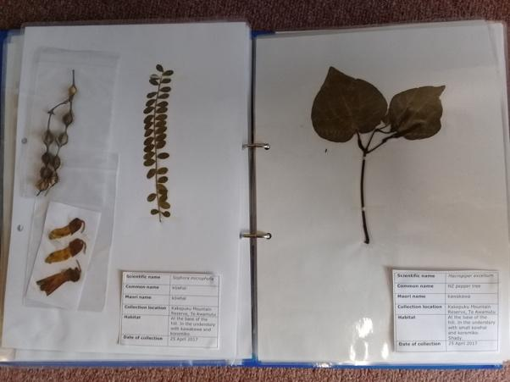
      - When the leaf is dry, trim it of any bulky stem materials.

      - Place the leaf on a backing sheet, if desired. Alternatively, place the leaf directly on the laminating sheet. This allows you to see the back of the leaf, which may look different to the front.

      - Position the label on the laminating sheet. Position any other information you want to use – for example, a photo of the plant, information about the plant species or dried flowers.

      - Use a laminator to heat seal the leaf. Take special care when laminating leaves with thick stems.

      - If the leaf is too bulky to laminate, tape it onto cardboard and place it in a plastic sleeve.

      - If you have collected seeds or bark, place the material in a small bag and attach the bag to the laminated sheet.

      - Place the sheets in a notebook.

Plant information

Plant number – write on the collection bag
Plant name – you can identify it later if you don’t know

Collection location – map co-ordinates, transect information, altitude

Habitat – forest, wetland, next to a stream etc.

Name of collector

Date of collection

Plant number – write on the collection bag
Plant name – you can identify it later if you don’t know

Collection location – map co-ordinates, transect information, altitude

Habitat – forest, wetland, next to a stream etc.

Name of collector

Date of collection

Plant number – write on the collection bag
Plant name – you can identify it later if you don’t know

Collection location – map co-ordinates, transect information, altitude

Habitat – forest, wetland, next to a stream etc.

Name of collector

Date of collection

Identification labels

Scientific name
Common name
Māori name
Collection location
Map co-ordinates
Transect location
Altitude
Habitat
Name of collector
Date of collection

Scientific name
Common name
Māori name
Collection location
Map co-ordinates
Transect location
Altitude
Habitat
Name of collector
Date of collection

Scientific name
Common name
Māori name
Collection location
Map co-ordinates
Transect location
Altitude
Habitat
Name of collector
Date of collection

