ACTIVITY: Label the landfill

Activity idea

In this activity, students use online and/or paper resources to identify and label components of modern landfill systems.

By the end of this activity, students should be able to:
- label the components of a modern landfill system
- discuss how these engineering practices help to protect us and the environment
- consider other aspects of landfill systems that are not explicitly labelled in the interactive.

Background information for teachers
Student instructions
Activity answers

Background information for teachers

Modern landfill systems have changed significantly from the days of tips or dumps. Many landfills that operate in New Zealand have components designed to protect the surrounding environment, allow for environmental monitoring, capture methane gas for reuse and capture and treat leachate. Ideally, the landfills are located in areas that are open spaces but also have vegetation to capture and reduce rainfall/run-off water to the site.

Use the Label the landfill interactive to identify some of the components used when constructing and operating a landfill.

These resources support student understanding:
Soil contamination – article
Point source contamination – video
Anaerobic digestion (methane gas production from wastes) – article

The activity also provides practice with the science capability ‘Interpret representations’.

Questions to deepen student thinking

Questions regarding landfill construction and use:
- What is the role of each component?
- How do the components help to protect the environment?
- How do the components help to protect humans?
- Are there components that are missing in the image? (Capping system, methane or leachate storage tanks, electricity generation plant, for example.)
- What role does the surrounding environment play, for example, vegetation, proximity to surface water?

Questions regarding the science capability ‘Interpret representations’:
- What does this representation tell us about landfill systems?
- Why is it represented in this particular way?
- How does the diagram accurately (and/or inaccurately) portray a landfill?
- What are the advantages of using a diagram like the one presented?
- What are the drawbacks of using this type of diagram?
- Is the diagram drawn to scale? Should it be? Does it matter?
- What is left out of the diagram?

Student instructions

Use the labels at the top of the Modern landfill system diagram (see below) to identify the components of a landfill system.

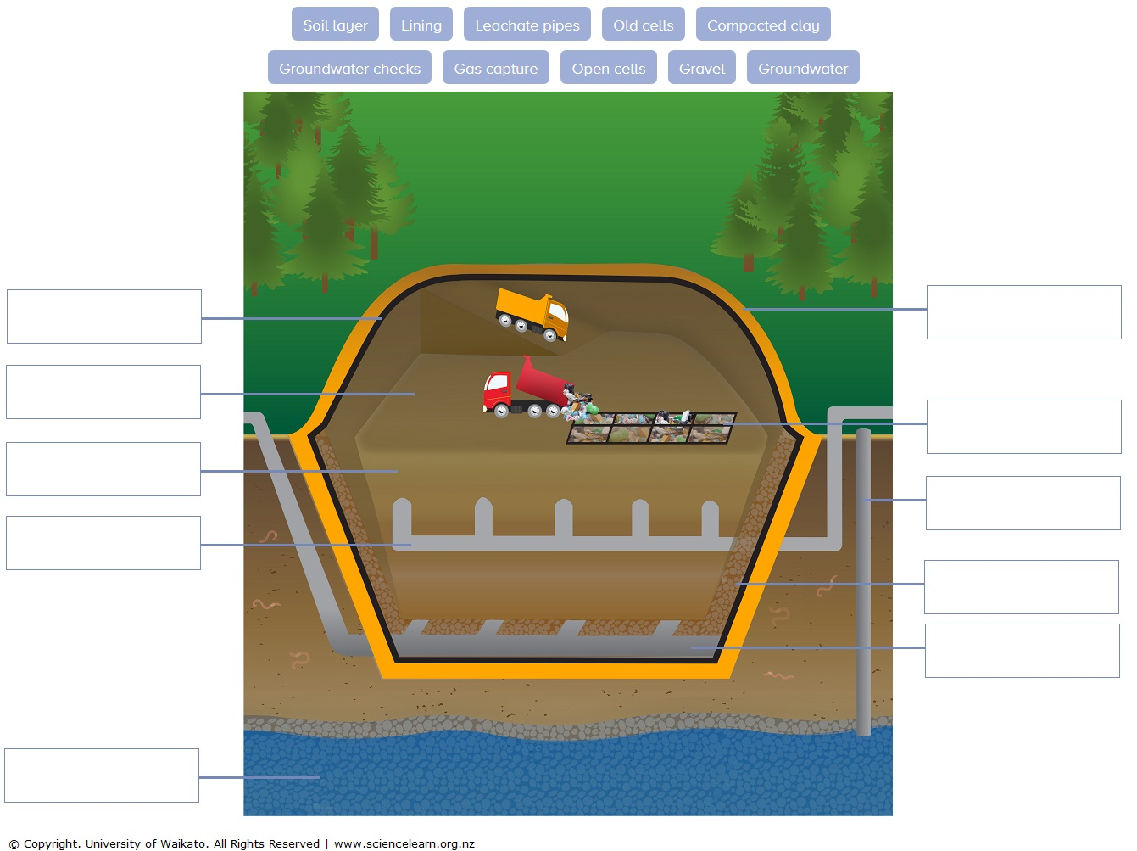
Use arrows to match the landfill component label to the corresponding function description.

Component |  | Function description
Soil layer |  | A combination of heavy HDPE and geotextile mats line the landfill walls and/or cells.
Lining |  | Larger landfills have cells that are filled progressively. When a cell is full, a new cell is opened.
Gravel |  | In large landfills, soil is used as a daily cover. The volume is between 4:1 and 5:1 waste to soil cover.
Gas capture |  | When a cell is filled to capacity, it is capped and restoration begins.
Leachate pipes |  | Clay forms an impermeable layer, much like a plastic liner. Some practices see 600 mm of clay compacted to 150 mm layer.
Open cells |  | Pea-sized gravel is placed over the linings on the bottom and slopes of the landfill and/or each cell.
Old cells |  | Perforated PVC pipes collect leachate – liquid that filters through waste. Leachate is pumped out and treated.
Groundwater |  | Ideally, the landfill system is above the saturated zone. Otherwise, special systems drain the groundwater.
Compacted clay |  | Groundwater around the landfill is regularly monitored and tested to ensure the system is functioning as designed.
Groundwater checks |  | Wells are dug into cells to capture gases formed during decomposition – usually methane.

Activity answers
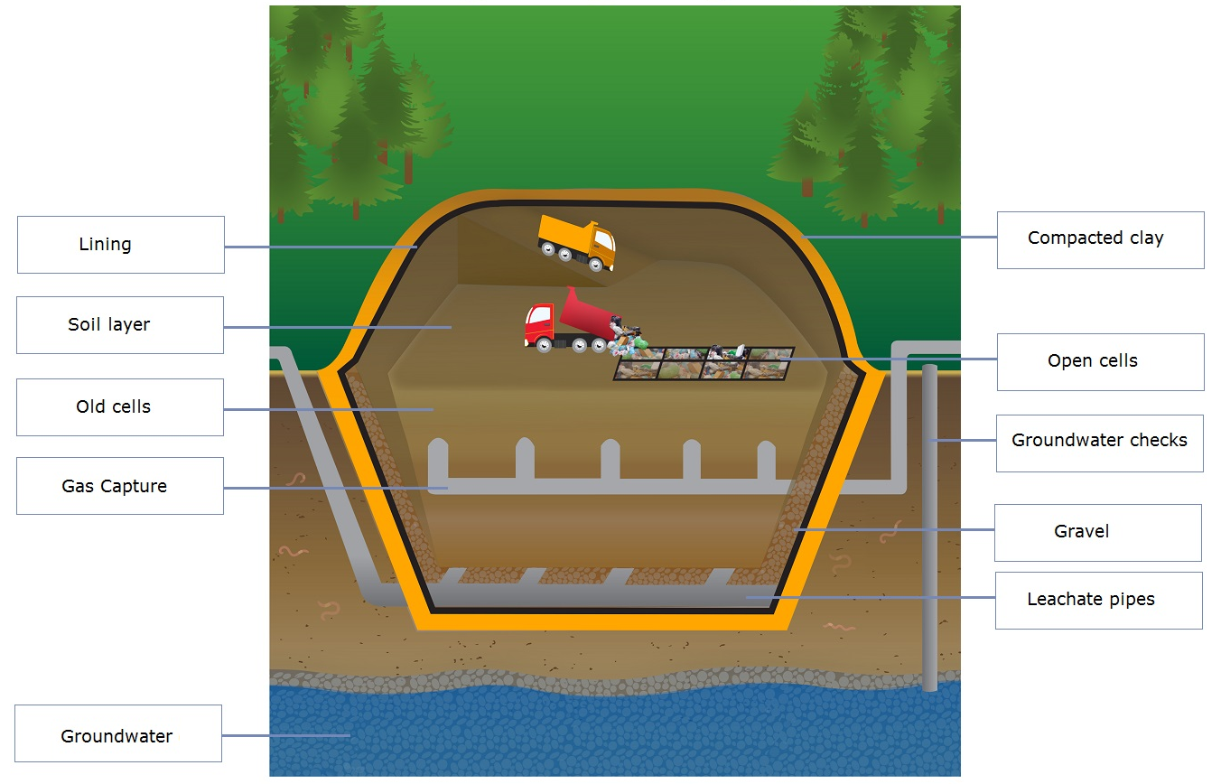

Parts of a modern landfill system

Components | Function description
Lining | A combination of heavy HDPE and geotextile mats line the landfill walls and/or cells.
Open cells | Larger landfills have cells that are filled progressively. When a cell is full, a new cell is opened.
Soil layer | In large landfills, soil is used as a daily cover. The volume is between 4:1 and 5:1 waste to soil cover.
Old cells | When a cell is filled to capacity, it is capped and restoration begins.
Compacted clay | Clay forms an impermeable layer, much like a plastic liner. Some practices see 600 mm of clay compacted to a 150 mm layer.
Gravel | Pea-sized gravel is placed over the linings on the bottom and slopes of the landfill and/or each cell.
Leachate pipes | Perforated PVC pipes collect leachate – liquid that filters through the waste. Leachate is pumped out and treated.
Groundwater | Ideally, the landfill system is above the saturated zone. Otherwise, special systems drain the groundwater.
Groundwater checks | Groundwater around the landfill is regularly monitored and tested to ensure the system is functioning as designed.
Gas capture | Wells are dug into cells to capture gases formed during decomposition – usually methane.

