ACTIVITY: Reflections in a full-length mirror

Activity idea

In this investigation, students conduct a science investigation to determine how tall a full-length mirror must be to allow them to see their entire reflection head to foot. The students will take measurements and produce a scaled drawing.

By the end of this activity, students should be able to:
- draw a scale diagram showing light rays from their head and feet bouncing off of the mirror and going into their eyes
- conduct a simple experiment to solve a real-world problem

Background information for teachers
Investigation instructions
Extension ideas

Background information for teachers

This investigation asks students to respond to a science-based question: “How tall does a full-length mirror need to be in order for you to see your full reflection?” The answer would seem to depend on how close you stand to the mirror. However, an investigation will show that this is not the case. By taking a few simple measurements and constructing a scale drawing, the students will see how the light from their feet – specifically, their heels – and the top of their head bounces off the same spot on the mirror regardless of how far away they stand. (Although it is easier to see the toes, they are closer to the mirror than the top of the head and the investigation assumes that both their head and feet are the same distance from the mirror.)

If your students have never made a scale drawing, you will need to explain the concept of scale and how, by using a scale drawing, you can measure things on the drawing and convert them to real-world measurements. Thus, if the scale is 1 cm = 1 mm, a distance of 125 mm on the drawing is equal to 125 cm (or 1.25 m) in the real world.

You will need:
- a full-length mirror mounted on a wall at a height so that everyone in the class can see a full reflection of themselves – the top of the mirror should be approximately level with the top of the head of the tallest person
- Post-it notes to mark positions on the mirror
- Measuring tapes or metre sticks.

Four measurements are required for this investigation:
- Distance from the mirror.
- Height of student
- Measurement from the floor to the position on the mirror where the student sees their heels.
- Measurement from the floor to the position on the mirror where the student sees the top of their head.

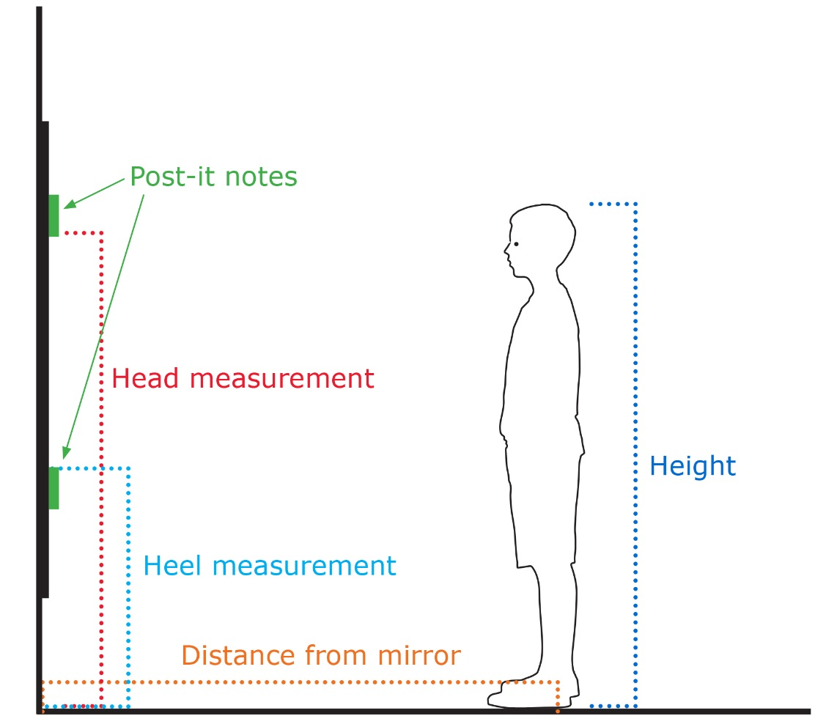
From these measurements, the students produce a scale drawing of the mirror, themselves and the light rays. Some students may not understand that light rays start at the object and end in the eyes.
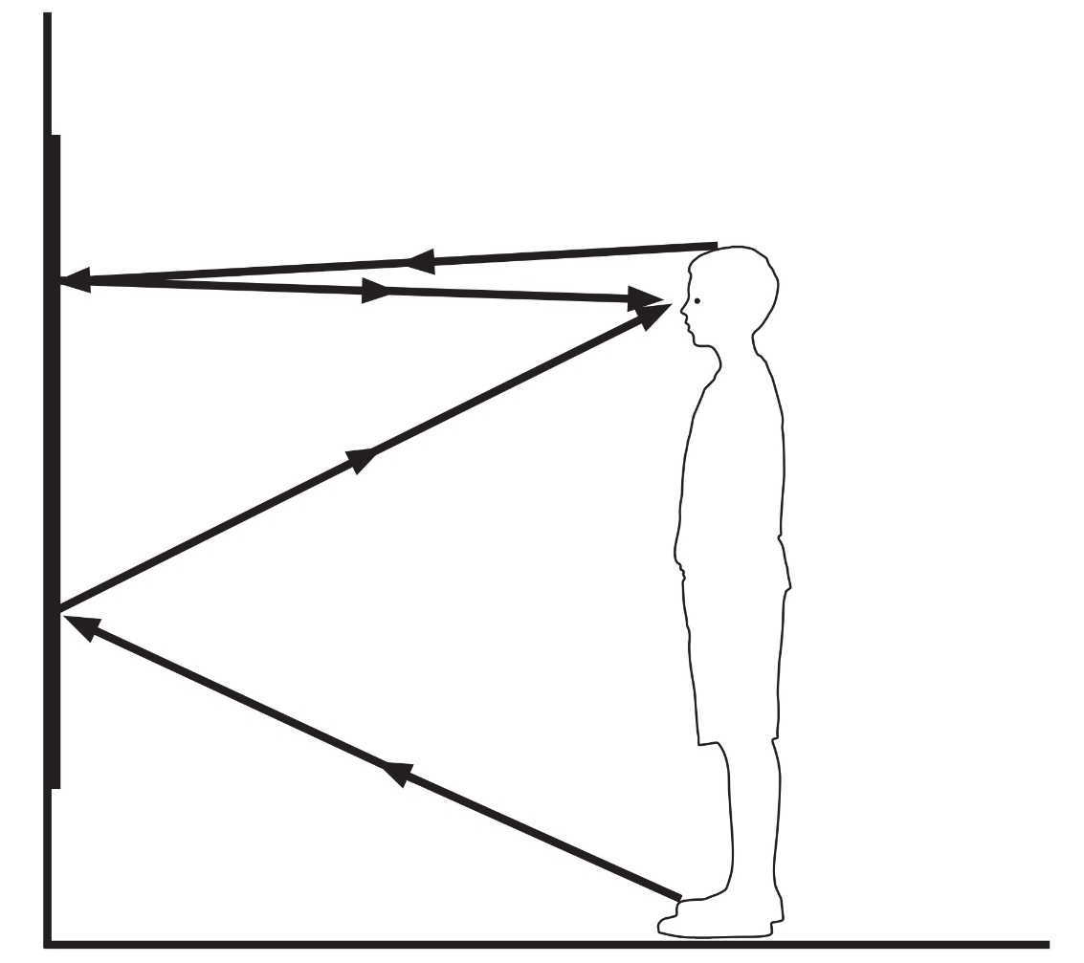
Some students will think that the further you get from the mirror, the smaller it needs to be. This is why it is important to conduct the experiment, repeating the procedure at a distance further from the mirror.
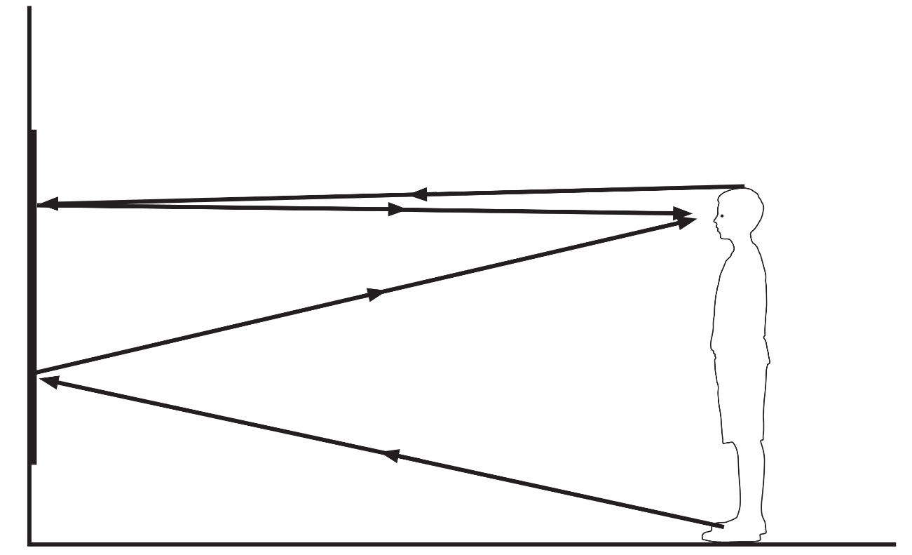

When students compare their two drawings, they will find that the size of the mirror needed to see their complete reflection is not dependent on how far they are from the mirror.

If you ask the class how tall a mirror needs to be for them to see their own complete reflection they will have different answers. If they compare their own answer to their height, they should find that they would need a mirror exactly half of their height to see their full reflection.

Note: This provides students with an opportunity to recognise patterns in their data.
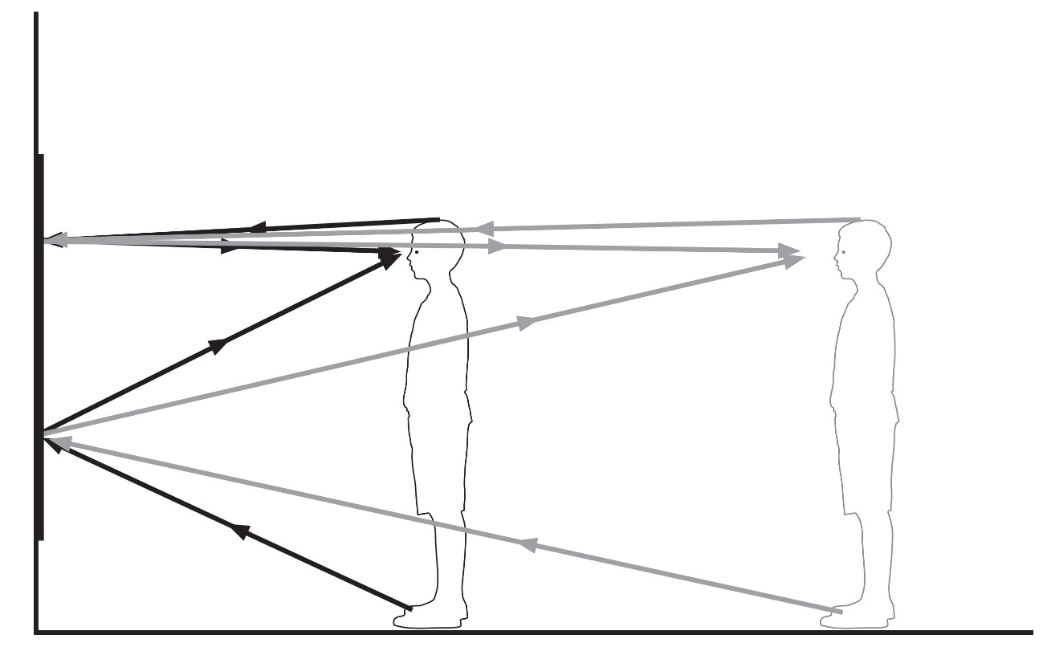

Scientific explanation
Light rays travel in straight lines. When light rays strike an object, they are ether reflected (bounce off the object), refracted (travel through the object) or absorbed (stopped by the object). In reality, almost all objects will do all three to some extent. Plane (or flat) mirrors have the ability to reflect most of the light that strikes them without altering it.

When we look at our reflection of our head in a mirror, we only see the light that comes from our head and hits the mirror at exactly the correct angle to bounce into our eyes. By marking the location on the mirror where we see our head, we are marking the position of the ray of light that travels from our head, bounces off the mirror and goes into our eyes.

A common alternative conception
A common alternative conception about light involves the direction the light is travelling. Some students will think the eyes are the active component, drawing arrows of light coming from the eyes and going to the object being observed.

Teaching considerations
Depending on the age and understanding of your students, you may decide to provide them with specific instructions on the distances to stand and provide them with a partially drawn picture with the floor and mirror drawn to scale.

Extension ideas

Introduce the concept of virtual images appearing to be behind the mirror. The images that are made by plane mirrors are known as virtual images. We can see an image that appears to be behind the mirror, but it only exists in our perception. When we look at ourselves in a plane mirror, we appear to be standing behind the mirror at the same distance we are in front of the mirror.
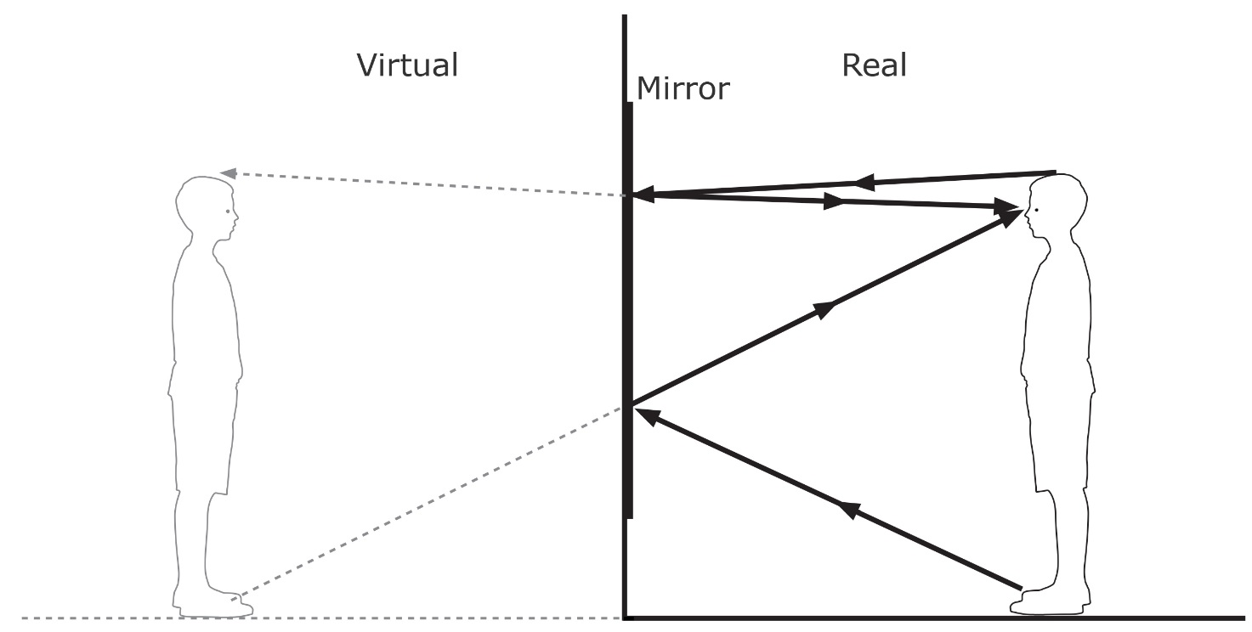
The angles formed by the light rays hitting the mirror should be the same as the angle formed as they leave the mirror. The students could use a protractor to measure these angles on their drawings. In physics, there is a specific term for these angles – angle of incidence and angle of reflection. They are measured between the light ray and a line perpendicular to the surface.
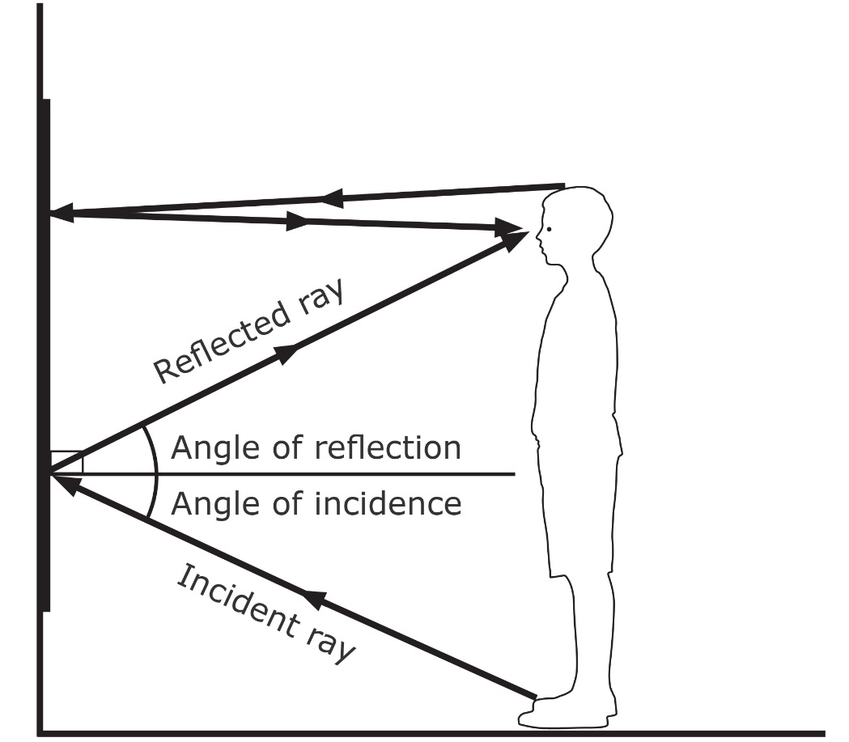
Investigation instructions

- Working in pairs, one student stands in front of the mirror and directs the other student to mark the position on the mirror (using Post-it notes) where they see the top of their head, and where they see their feet (specifically their heels). Note that the Post-its are being placed on the points where the person standing in front of the mirror sees their reflections, not where the person placing the Post-it notes sees the reflections.

- Measure the distance from the mirror to where the reflected person is standing, the height (above the floor) of the two positions on the mirror and the height of the student.

- Repeat at different distances from the mirror.

- Produce a scale drawing (a handy scale is 1 cm = 1 mm, which should fit on an A4 page).

- Discuss observations and findings.

