ACTIVITY: What is refraction?

Activity idea

In this activity, students are introduced to an analogy through a role-play that helps them visualise the refraction of light. The analogy explains why light bends when it enters or exits transparent materials and also why a prism separates white light into a colour spectrum.

By the end of this activity, students should be able to:
- explain why light bends when entering a material
- explain why a prism breaks light into a spectrum.

For teachers

Introduction/background

Physicists describe light as having properties of both a particle and a wave.  It is sometimes useful to think of light as a set of waves travelling outwards from a light bulb much like water waves would travel out from a stone thrown into a pond (wave theory). At other times, it is helpful to think of light as a ray or a single point on a wave travelling straight outwards from the source like a surfer riding the wave (particle theory). Both ways of thinking about light are useful depending on the context. | 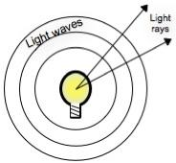
Refraction is the bending of light when it passes through a transparent material like glass or water at an angle other than 90°.  This diagram shows how a ray of light bends as it travels through glass. | 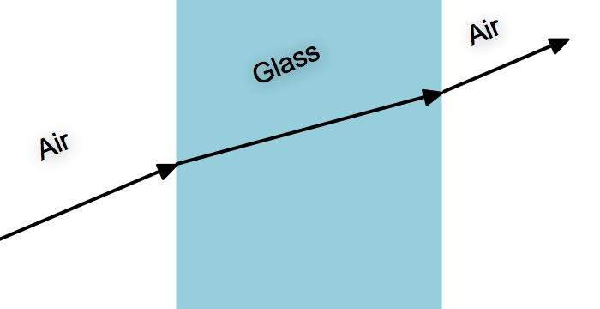
This diagram shows the same scene with the light waves added. It is conventional to draw waves as a series of lines, with each line indicating the same point on each wave (the red outline shows a sine wave superimposed on the diagram).  The waves begin on the left side of the diagram and travel towards the glass at a specific speed. When the waves strike the glass, they slow down. Because the glass is at an angle, part of the wave slows down and the rest keeps going at the same speed until each part strikes the glass. | 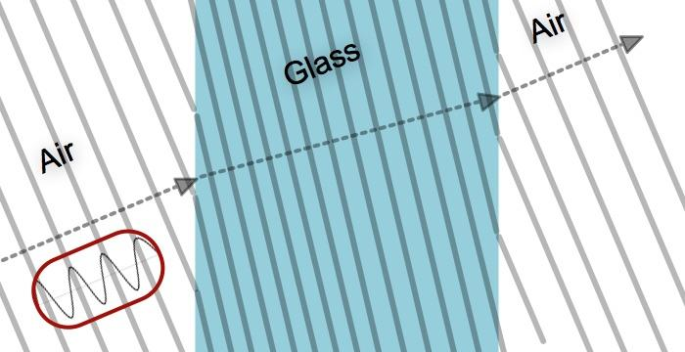

This phenomenon is sometimes difficult to understand by looking at diagrams, and an analogy may help.
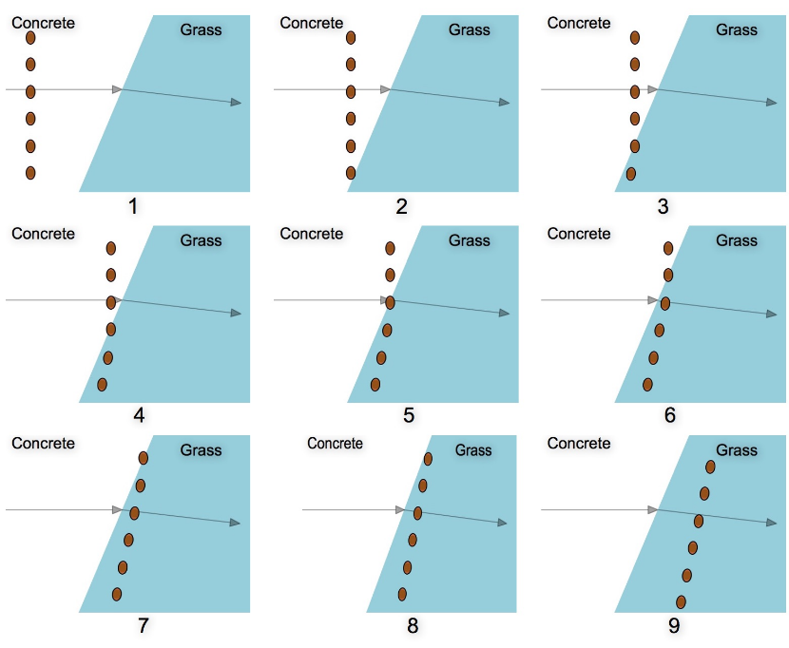
Have a group of students line up (linking arms helps) so that as they march forward, one end of the line will reach a boundary before the other end. Marching on a concrete playground towards grass works well.

The students should take large steps on the concrete and much smaller steps on the grass. This is analogous to how the waves change speed (and therefore change direction) in different media. It sometimes helps to practise taking large and small steps so everyone in the line takes the same size steps.

As the students cross the boundary and slow down, the line will bend and the group will turn. When everyone is on the grass, the line will be moving in a slightly different direction to when they were on the concrete.

In this analogy, the students are acting as a wave and the turning is analogous to what happens when a wave changes speed when passing from one media to another. The amount of turning depends on how different the speeds are in the two media and also the angle at which the light wave strikes the transparent medium.

Consider what would happen if the students marched onto the grass at a 90° angle. No matter how much they slow down, the line would not turn because all parts of the wave encounter the boundary at the same time.  The situation can now be reversed with the students marching from a slow medium into a faster medium. In this case, the line will turn in the opposite direction (have the line begin at position 9 above and go to position 1). | 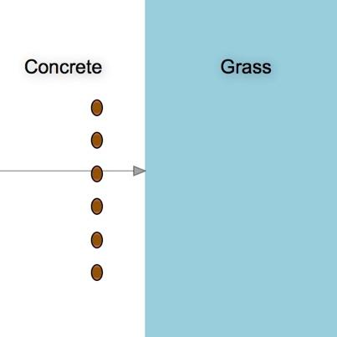
If your students are studying colour, you can use this analogy to explain why white light separates into the colours of the visible spectrum as it passes through a prism.  Have the students imagine that they are marching from a hard surface into mud, where each step is more difficult. Now have them imagine that some of them get to take longer strides and others take smaller steps. Once they hit the mud, the people who are taking long strides have an easier time of it, and they slow down less than the people who are taking small steps. Therefore, the people taking long steps will not turn as much when entering the mud as the people taking smaller steps. | 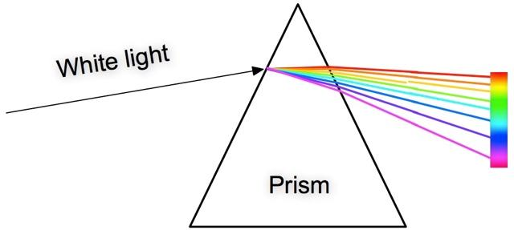

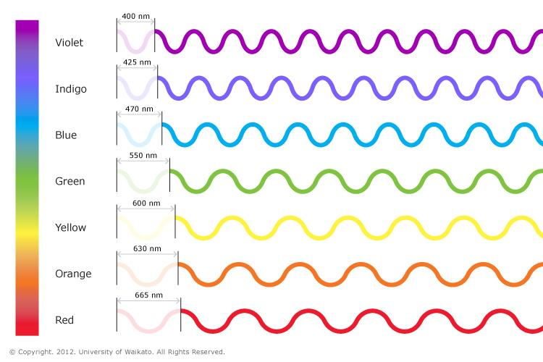
White light is made up of all of the colours, and each colour has a different frequency and wavelength. In the analogy of the students marching into mud, the wavelength is analogous to the length of their stride.

Red light has the longest wavelength in the visible spectrum, and like the students taking long strides, it does not slow down as much (and therefore bend as far) as light with shorter wavelengths. Violet has the shortest wavelength, and like the students taking shorter steps in the mud, it slows down the most and bends the farthest.

Analogies can help us understand things we cannot directly observe. They are used by scientists to create models to explain and test ideas and by science teachers to help demonstrate ideas. The analogy introduced in this activity helps students remember how light waves behave when they travel from one medium to another.

Extension ideas

- Visible light represents a fairly narrow portion of the electromagnetic spectrum. Other types of electromagnetic waves are also refracted by various materials. Students might find it interesting to consider how other waves such as microwaves, radio waves or X-rays are refracted and how this feature is exploited in modern technologies.
- Light can be represented as both a wave and a particle. Challenge students to consider whether the refraction of light is evidence for the wave or particle nature of light.

