ACTIVITY: Making a mushroom spore print

Activity idea

In this activity, students create a spore print from a mushroom. Individual fungal spores are microscopic and cannot be seen with the human eye, but spore prints allow students to visualise spores. Students also have the opportunity to choose a question regarding spore prints and to design an investigation to answer their question.

By the end of this activity, students should be able to:
- follow instructions to create an initial spore print
- consider why the print did or did not work
- gain experience in phrasing a question that can be answered with a simple investigation
- gain experience in designing and carrying out a simple investigation.

For teachers

Introduction/background

Spores are how fungi reproduce. A mushroom (fungus) cannot move, so it releases thousands of spores that are dispersed by wind or water. Spores are microscopic so we cannot see them with the human eye. However, when thousands of them are released in a spore print, we can see the patterns they make.

For safety reasons, this activity uses edible mushrooms. Whether a spore print is successful depends on the maturity of the mushroom. Mushrooms that are too young or too old will not work. If you collect your own mushrooms, choose healthy-looking mushrooms in the morning when there is rain. If you are using supermarket mushrooms, choose mushrooms that have their gills exposed.

If the mushrooms you use do not make a spore print after 24–48 hours, all is not lost. It demonstrates an important aspect of the nature of science. Not all investigations work, and it’s the job of scientists to examine the investigation to determine what went wrong and what to try differently. It also provides a natural context for students to design their own investigations.

Use the article Ngā Hekaheka o Aotearoa – kuputaka to find article links for background information and vocabulary terms in te reo Māori and English.

What you need

- Mushrooms (one or more varieties – trials indicate that flat brown Portobello and shiitake mushrooms work well)
- White and black paper (some spores are dark and some are light)
- Knife
- Ice cream containers or similar
- Magnifying devices (hand lenses, digital microscope or camera)

What to do

Making a spore print

- Use magnifying devices to examine mushrooms for spores.

- Follow the instructions for making spore prints.

- Examine the prints the next day. Discuss the outcomes, whether successful or not.

- Use the magnifying devices to examine the spore prints. Make comparisons between the prints and the mushrooms.

- If desired, conduct student-led investigations to answer questions the students might have.

Designing a student-led investigation

- Choose a question to answer. Example questions might be:
- Do all mushrooms make spore prints?
- Do mushrooms make darker prints if we leave them for longer?
- Does the age of a mushroom affect whether it leaves a spore print?
- Does temperature (or humidity) affect the spore print?
- Do different mushrooms species have the same coloured spores?
- Will the mushrooms still release spores if we leave them uncovered?

- Plan the investigation. Students need to consider:
- materials they need for the investigation
- time it will take to do the investigation – is it manageable?
- validity – will the investigation answer the question?
- the variables (any factor that can be controlled or changed in an investigation)
- measuring, recording or reporting their plan, the investigation process and the results – how will they make measurements and how will they present the data?

- Write out the question and the steps the students plan to take.

- Conduct the investigation and record the results.

- Discuss the results:
- Did the investigation answer the question?
- Were there any challenges to the investigation? How did you handle them?
- Would you make any changes to your investigation if you were to do it again?

Alternative conceptions

Mushrooms are not plants – they are fungi.

Spores are not seeds, but they serve a similar purpose. Spores allow fungi to reproduce.

For students

- Cut off the stalks. | 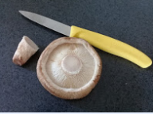
- Place the caps gill-side down on black and white paper. | 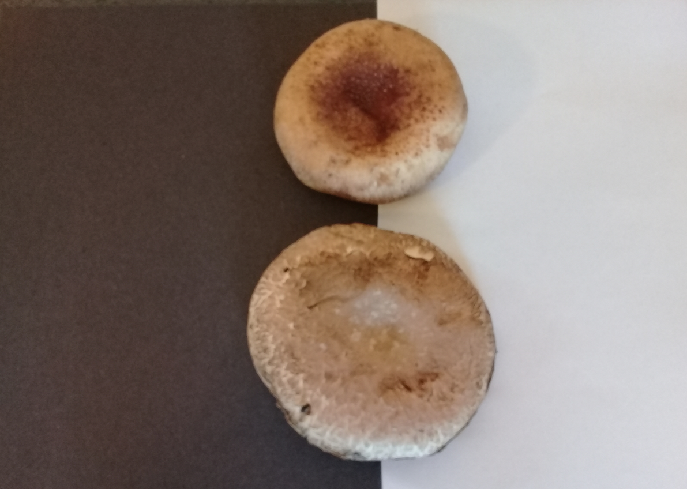
- Cover the mushrooms to keep moist overnight. | 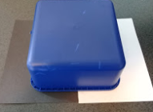
- Remove the cover and mushroom caps to reveal a print of the spores released from the gills. | 