ACTIVITY: Abiotic and biotic factors for takahē

Activity idea

In this activity, students identify the abiotic and biotic factors associated with the Murchison Mountains environment and the wild takahē population.

By the end of this activity, students should be able to:
- identify abiotic and biotic factors
- group the biotic factors into four categories – producers, consumers, decomposers and environment.

For teachers

Introduction/background

The takahē (Porphyrio hochstetteri) is an endangered species and classed as nationally vulnerable under the New Zealand Threat Classification System. The takahē is a flightless bird found only in New Zealand. It was presumed extinct in 1898 but rediscovered by Dr Geoffrey Orbell and his team in a remote valley in the Murchison Mountains in 1948. The takahē and its habitat have been widely researched, which is key to supporting the recovery of the population.

Identifying abiotic and biotic factors and exploring the interrelationships between them provides important data for the Takahē Recovery Programme.

This activity provides an opportunity to identify and sort abiotic and biotic factors associated with the takahē population in the Murchison Mountains.

Resources to support this activity

- Identify abiotic and biotic factors – student handout
- Population biology – article
- The takahē’s ecological niche – article
- Takahē conservation efforts – article

What to do

- This activity can be done individually or in pairs. Distribute copies of the student handout.

- Discuss background information. Identify abiotic and biotic factors in different ecosystems and how and why may they be different.

- Allow students time to complete the handout. Refer to the articles Population biology, The takahē’s ecological niche and Takahē conservation efforts to find out more about takahē and their environment. Encourage students to transfer their understanding to other contexts.

Identify abiotic and biotic factors – answers

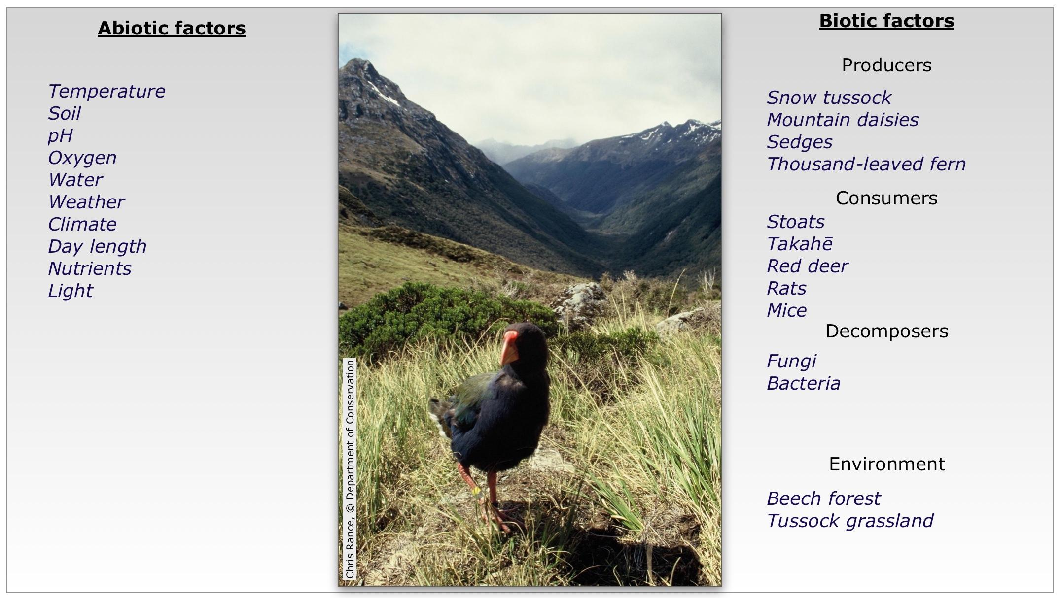

For students

Identify abiotic and biotic factors

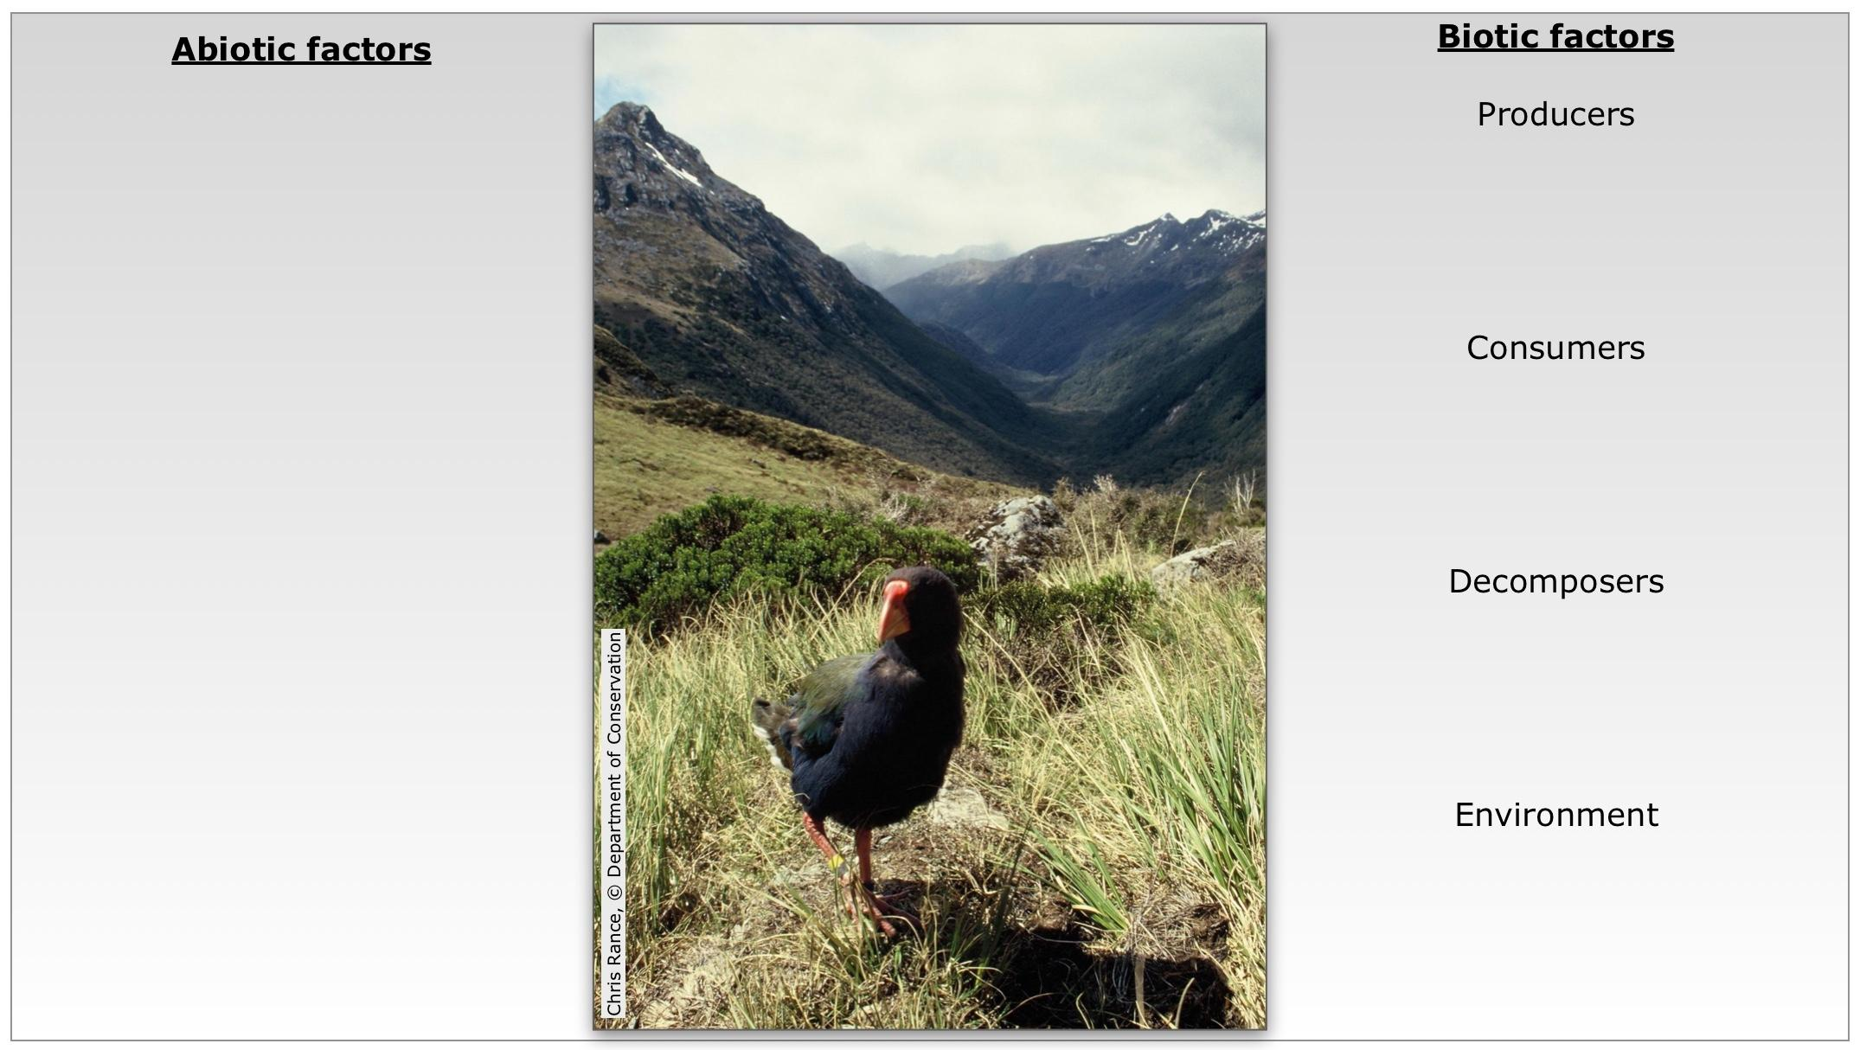

Sort the list of words into abiotic and biotic factors. Categorise the biotic factors into producers, consumers, decomposers and environment.

temperature | snow tussock | day length
climate | soil | red deer
mice | bacteria | nutrients
fungi | stoats | light
sedges | beech forest | water
tussock grassland | takahē | thousand-leaved fern
mountain daisies | pH | rats
weather | oxygen

